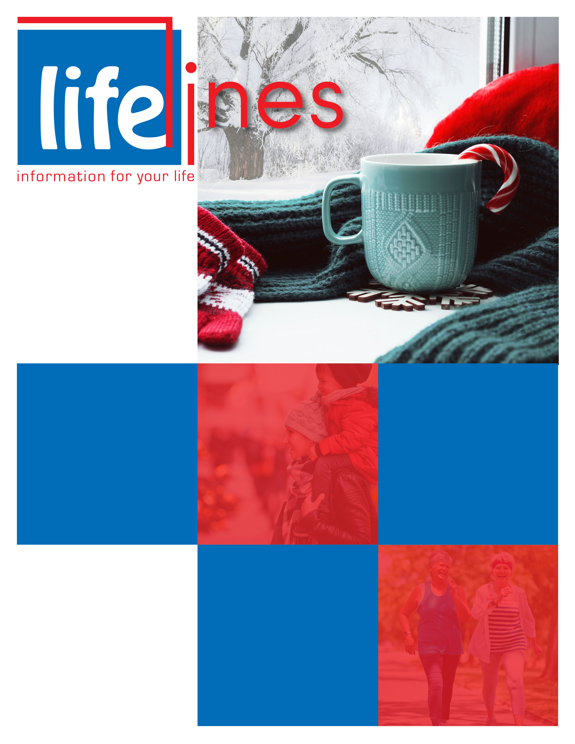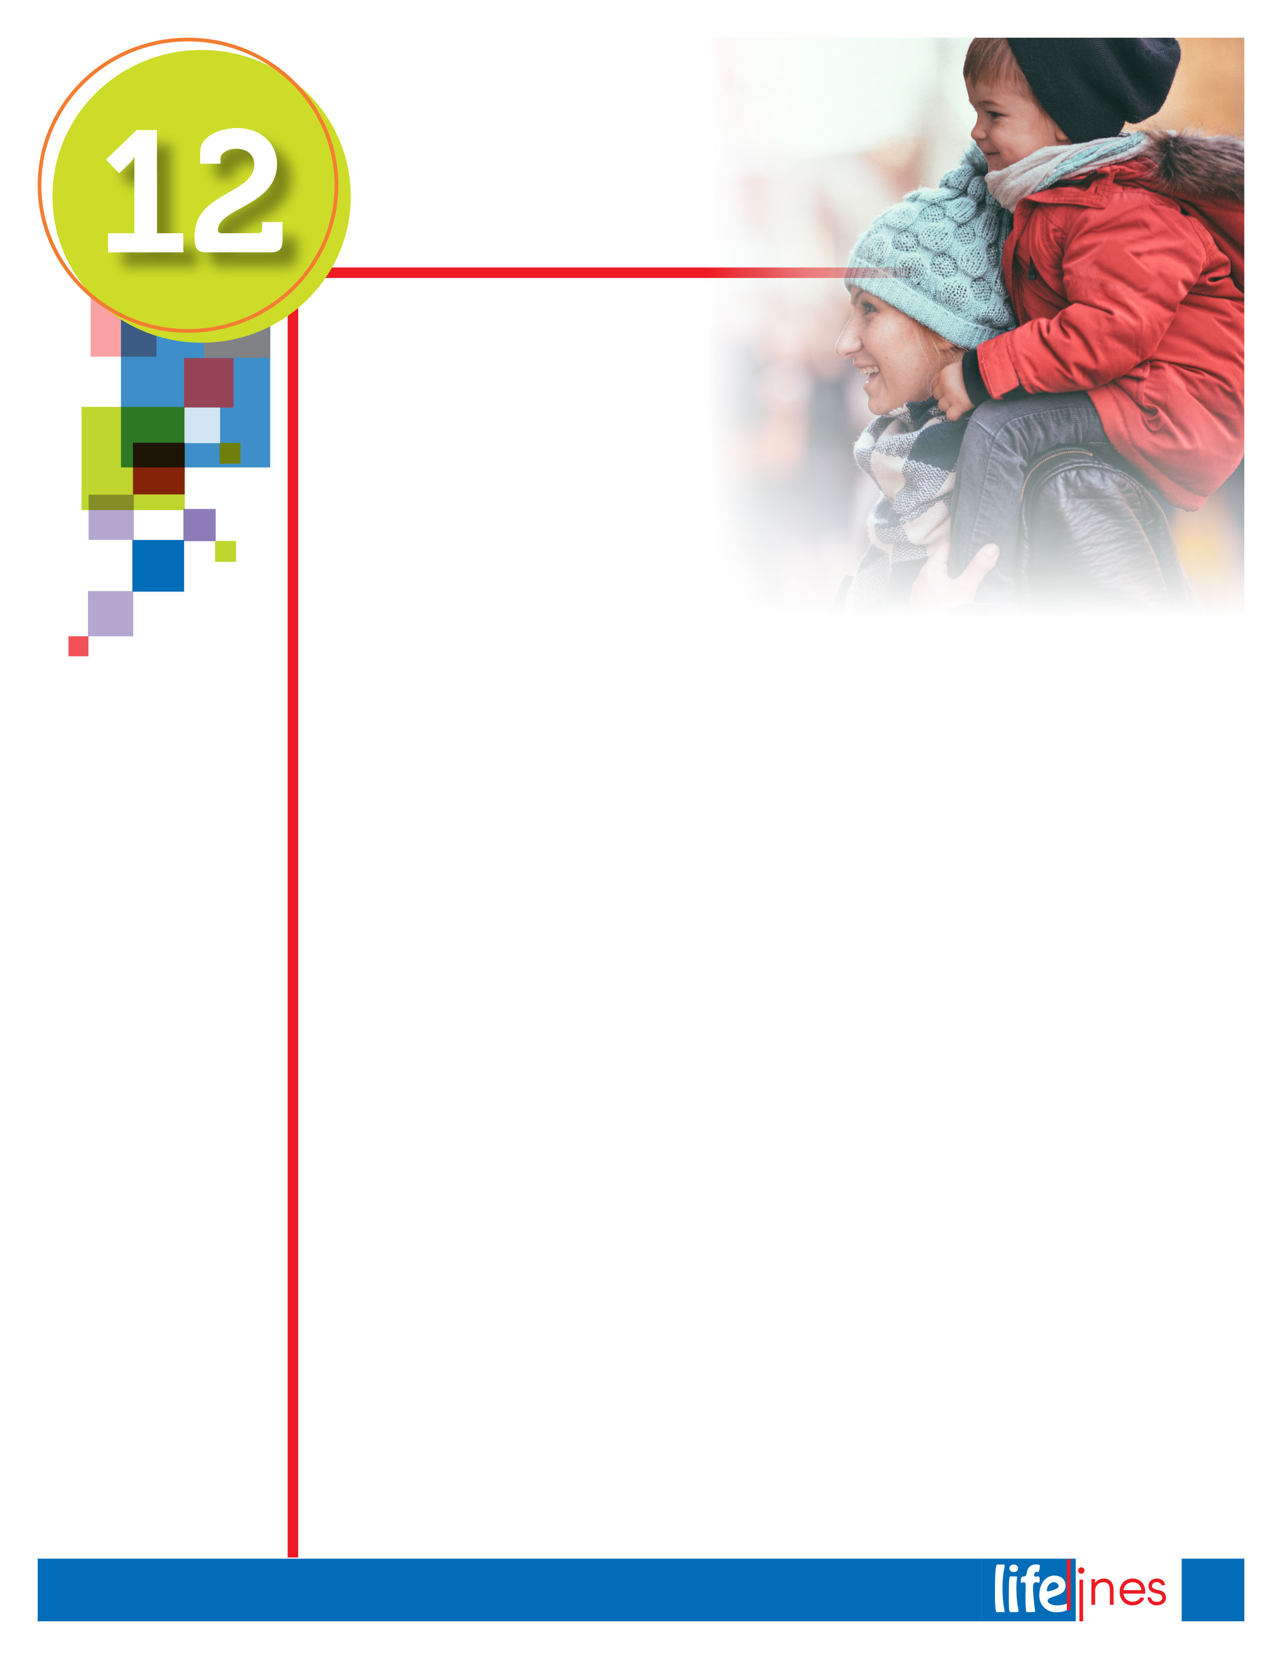



**Contact Us**

TOLL-FREE: **800-000-0000**

TTY/TTD: **866-228-2809**

**www.websiteinformation.com**

USERNAME: username

PASSWORD: password

**WINTER  
ISSUE**

# 2018

UNDERSTANDING STRESS AND BUILDING RESILIENCE

# PG: 3

# AGING SUCCESSFULLY

# PG: 6

12 WAYS TO HAVE A HEALTHY HOLIDAY SEASON

# PG: 2

ENERGY SAVERS:

# SAVE ENERGY AND MONEY TODAY

# PG: 5

**winter 2018**

2

Limit your portion sizes and foods high in fat, salt, and sugar. Also, be active for at least 2½ hours a week, and help kids and teens be active for at least   
1 hour a day.

1. **Wash hands often to help prevent the spread of germs.** It's flu season. Wash your hands with soap and clean running water for at least 20 seconds.
2. **Manage stress.** Give yourself a break if you feel stressed out, overwhelmed, and out of control. Some of the best ways to manage stress are to find support, connect socially, and get plenty of sleep.
3. **Don't drink and drive or let others drink and drive.** Whenever anyone drives drunk, they put everyone on the road in danger. Choose not to drink and drive, and help others do the same.
4. **Bundle up to stay dry and warm.** Wear appropriate outdoor clothing: light, warm layers; gloves; hats; scarves; and waterproof boots.
5. **Be smoke-free.** Avoid smoking and secondhand smoke. Smokers have greater health risks because of their tobacco use, but nonsmokers also are at risk when exposed to tobacco smoke.
6. **Fasten seat belts while driving or riding in a motor vehicle.** Always buckle your children in the car using a child safety seat, booster seat, or seat belt according to their height, weight, and age. Buckle up every time, no matter how short the trip, and encourage passengers to do the same.
7. **Get exams and screenings.** Ask your health care provider what exams you need and when to get them. Update your personal and family history. Get insurance from the Health Insurance Marketplace if you are not insured: https://www.healthcare.gov/get-coverage/.
8. **Get your vaccinations.** Vaccinations help prevent diseases and save lives. Everyone   
   6 months and older should get a flu vaccine each year.
9. **Monitor children.** Keep potentially dangerous toys, food, drinks, household items, and other objects out of children's reach. Protect them from drowning, burns, falls, and other potential accidents.
10. **Practice fire safety.** Most residential fires occur during the winter months, so don't leave fireplaces, space heaters, food cooking on stoves, or candles unattended. Have an emergency plan, and practice it regularly.
11. **Prepare food safely.** Remember these simple steps: Wash hands and surfaces often, avoid cross-contamination, cook foods to proper temperatures, and refrigerate foods promptly.
12. **Eat healthy foods, and stay active.** Eat fruits and vegetables, which pack nutrients and help lower the risk for certain diseases. Limit your portion sizes and foods high in fat, salt, and sugar. Also, be active for at least 2½ hours a week, and help kids and teens be active for at least 1 hour a day.

U.S. Centers for Disease Control and Prevention (CDC). (Updated 2017, December 4). *12 ways to have a healthy holiday season*. Retrieved November 8, 2018, from http://www.cdc.gov/

Take steps to keep you and your loved ones safe and healthy.

Brighten the holidays by making your health and safety a priority. Take steps to keep you and your loved ones safe and healthy—and ready to enjoy the holidays:

**Ways to Have a Healthy Holiday Season**

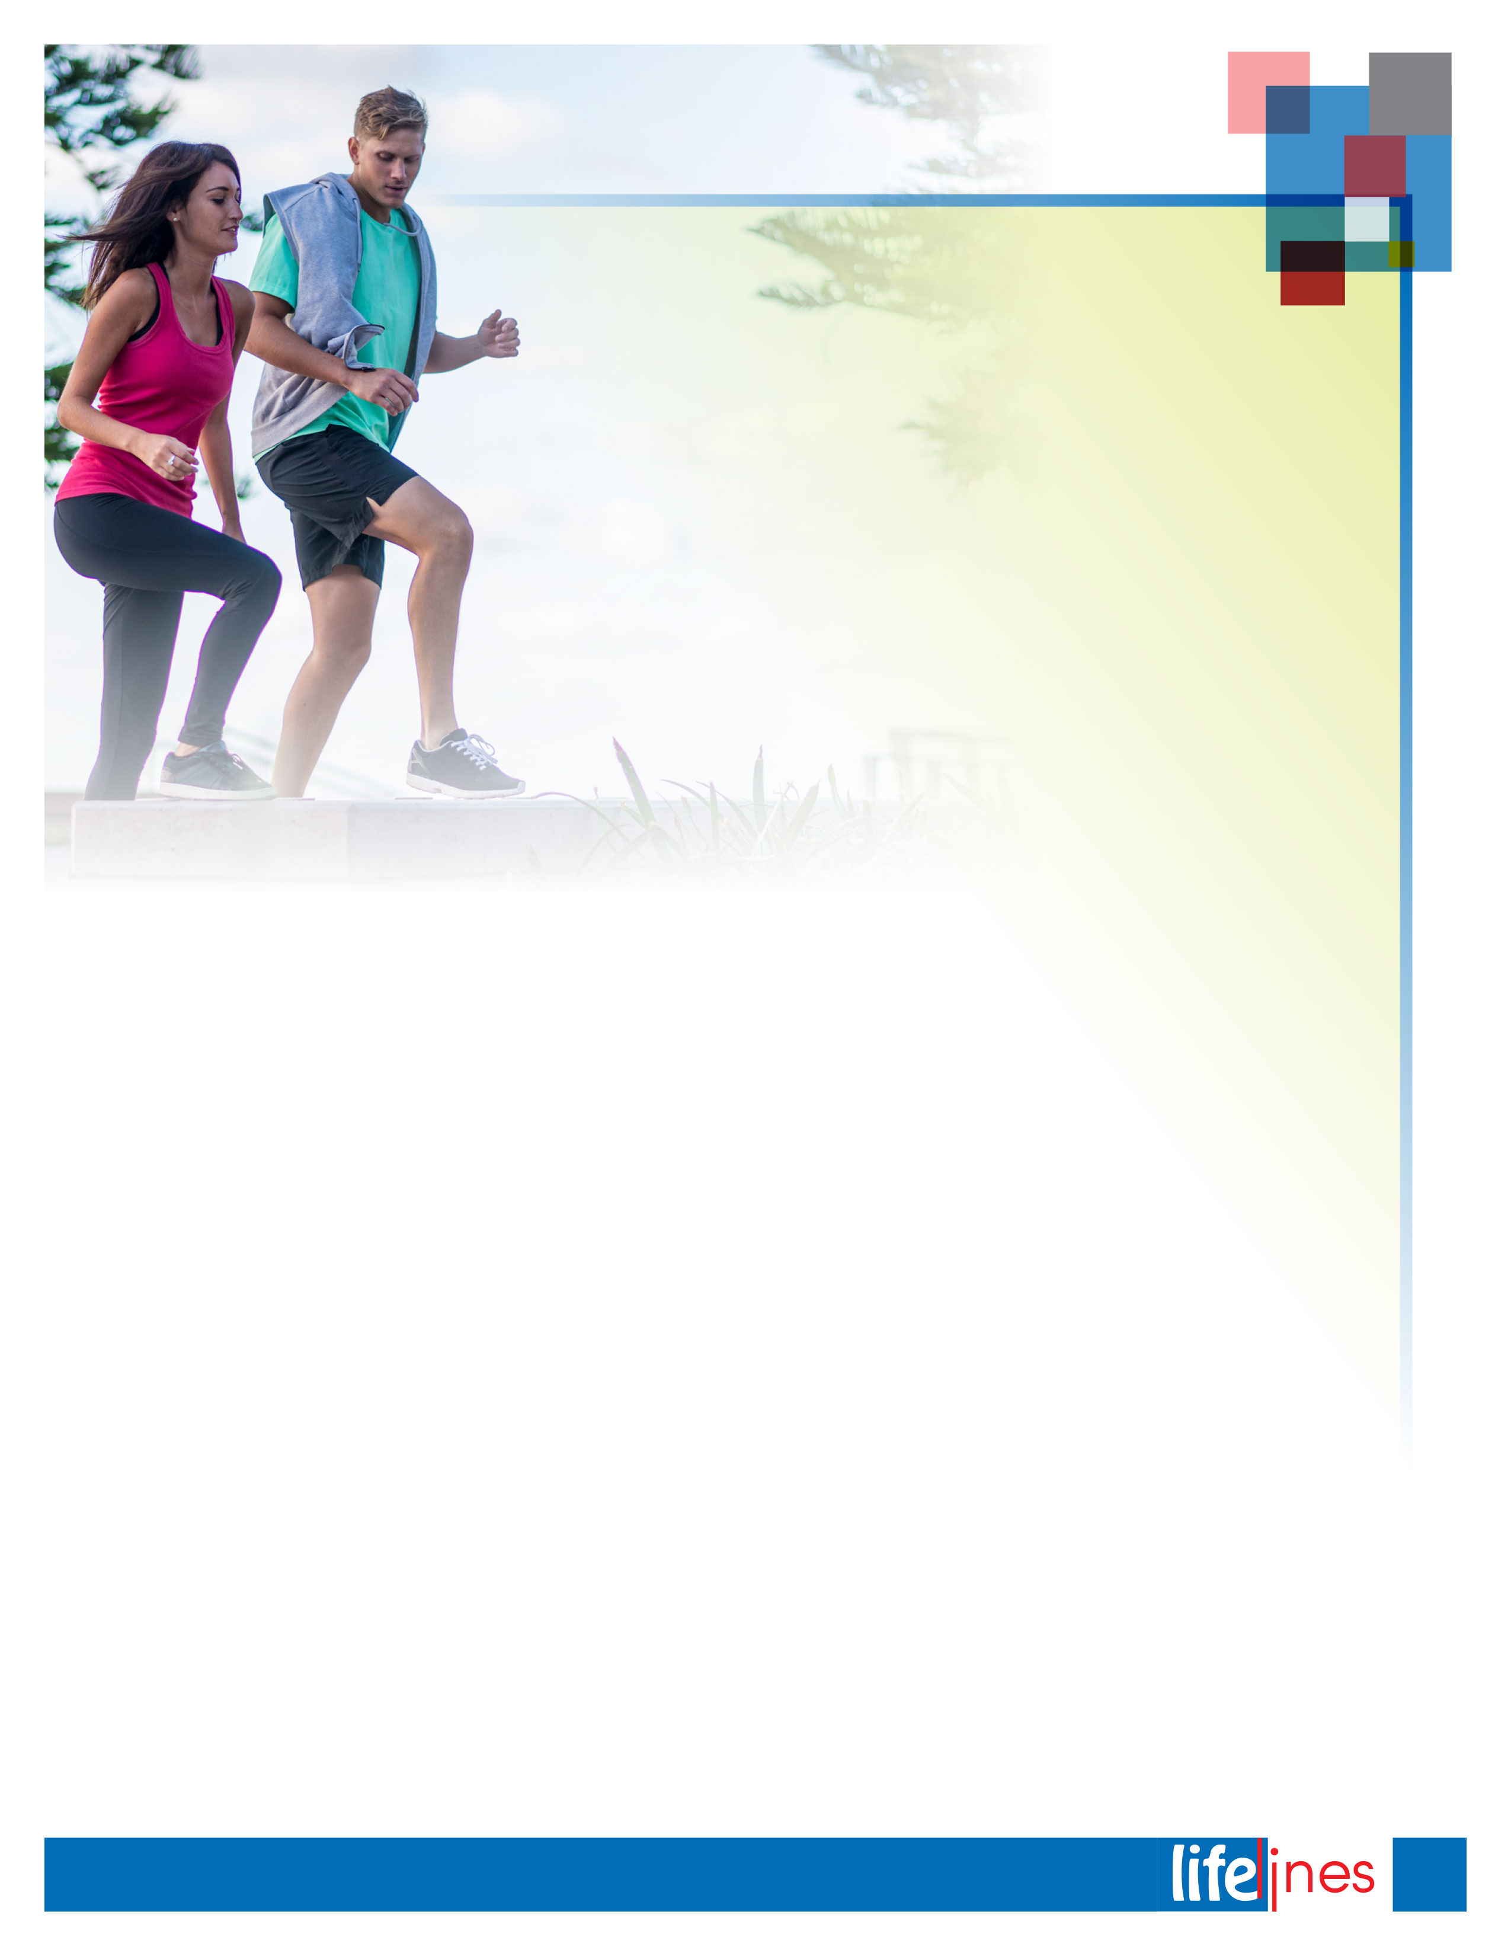

**WHAT IS STRESS?**People experience stress as they adjust to a continually changing environment. Stress has physical and emotional effects; it can create both positive and negative feelings. Positive stress can energize you and help you reach your peak performance. However, too much pressure turns into negative stress. Prolonged exposure to stress can be harmful to your physical and mental well-being. One of the first steps to managing stress is to understand what causes it.

**SOURCES OF STRESS**There is a wide range of sources of stress. These include daily hassles, major life events, home, and work. What are the things in your life that cause you stress?

**Home (Stress factors can include)**

* Relationships
* Money problems
* Children
* Sickness
* Housework

**Work (Work stress factors include)**

* Overload
* Relationships
* Pace of change
* Deadlines
* Unrealistic workloads or demands

**DID YOU KNOW?**

* Over 80% of the world's technological advances have occurred since 1900.
* A newspaper today contains more information than a person would see in his or her lifetime in the 18th century.

**STRESS MANAGEMENT AND PREVENTION**In addition to managing your response to stress, it is helpful to identify ways to prevent harmful levels of stress and build stress resilience.

**Prevention**

* Look at root causes of stress.
* Focus on building resilience to stress.

**Prevention Ideas**

* Keep a stress log—identify the sources of stress in your life.
* Identify your signs of stress—be aware of your stress level before it is unmanageable.

**BUILDING STRESS RESILIENCE**

* Exercise three to four times a week to reduce muscle tension.
* Minimize intake of sugar, caffeine, and other artificial stimulants.
* Get enough rest.
* Practice at least one relaxation exercise.

**STRESS SIGNS**Know your stress signs. A second step to managing stress is to understand how you react to it. Which of the following signs of stress do you experience?

Common stress signs include

* Muscle tension
* Headaches
* Indigestion
* Dry mouth
* Diarrhea or constipation
* Anxiety or excessive worry
* Difficulty concentrating
* Forgetfulness
* Irritability
* Tearfulness
* Depression

**UNDERSTANDING STRESS AND BUILDING RESILIENCE**

*continued on page 4*

3

**winter 2018**



### Boredom

### Apathy

### Changes in sleep patterns

### Withdrawal

### Accident proneness

### Reduced sex drive

### Increase in use of drugs, smoking, or alcohol

### Some of these signs may have causes other than stress. Check with your doctor if symptoms persist.

### STRESS RELIEVERS

### Get up 15 minutes earlier in the morning (making morning mishaps less stressful).

### Listen to music.

### Make time for fun.

### Unplug your phone.

### Stress Strategies

### Step 1: Awareness In order to manage stress, it is helpful to understand what causes your stress and how you react to stress. Ask yourself these questions:

### What are the sources of stress in my life?

### What are my emotional and physical reactions to them?

### What are my strengths in dealing with stress? (e.g., "I delegate well.")

### What are my limitations in dealing with stress? (e.g., "I sometimes have difficulty saying no to work requests.")

### Step 2: Plan

### Develop a plan of action by asking yourself these questions:

### What sources of stress can I eliminate or avoid?

### What sources of stress are changeable?

### What one change could I start with that would make the most difference in my life?

### Whom can I enlist in helping or supporting me with this change?

### How can I include taking care of myself in my plan?

### Step 3: Action Put your plan into action:

### Choose one new strategy to add to or change about your current strategies for dealing with stress.

### Practice a relaxation technique (breathing is one of the most effective ways of reducing tension).

### Identify what you do well at in managing your stress (use your past experience as a resource).

### Deal with the sources of stress that you can change (create a plan to eliminate, reduce, or avoid these sources).

### STRESS TIPS

### Share your concerns—talk to someone.

### Do something you enjoy.

### Take a brisk walk.

### Exercise.

### Take a break.

### Get a change of scenery.

### Set aside time for yourself.

### RELAXATION TECHNIQUE

### Find a comfortable place to sit, close your eyes, and begin to pay attention to your breathing.

### Take a deep breath in, and exhale slowly.

### Continue breathing deeply, and imagine a relaxing holiday spot.

### As you continue to breathe slowly, look around at the sights. Imagine the sounds, the smells, and the like.

### See yourself relaxed in this place.

### As you bring your attention back to the room you are in, remember that you can visit this place again anytime.

### OTHER IDEAS

### Additional ideas to reduce or combat stress include

### Counseling

### Yoga

### Meditation

### Hypnosis

### Biofeedback

### Relaxation CDs

### Massage

### Complementary medicine

### ACTION PLANNING

### Set short and long-term goals.

### Plan to make one change at a time.

### Check that your goal is specific and measurable.

Workplace Options. (Revised 2018). *Understanding stress and building resilience*. Raleigh, NC: Author.

*continued*

**UNDERSTANDING STRESS   
AND   
BUILDING RESILIENCE**

**winter 2018**

4

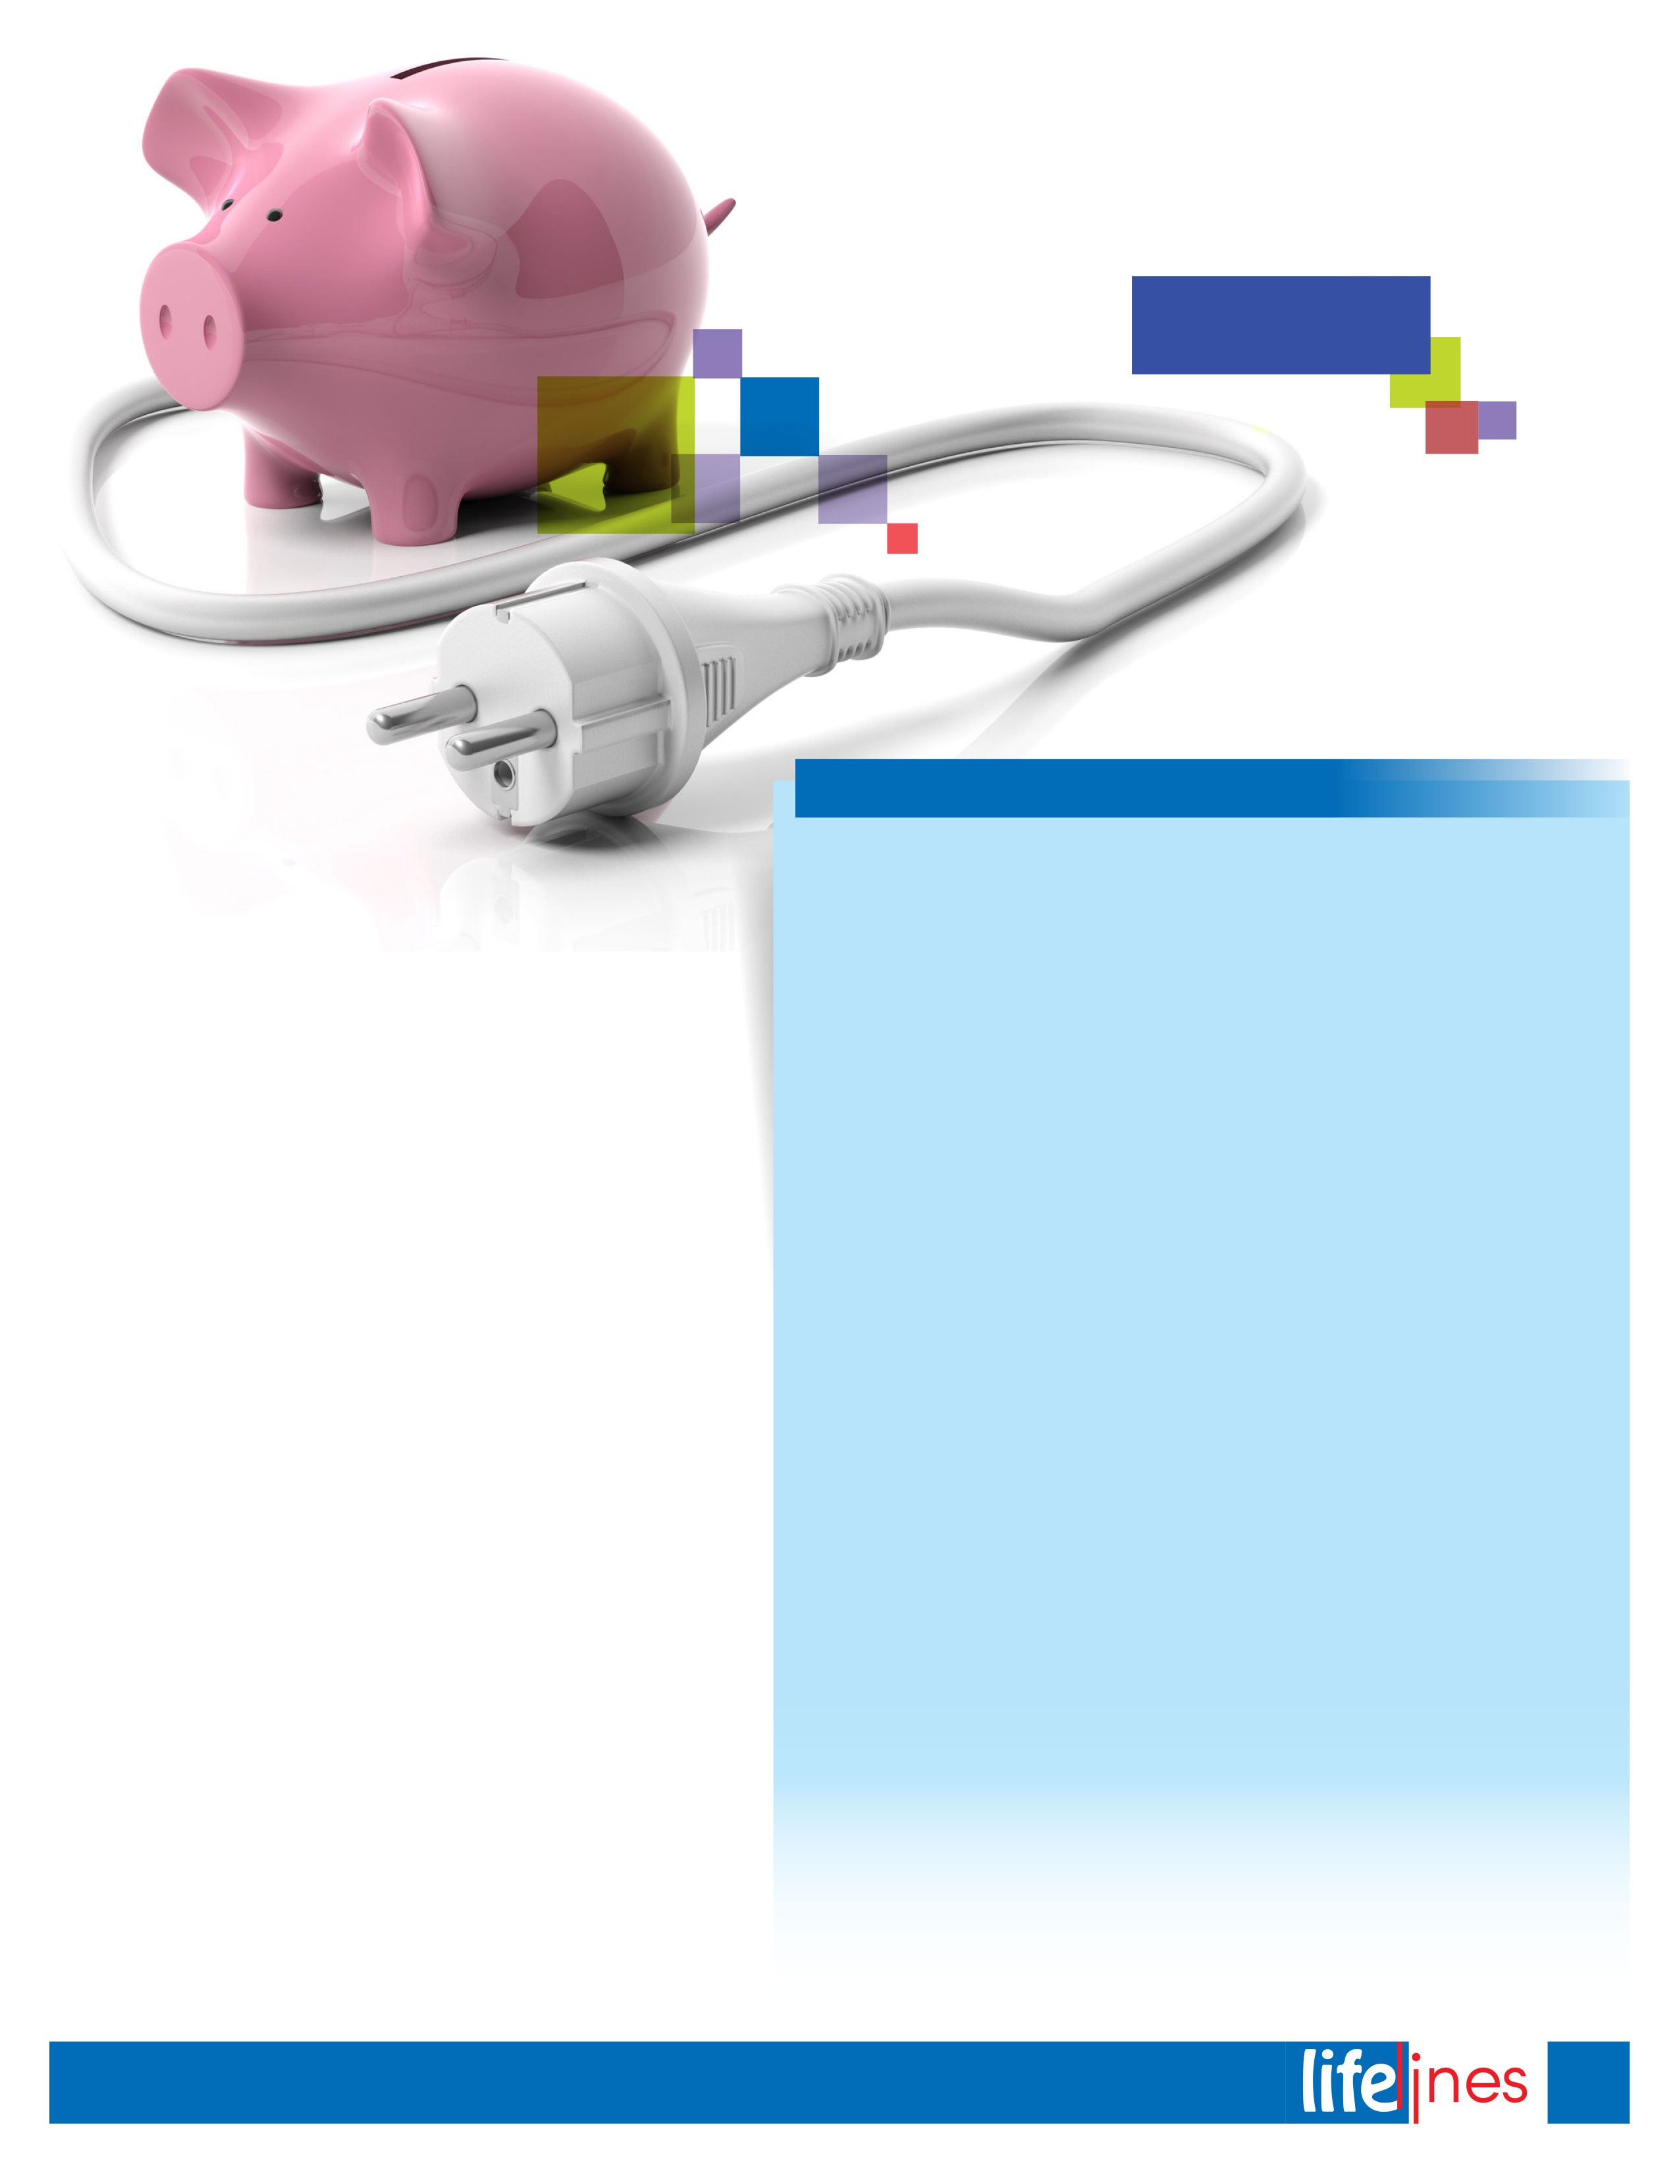

**Tips to Save Energy Today**

Energy Savers:

**Save Energy and Money Today**

**Here are some easy, low-cost, and no-cost ways to save energy:**

* Install a programmable thermostat to lower utility bills and manage your heating and cooling systems efficiently.
* Air-dry dishes instead of using your dishwasher's drying cycle.
* When you are not in the room, turn off things such as lights, TVs, entertainment systems, and your computer and monitor.
* Plug home electronics, such as TVs and DVD players, into power strips; turn the power strips off when the equipment is not in use (TVs and DVDs in standby mode still use several watts of power).
* Lower the thermostat on your water heater to 120°F.
* Take short showers instead of baths, and use low-flow showerheads for additional energy savings.
* Wash only full loads of dishes and clothes.
* Air-dry clothes.
* Check to see that windows and doors are closed when heating or cooling your home.
* Drive sensibly. Aggressive driving, such as speeding and rapid acceleration and braking, wastes fuel.
* Look for the ENERGY STAR® label on light bulbs, home appliances, electronics, and other products. ENERGY STAR products meet strict efficiency guidelines set by the U.S. Environmental Protection Agency and the U.S. Department of Energy.
* Visit https://energy.gov/energysaver/energy-saver for more energy-saving ideas.

U.S. Department of Energy (DOE). (Updated 2011, December). Save money and energy today (p. 3). In *Energy savers: Tips on saving money & energy at home* (Pub. No. DOE/GO-102011-3291). Retrieved November8, 2018, from <https://energy.gov/>

An energy-efficient home will keep your family comfortable while saving you money. Whether you take simple steps or make larger investments to make your home more efficient, you'll see lower energy bills. Over time, those savings will typically pay for the cost of improvements and put money back in your pocket. Your home may also be more attractive to buyers when you sell.

The 113 million residences in America today collectively use an estimated 22% of the country's energy. Unfortunately, a lot of energy is wasted through leaky windows or ducts, old appliances, or inefficient heating and cooling systems. When energy is wasted in homes, people are throwing away money that could be used for other things. The typical U.S. family spends at least $2,000 a year on home utility bills. You can lower this amount by up to 25% through following the long-term savings tips below.

The key to these savings is to take a whole-house approach—by viewing your home as an energy system with interdependent parts. For example, your heating system is not just a furnace—it's a heat-delivery system that starts at the furnace and delivers heat throughout your home using a network of ducts. Even a top-of-the-line, energy-efficient furnace will waste a lot of fuel if the ducts, walls, attic, windows, and doors are leaky or poorly insulated. Taking a whole-house approach to saving energy ensures that dollars you invest to save energy are spent wisely.

5

**winter 2018**



Successful aging depends on many factors, some of which are within your control and some of which are not. As your knowledge of the aging process grows, so does your ability to slow its effects.

**PHYSICAL CHANGES**Your muscular coordination and strength begin to decline as you age. However, even individuals in their 90s can benefit from exercise and strength training with weights. Biking, walking, and swimming can all improve balance, circulation, and overall fitness in people of all ages.

**MENTAL CHANGES**Normal changes in the aging brain account for some decline in the speed with which you learn new information, but healthy elders continue to learn and process new information throughout life. Minor forgetfulness (forgetting a name or where you put the car keys) is common. Remember that stress can also have a negative effect on your ability to process information.

Since older brains contain more data, it is logical to assume that gaps sometimes occur in information retrieval. To assist the process, make a mental note of when and where you put down an item, establish a routine, and keep a calendar of important dates.

Workplace Options. (Reviewed 2017). Aging successfully. Raleigh, NC: Author.

**Stay active.** With your doctor's help, establish an exercise routine.

**Do activities that stimulate the mind.** Volunteer, travel, read, learn a new language, study an instrument, do puzzles, play games, or sing songs.

**Eat a well-balanced diet.** Good nutrition is a key factor for good health.

**Be social.** Spend time with family and friends, join peer groups, or sign up for a class.

**Have a positive mental outlook.** A positive outlook will support a good attitude.

**Maintain a strong support system.** Keeping a formal and informal support system will help you be prepared for whatever situations you may face.

**Six Steps to Help You Stay Fit and Healthy**

**Aging Successfully**

**winter 2018**

6