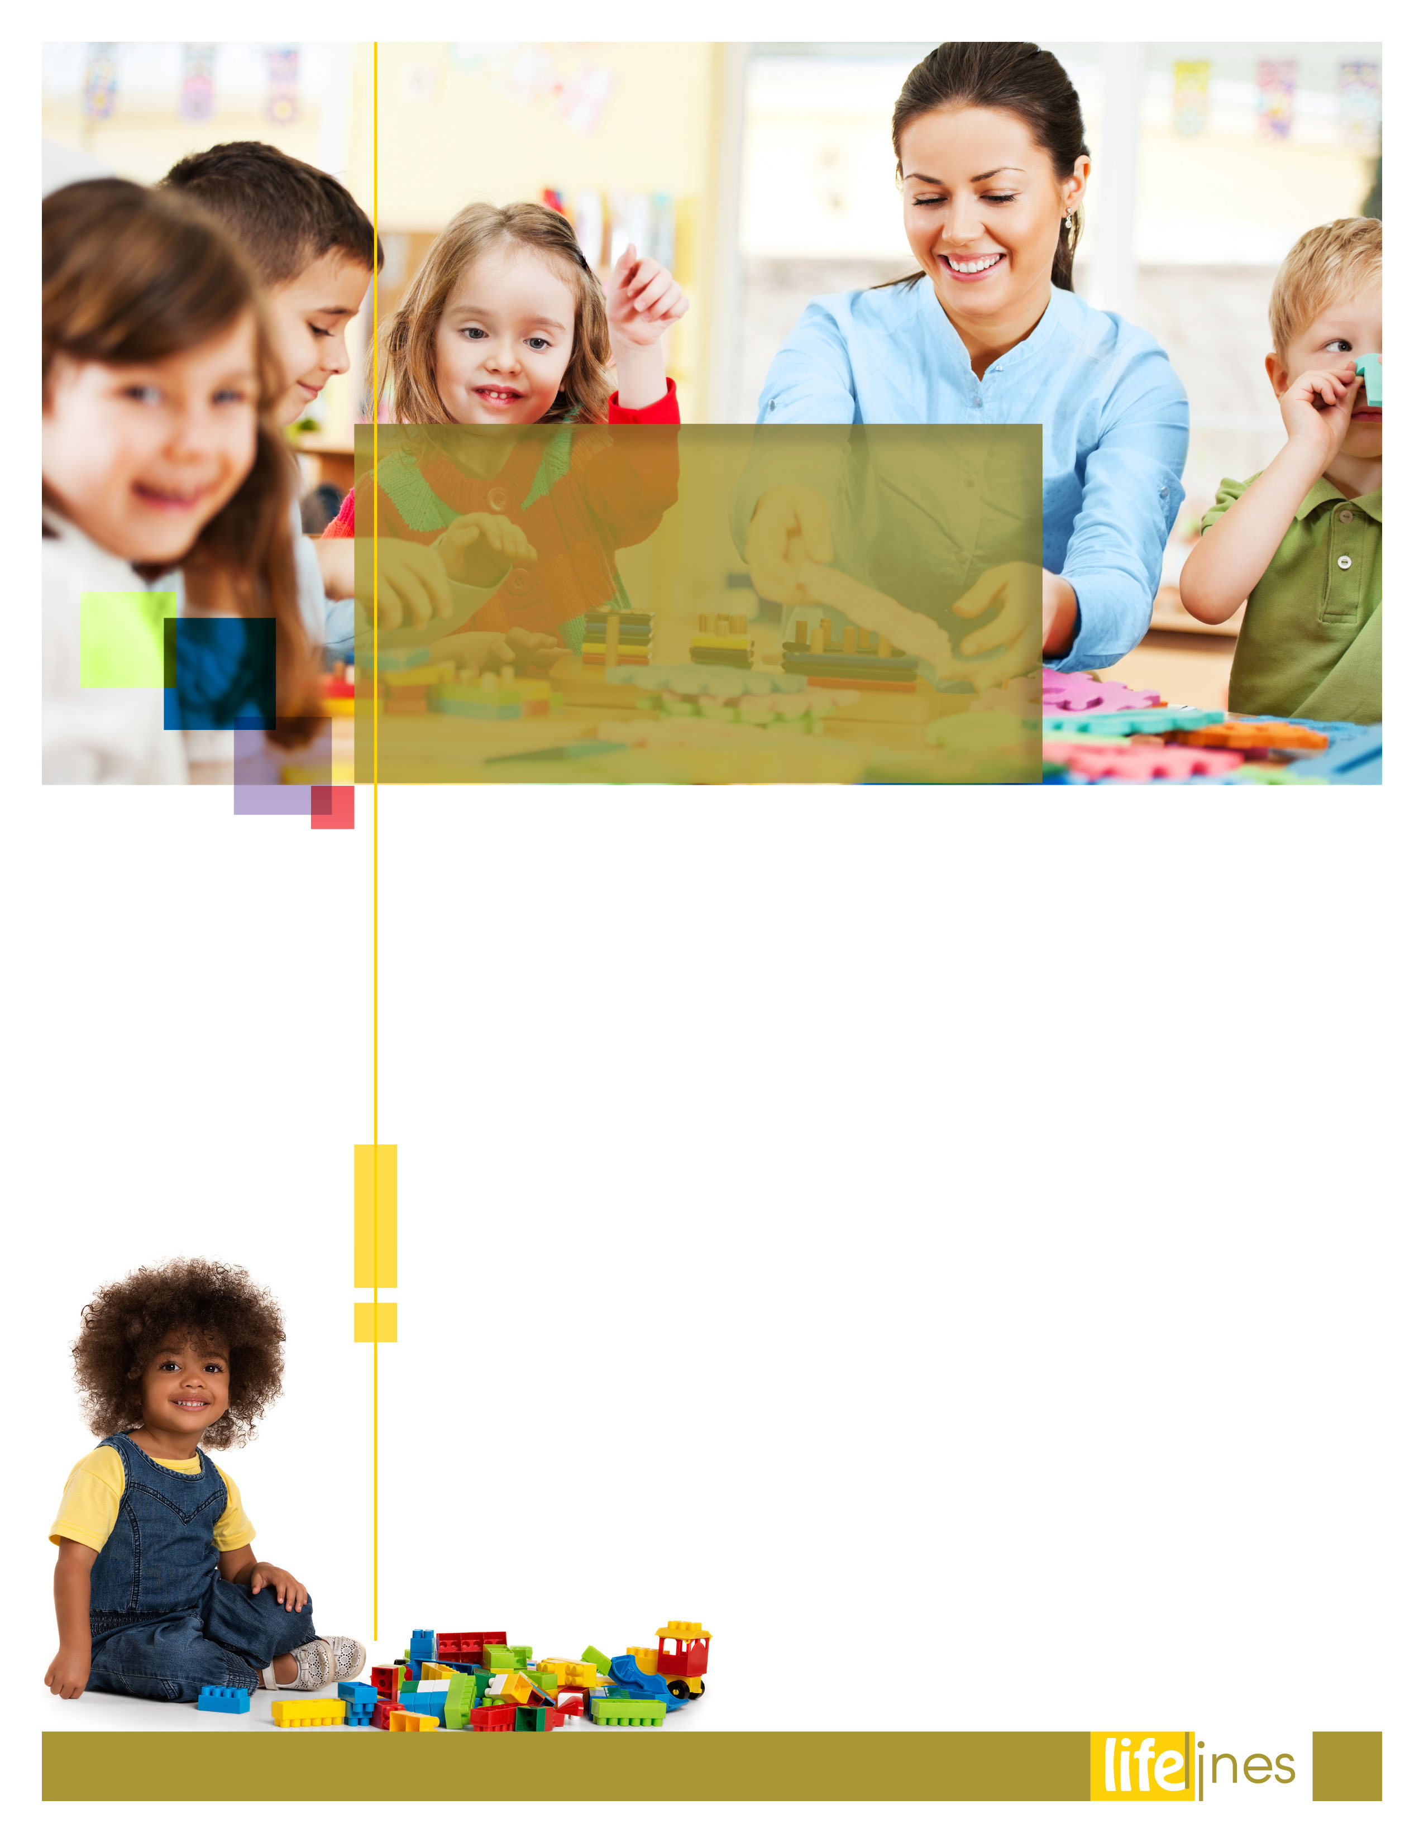

# MAKE THE HOLIDAYS YOUR OWN

# PG: 4

* UNDERSTANDING GRATITUDE

# PG: 6

* Choosing a Child Care Center

# PG: 2

* FAMILIES LEARN AND GROW TOGETHER

# PG: 8

**Contact Us**

TOLL-FREE: **enter number here**

TTY/TTD: **enter number here**

www.[**enter website URL here**](http://www.websiteinformation.com)**.com**

USERNAME: **username**

PASSWORD: **password**

**FALL  
ISSUE**

# 2019

|  |  |
| --- | --- |
| **PROS** | **CONS** |
| Centers are usually regulated to set minimum standards for health, safety, and adult-to-child ratios. | Centers are usually not flexible about hours of operation and may charge late fees. |
| Center directors and staff usually have education  in child development. | Center care may be expensive—especially for infants and toddlers. |
| Centers may offer a wide variety of activities and experiences as part of their programming. | Your child may not get as much individual attention at a center as in a family day care environment or from a nanny. |
| Your child will have playmates his age and may also meet children of different backgrounds or cultures. | A center may not accommodate all of your children. |
| Centers are able to provide care even if a  teacher is ill. | Centers are unable to care for a mildly ill child. |

CHOOSING A CHILD CARE CENTER

*continued on page 3*

Child care centers provide group care in a nonresidential setting. They are licensed by a state agency to care for a specific number of children at each level, with limits on the ratio of children to caregivers. They may offer part-day, full-day, after-school, or kindergarten options. Centers for children 3-5 years old are the most prevalent, however, many centers offer programs for infants, toddlers, and school-age children.

Centers are located in schools, hospitals, religious or spiritual organizations, recreation centers, or self-contained buildings. They usually have outdoor play space or a park nearby. Variations of centers include preschools or nursery schools. Nursery schools are part-day programs aimed at providing enrichment activities for children who do not need full day care.

Full-day programs may provide breakfast, lunch, and two snacks. Centers usually follow a daily curriculum or schedule. Hours of operation typically begin between 6:00 a.m.—7:00 a.m. and end between 6:00 p.m.—6:30 p.m. Times may vary depending on the center. The following is a list of considerations:

**Centers for children 3-5 years old are the most prevalent, however, many centers offer programs for infants, toddlers, and school-age children.**

**fall 2019**

2



*….continued*

Carefully review these materials prior to visiting the centers. Call in advance to make an appointment. Your referral service will provide you with basic information regarding vacancies, fees, hours, and policies. It is usually best not to bring your child along to every program you visit. It may be confusing for the child. Once you have narrowed your choices, consider making another visit with your child.

The activities of the day and the interaction between the provider and the children are strong indicators of the quality of care provided. Observe your child's prospective classroom. Pay attention to first impressions. Is the room bright and cheerful? Is children's art work displayed? Are children engaged in a variety of activities? Do the children seem involved and happy? Are staff members pleasant and responsive to the children and each other?

You will want to spend some time talking with the director about the program and tour the entire center.

Workplace Options. (Reviewed 2017). *Choosing a child care center.* Raleigh, NC: Author.

**Accreditation**

In addition to a license, which allows the facility to operate, there is a growing trend to apply for accreditation. The National Association for the Education of Young Children (NAEYC) offers an accreditation program for child care centers. Accreditation is a seal of approval. NAEYC has developed criteria, which includes parent input and inspector validation. Centers must apply to NAEYC in order to be accredited and are subjected to an extensive external review process. While accreditation indicates that the center has met NAEYC's standards, it does not mean that accredited programs are necessarily better than those that have not applied for accreditation.

**Evaluating Child Care Centers**

In order to evaluate child care centers, it is important to visit several programs and spend time observing in each one.

**fall 2019**

CHOOSING A CHILD CARE CENTER

3



**Are the holidays about extended family, or about solitude? Is this the time to explore cultural roots and reconnect with religion, or a chance to reach out to strangers? Forget about what everyone else says or what your mother has always done, what do you want your holiday traditions to be?**

*continued on page 5*

So it's that time of year again. You take one look at the calendar and you're hit with pictures of perfect holidays. There are kids frolicking in the snow, big families laughing around a huge meal, and smitten couples exchanging gifts in front of the fireplace. The pressure is on to make the traditional holiday images come to life—or else!

But what about those people who aren't included those snapshots? What if you are single, without little ones to decorate the Christmas tree or light menorah candles? More and more people are divorced and part of blended families who are dealing with multiple traditions in the same house. The truth is that lots of families today don't have a mom, a dad, and 2.5 Norman Rockwell children. And for many people, the pressure becomes too much. If you don't belong in a traditional holiday portrait you can still make the holidays your own by creating your own traditions.

**Figure out what you want.**

Basically, holiday stress is caused by unrealistic expectations. In one word, stress is *should*. During the holidays, everyone, particularly those people who don't live anywhere near "It's a Wonderful Life," can use a reminder to think about their own needs and desires for this time of year and not focus on what they've come to believe they should do.

Before the holidays, spend some time with yourself. Set aside a couple of days to examine what you're really looking for during the holidays. If you had it your way, how would you paint the picture? Are the holidays about extended family, or about solitude? Is this the time to explore cultural roots and reconnect with religion, or a chance to reach out to strangers? Forget about what everyone else says or what your mother has always done, what do you want your holiday traditions to be?

Make the Holidays Your Own

**fall 2019**

4



Workplace Options. (Reviewed 2017). *Make the holidays your own.*Raleigh, NC: Author.

**Going It Alone, or Not**

If you're single, you might look into doing volunteer work at a local soup kitchen, food bank, or homeless shelter. Or maybe you want to do something totally self-indulgent. What's stopping you from spending a day relaxing at a spa, hiking or biking, or hopping on a plane and enjoying the holidays at the beach? Rely upon your family or friends who may have all sorts of interesting things planned. Also, friends with kids are not off limits during the holidays. If you want to be around children, find the families in your circle who'll welcome a guest to a holiday meal, and then ask what you can contribute. Maybe you're helping them fulfill their tradition.

The holidays also tend put extra pressure on new relationships, whether it's a new romance or a new family unit. Keep in mind that now is not the time to force things. Concentrate on what's truly at the core of the holidays for you and find ways to embrace that together. Have fun. Chances are the new people in your life will feel relief as well without having to rush into a situation loaded with expectations.

**Blending a family means staying flexible.**

Blended families are faced with a particular challenge during the holidays. For kids and adults, thinking about celebrations past inevitably brings back memories, good and bad. It's important to talk about what each side of the family used to do, and what the new family can do now to make things special. Be flexible. It may be combining traditions or it may be starting fresh. Planning can get complicated if the holidays are divided between families, but kids often don't mind celebrating more than once—in a different way in each home—no matter what date the celebration happens to fall upon.

**Make a list of *no's*.**

Just as important as your holiday wish list is pinning down what you don't want. Come up with a list of all the things that are not part of your ideal holiday, even if you may not be able to realistically eliminate them. Do you really want to deal with expensive gifts this year? Must you make an appearance at your neighbor's annual party? Do you have to invite your husband's ex-wife over for dinner? Include everything that makes you nervous just thinking about it. Call it a *stress list.*

Then practice saying *no.* It may sound silly, but practice it in front of the mirror. You'll probably find out that it works remarkably well when the time comes. And if not, at least you spoke up.

**Timing is everything.**

If you decide to shake your holidays up a bit you'll probably want to start planning early. Don't ambush your loved ones at the last minute by opting out of the family meal and announcing a solo trip to Mexico, or throw a new tradition at the kids on Christmas Eve. You may have shifted your outlook, but it could take some time for the rest of the world to join you.

Change isn't always easy, especially when people are bombarded with old-fashioned images of holidays past that probably were not ever quite real. But once you can let go of the unrealistic expectations, visualize what you need, and take the holidays into your own hands, you are one step closer to having a stress-free season truly worth remembering.

*….continued*

Make the Holidays Your Own

*continued*

5

**fall 2019**



"Gratitude implies humility—a recognition that we could not be who we are in life without the contributions of others. Gratitude also implies the recognition that it is possible for other forces to act towards us with beneficial, selfless motives. In a world that was nothing but injustice and cruelty, there would indeed be no possibility of gratitude. Being grateful is an acknowledgement that there are good and enjoyable things in the world."   
**—*Dr. Robert A. Emmons,*** *published in* Thanks! How the New Science of Gratitude Can Make You Happier

*continued on page 7*

mind the things and people in your life you are grateful for. Remind yourself that they are gifts, because none of this is owed to you.

* **Create a short prayer or affirmation concerning the gifts you have received.** Use this on a daily basis to remind yourself that even though you have worked and planned for what you have, life could have turned out differently.
* **Use a daily gratitude journal.** Make it special by purchasing an inexpensive journal you can use just for this purpose. Every day write at least five things that you are grateful for. Your entries can be short or long; it doesn't matter. To begin, make a commitment to do this for at least two weeks, and then work to develop it into a lifelong habit. The key to doing this is to never repeat an entry. Each new entry has to be different. You will find that this helps you to begin to pay attention to many of the small gifts that come into your life.
* **If you have children in your life, make it a practice to discuss gratitude on a daily basis.** Help them to create and use their own gratitude journal. Doing this is a wonderful teaching tool as you help your children to develop resilience.
* **Focus on the fact that gratitude can turn difficulties into gifts**, and use this truth each time you are faced with a challenge in life.

Gratitude is a positive emotion that occurs when you understand and acknowledge that the positive experiences you have in life, small or large, are not owed to you but are gifts. It is the opposite of taking things for granted. The experience of this emotion on a regular basis has been shown to have very positive effects on enthusiasm, energy, and well-being. Because of the positive benefits of gratitude on health and happiness, it is important to increasing your resilience to bring the regular practice of gratitude into your life.

Research has shown that the positive effects of gratitude are multiplied as you increase

* The strength of your feeling of gratitude
* How often you experience gratitude in any given minute, hour, or day
* How many life circumstances you feel grateful for
* The number of people in your life to whom you feel grateful

**Developing Gratitude**

There are a number of exercises that can increase your sense of gratitude in each of these areas. They take just a few minutes a day and can have a life-changing effect:

**Begin each day with a two-minute gratitude session.** Find a quiet space of two minutes, close your eyes if possible, and bring to

Understanding **Gratitude**

6

**fall 2019**



Defense Centers of Excellence, National Center for Telehealth & Technology, Afterdeployment. (2010). *Understanding gratitude*. Retrieved January 12, 2018, from http://afterdeployment.dcoe.mil/

**Write a gratitude letter.**

This exercise takes the form of identifying a person to whom you are grateful for his or her presence in your life or for something that was done for you recently or in the past. The person does not need to be present in your life now. This person should be someone to whom you believe you have not sufficiently, or ever, previously expressed your gratitude.

After you have identified this person, take a few minutes to write a letter expressing your gratitude, how your life was affected by the person's actions, and specifically what the person did for which you are grateful. Be as specific as possible in describing the contribution this person made to your well-being.

If you decide to actually express your gratitude to someone and you don't get the response you hoped for, remind yourself that this isn't a contract with the other person. You are not owed anything in return. This is about who you are.

Look for opportunities to be grateful for the experiences and people who come into your life on a minute-to-minute basis. Get used to noticing when the traffic lights are timed just right for you, when someone holds the door or lets you into traffic. Pay attention to the beauty that you are surrounded by all the time—a flower, a tree, a vista. Try not to repeat things you notice. There is plenty to be grateful for without repeating.

**fall 2019**

*….continued*

Understanding **Gratitude**

7



*continued on page 9*

**Responding to infants' crying and holding them often is important and develops a sense of trust.**

* **Babies first gain control** over their heads and then their bodies in the early months of life. Rolling over, sitting, crawling, walking and moving with a purpose can happen over the course of the first 12-15 months.
* **Babies are like sponges**, soaking up all of the talk around them. Thus, talking, singing, reading and interacting with your baby becomes critical to the development of language. Television and videos are not a substitute for face-to-face interaction with a loving caregiver.
* **Babies coo and babble**, but the main way they communicate is by crying. As all parents quickly learn, their babies' cries can change when they are hungry, tired, wet, frightened or overwhelmed. Responding to infants' crying and holding them often is important and develops a sense of trust.
* **Babies have their own temperaments and rates of growth**, as well as their own routine of feeding and sleeping. Each relationship between family and baby is special and unique!

Parents are a child's first and most important teachers, and it is in the everyday routines that great learning opportunities happen. This information is meant to be a source of simple and fun ideas and to be a reminder to make the most of every minute!

Each child and family is different. Children learn and grow at their own pace and in their own unique and wonderful way. Families also have their own special and unique traditions. There are many ways that families can learn and grow together—more than what is included here. You can also talk with your friends and other parents to share more good ideas and activities that create meaningful moments for your family.

**Infants (Birth to 15 Months):   
Growing Every Day**

Infant development is amazing! At the end of 12 months, your baby can be three times his birth weight and twice his birth length. Babies follow a similar path of development, yet each is unique. Here is what you can expect to see during the first 15 months of life:

Families **Learn** and **Grow** Together

8

**fall 2019**

*….continued*

*continued on page 10*

**Activities to Help You Learn and Grow Together**

* **Play with simple toys:** Your baby can drop; roll; and chew soft and colorful toys, such as stacking cubes, rattles and soft blocks.
* **Use toys at bath time:** Use toys that float or sink. Splash and play with these water toys, and always keep one hand on your baby during bath time.
* **Sing through routines:** Repeat lullabies, finger plays, and games like pat-a-cake and peek-a-boo to help build language skills. Your baby loves the sound of your voice!
* **Babies love to look at themselves in the mirror:** Provide child-safe mirrors for the car, stroller or play space. Point and say. "Here is your nose, there is your mouth, I see your eyes. …"
* **Read to your baby:** Look at chunky board books with colorful pictures or photographs. Let baby hold the book and turn the pages. This builds a solid foundation for literacy and school readiness.

**Parenting Tips**

* **Have a daily routine:** Provide a predictable daily routine for your baby. This gives your baby a sense of security and safety.
* **Respond to your baby's cries:** Immediately tuning in to your baby's needs develops attachment and trust. You cannot spoil your baby by responding right away.
* **Make sleep time safe:** Avoid toys, blankets and pillows in your baby's sleeping area, and always put your baby to sleep on her back.

**Toddlers (15 to 36 Months): On the Move**

Toddlers are busy and eager explorers with small bodies and big feelings! Toddlers are trying to do things for themselves but still need to be reassured by the adults in their lives. They are experiencing the world and trying to make sense of it all at the same time. Here is what you can expect to see in the toddler years:

* **Vocabulary takes off.** Toddlers are learning many new words and putting them together.
* **Toddlers start using words** to interact with parents and other people in their lives. This stage is marked by the frequent use of favorite toddler words: "No," "Mine" and "I do it!"
* **They are on the move!** Crawling, dancing, rolling and running all contribute to a toddler's growth.
* **Although they often get frustrated, this is just a temporary stage.** As toddlers develop more language, an understanding of how things work and what to expect, their frustrations melt away rather than melt down.
* **Toddlers are straightforward, concrete thinkers** who truly believe a kiss and hug can make things all better!

**Activities to Help You Learn and Grow Together**

* **Turn a walk into learning time:** Talk about what you see, like the colors of cars, or count the number of dogs. Let your child share her ideas with you and expand on what she says!
* **Sing your way through routines:** Take a familiar or favorite tune, such as "Row, row, row your boat," and use words to match your activities, such as "Brush, brush, brush your teeth."
* **Visit your local public library:** Check out new books to bring home and look at together. Children's librarians can help you find books to read with your child and may host special story times for toddlers.

**Parenting Tips**

* **Be patient with your little explorer:** Toddlers need to repeat activities many times until they can predict what will happen in a given situation.
* **Acknowledge feelings:** Give your child words for what he is feeling. "I know you are sad." He has to know you understand him before he can listen to you.
* **Redirect:** Head off a tantrum by offering another activity when you see your child is becoming frustrated. As you play with your child, you will learn to tune in to the signs that she needs a change of scene.

Families **Learn** and **Grow** Together

**fall 2019**

9

**Preschoolers (3 and 4 Years): Imagination on the Go**

Preschoolers are active and more confident of how their bodies move. Here is what you can expect at this stage:

* **They like to use their fingers** to build with blocks, use crayons and do puzzles.
* **You will see great growth** in your child's language, imagination and ability to play with other children.
* **They are curious about the world** and want to understand how everything works. They often ask questions and share their own stories and experiences.
* **This stage often marks the development of imaginary play** and role-playing, when children create rich and involved fantasies.
* **Busy preschoolers have a growing interest in playing** cooperatively with other children. All the time you spent encouraging your toddler to take turns now pays off!
* **Preschoolers learn concepts** of reading, math, writing and science as part of their play and everyday routines!

**Activities to Help You Learn and Grow Together**

* **Cook safely:** Make a shopping list, and plan to cook together. Ask your child to look at the supermarket flyer with you and tell you what needs to go on the shopping list. Always closely supervise cooking activities; turn pot handles away from your child and keep sharp or breakable objects out of reach.
* **Sort, count and label:** Build numbers into everyday routines. Count your way upstairs, or say out loud the number of bananas you are picking at the supermarket. Using math builds problem-solving skills and confidence.
* **Look at your child's baby pictures together:** Marvel at how your child has grown and changed! Let your child tell you about all the things she can do now that she could not do as a baby. Remember that even "big kids" need a cuddle.
* **Have an indoor "family picnic":** Plan an easy-to-prepare menu and select a theme. For a seasonal "Winter Wonderland," you can use sheets for snow, pillows for a snowman and bubbles for falling snow.

**Parenting Tips**

* **Let your child see you writing and reading:** You are the best role model your child has for supporting literacy.
* **Do chores together:** Develop cooperation and responsibility early on by letting your child help out.
* **Be amazed:** Let your child know how impressed you are with his accomplishments and abilities.

**Young School-Age (5 to 9 Years): Curiosity Rules**

When children start the formal school years, they become more independent and their world begins to expand. Here is what you can expect at this stage:

* **Children are experiencing physical growth and changes** at this stage. They are becoming stronger, and have better coordination and more energy.
* **Your child's natural curiosity** is also flourishing! You may be asked to respond to their questions with greater detail. In return, your child is able to relate experiences and solve problems with more depth and logic.
* **An understanding** of the difference between fantasy and reality emerges.
* **As they become confident readers**, school-age children may enjoy reading a book on their own.
* **During this stage, your child is forming more relationships** outside of the home with peers, teachers, coaches and others.
* **In order to embrace your child's expanding world**, participate in her school or after school (organized or informal) activities. Allowing your young school-age child to be more independent and active in her environment will enhance family moments.

**Activities to Help You Learn and Grow Together**

* **Engage with story starters:** Begin to tell a story, and stop at a suspenseful moment. Let your child continue the story using his own thoughts and imagination.
* **Plan a scavenger hunt:**Encourage your child to partner with a sibling or friend. Let each team select a few items to hide in the home or designated area. Teams may give hints for hard to find objects.
* **Talk about current events:**While reading the newspaper, waiting at the bus stop or eating dinner, talk about an article or current event. Encourage your child to give her reaction and share her perspective or thoughts.

*….continued*

*continued on page 10*

**fall 2019**

10

Families **Learn** and **Grow** Together

Massachusetts Department of Early Education and Care (EEC). (n.d.). *Families learn and grow together*. Retrieved January 3, 2017, from http://www.mass.gov/

*….continued*

**Parenting Tips**

* **Reinforce mastered skills:** Give children opportunities to be successful in new activities that build on skills that they have already learned.
* **Encourage humor:** Humor in your daily communications with your child can enhance positive family experiences.
* **Set reasonable limits:** Provide consistent and loving support to your independent learner as he becomes skilled at making his own choices.

**School-Age (10 to 14 Years): Young Minds at Work**

There is noticeable growth and change in the child of 10-14 years. Here is what you can expect at this stage:

* **During these years**, physical exercise, good nutrition and an appropriate amount of sleep are important.
* **Their young minds are able to understand logical** and abstract thinking. They are learning quickly and need to be challenged in new and exciting ways.
* **You may notice that your child is now able to concentrate** for longer periods of time and can memorize and recall larger amounts of information.
* **Puberty begins** sometime in this age span and varies from child to child.
* **Children may show an interest in sports or the arts**, while others may be more social and concerned about their relationship with friends.
* **Your 10-14-year-old is working to develop his own identity** and may worry about "fitting in."
* **Encourage independence** by giving them some control over their lives, but remember they still need direction, understanding, support and positive reinforcement from the adults in their lives. As a result, you should see that they are capable of using good judgment and accepting responsibility for their actions.

**Activities to Help You Learn and Grow Together**

* **Create a dictionary:** Have your child write a word and its definition and then decorate the page. Hang on the fridge and talk about ways to use the word in a sentence. After a few days, pick out another word! Collect the pages and create a "child's" dictionary!
* **Have a "game night":** Games promote the everyday skills of cooperation, honesty and making choices. Games strengthen skills used in school such as memorization, spelling, problem-solving and taking turns.
* **Talk about when you were growing up as a child:** Telling family stories and history can be the beginning of tracing the family tree. Children can interview other family members, write out the stories and use photographs to create a family scrapbook.

**Parenting Tips**

* **Positive reinforcements:** Give support to your child through open communication. Give the message:   
  "We can talk about anything." You can promote a trusting and positive self-image in your child.
* **Set up a homework area:** A stationary work space, a specific time set aside for the task and perhaps a "no TV" rule can help your child concentrate. Try to be available to answer any questions or help with homework.
* **Safe Internet use:** Make Internet use a family activity, and support your child's responsible and safe exploration of the Web.

**fall 2019**

11

Families **Learn** and **Grow** Together