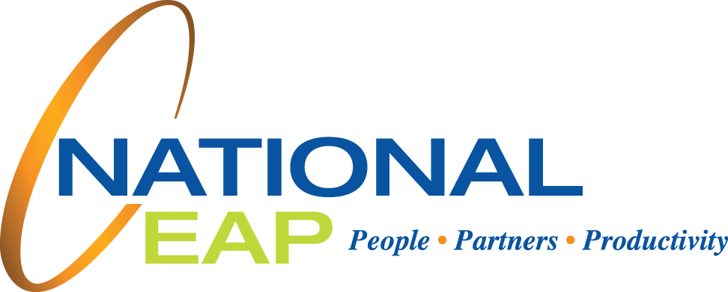

Stronger relationships in the workplace typically means more collaboration, happier co-workers, higher productivity, and less burnout. However, when workplace relationships are unhealthy,   
it could mean the opposite. Bullying in the   
workplace is not okay, but receiving legitimate feedback or a disciplinary action is. Building strong relationships, whether they are family or romantic, friend or professional, can have a positive impact   
on your life.

This session helps participants identify the characteristics of healthy and unhealthy relationships and what kind of relationships to avoid.

Your Employee Assistance Program is available 24/7 to help with you and your family.

**ONLINE SEMINAR**

**Examining Relationships:   
Healthy vs. Unhealthy**

December

**WHATEVER YOU NEED,**

**WE ARE HERE TO HELP.**

***Just call or log on to get started.***

TOLL-FREE:

**800-624-2593**

WEBSITE:

**www.nationaleap.com**

USERNAME:

**Your Company Name**

PASSWORD:

**Your Company Name**

**Visit your home page starting December 17th:**