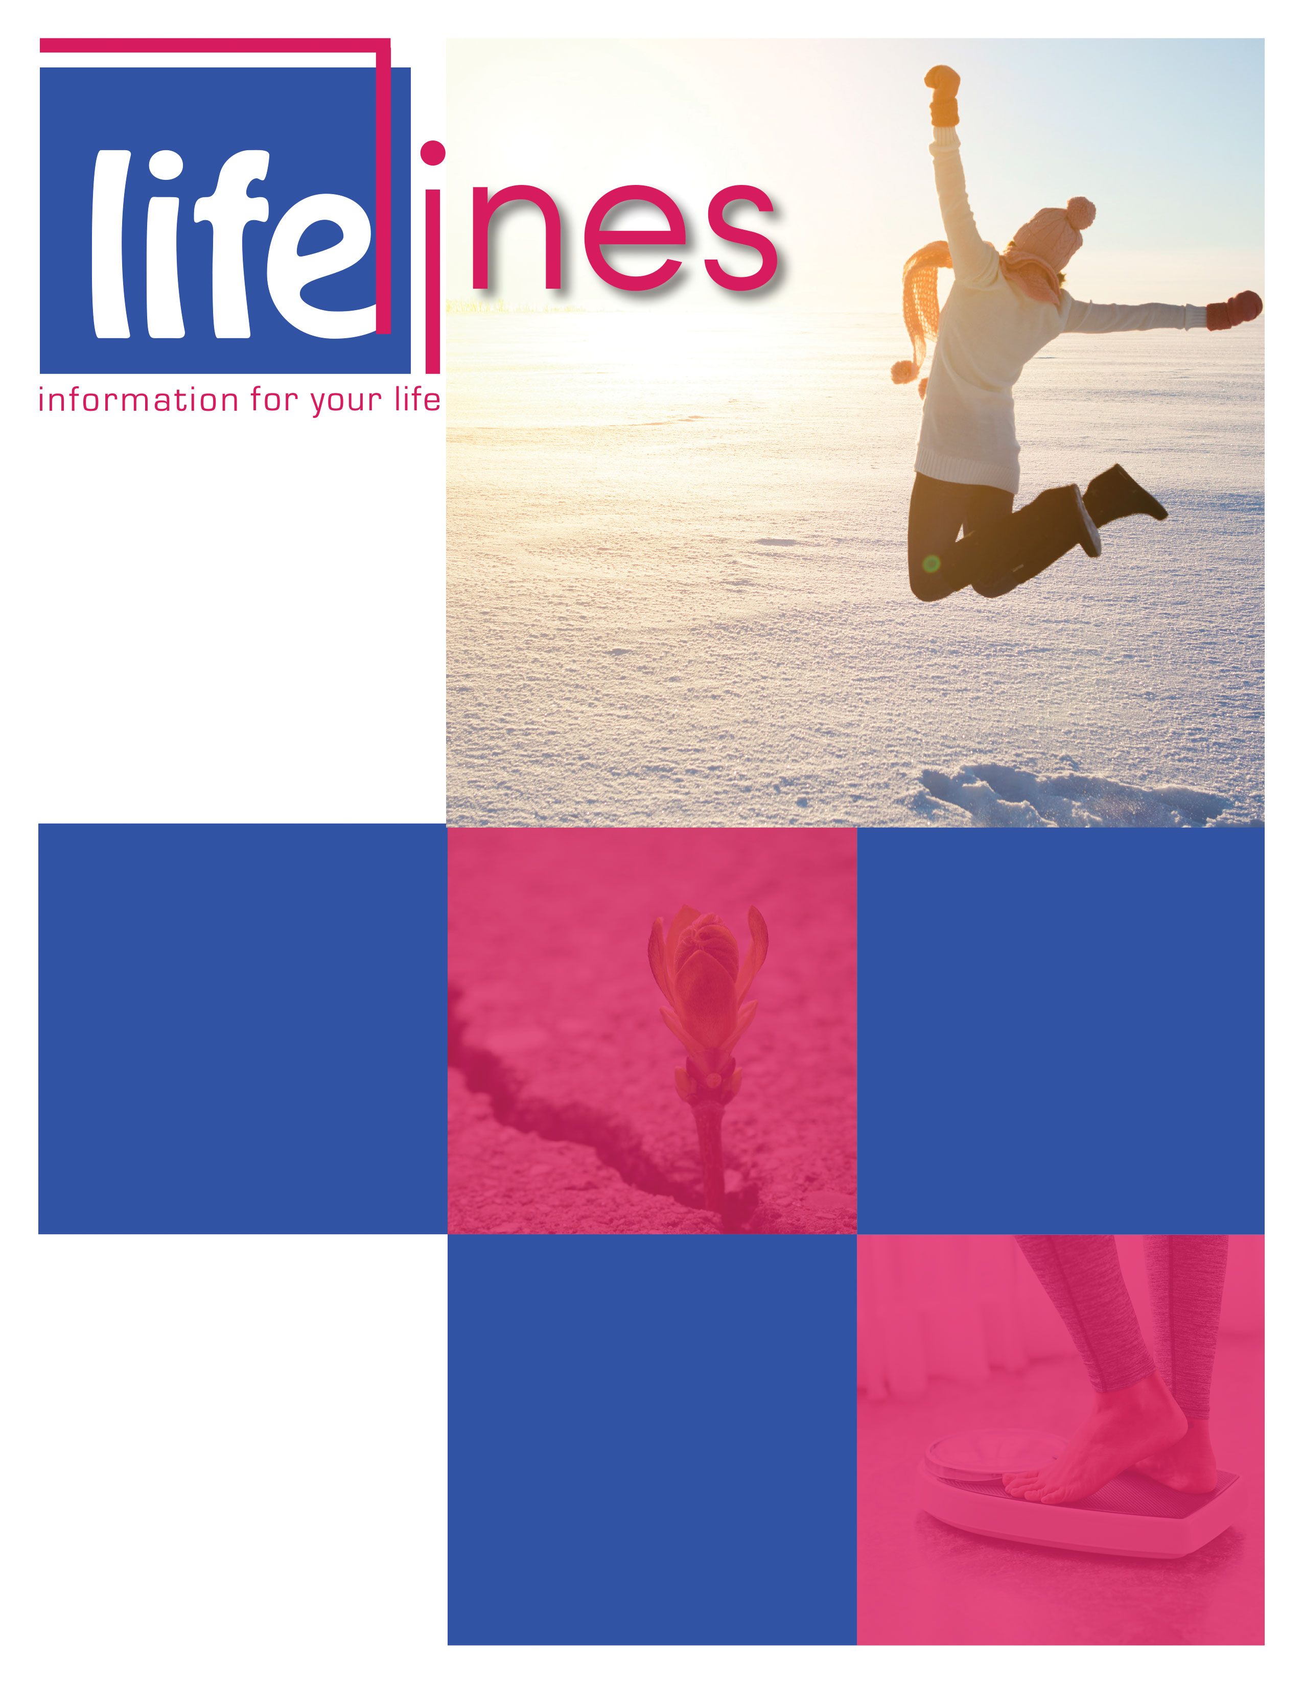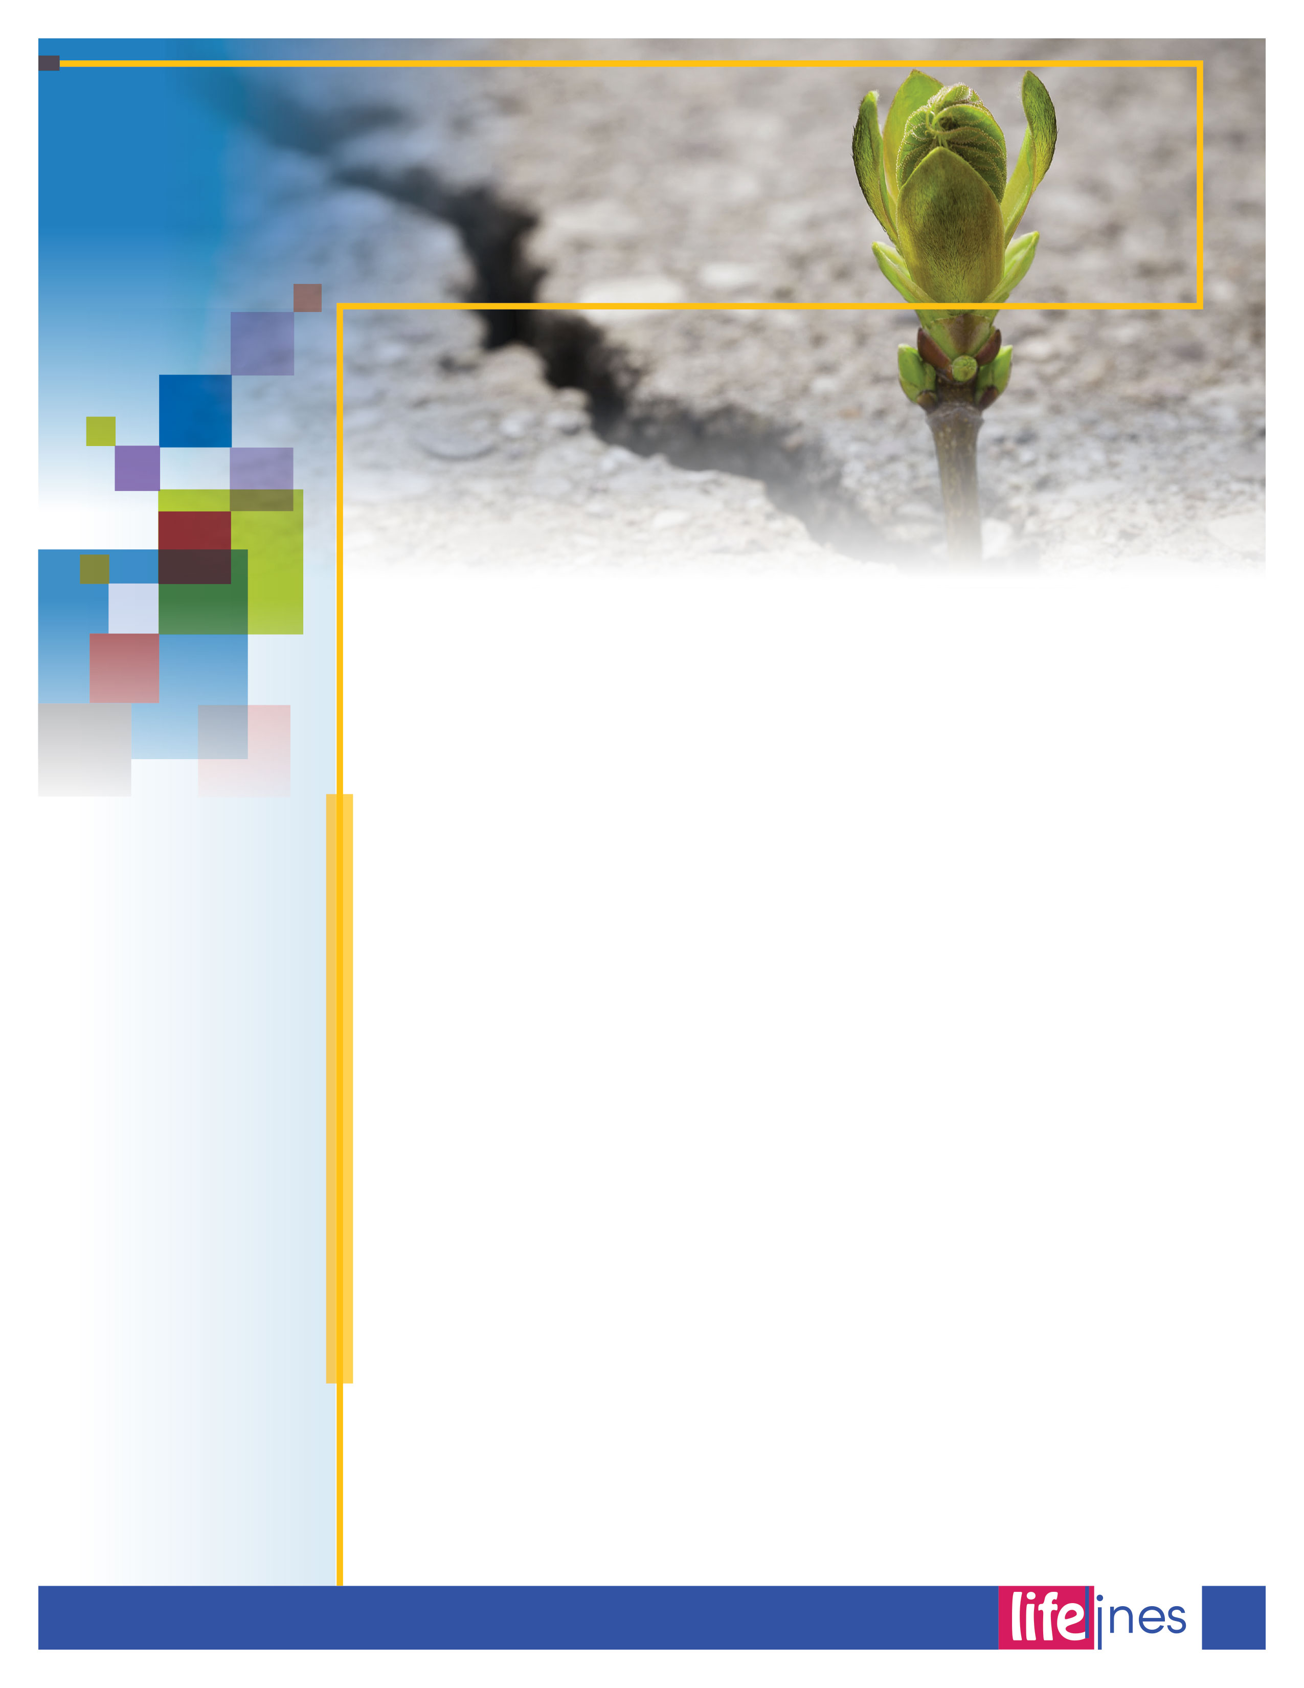

AIM FOR A HEALTHY WEIGHT

# PG: 6

# ARE YOU READY TO BE EVEN MORE ACTIVE?

# PG: 3

BOOST YOUR SELF-ESTEEM AND SELF-CONFIDENCE

# PG: 5

Understanding Resilience

# PG: 2

**Contact Us**

TOLL-FREE: **1-800-624-2593**

www.nationaleap.com

USERNAME: **Your Company Name**

PASSWORD:**Your Company Name**

**WINTER  
ISSUE**

# 2019

____________________________________________  
Defense Centers of Excellence, National Center for Telehealth & Technology, Afterdeployment. (2010). *Understanding resilience*. Retrieved January 12, 2018, from <http://afterdeployment.dcoe.mil/>

*Resilience* helps you through the challenges in life; it allows you to bounce back from stressful situations and also reduces the initial impact of stress. However, resilience is not something that you either "have" or "don't have." Resilience is about the way you approach situations from moment to moment and can be strengthened in the same way as you strengthen your muscles—through repetition and practice. As you do this, it is like developing personal protective equipment (PPE) that is with you at all times protecting you from the negative effects of stress.

If you can develop and maintain relationships with others so you always have some support, if you are able to see the world clearly and respond appropriately, and if you can manage to live in a balanced way, you will have developed resilience. This in turn leads to a healthier, happier, and more successful life.

**Developing Relationships**

Maintaining good relationships with others is a basic resilience skill. When you are challenged or stressed, it is much easier to respond successfully if you have the support of your family or community of friends and coworkers. Poor communication skills can leave you feeling isolated, making it much more difficult to respond to life's challenges. You'll be more effective in your professional mission if you can gain the cooperation of others by learning to resolve conflicts when they arise. Assertiveness and conflict-resolution are skills that allow you to successfully navigate the normal   
interpersonal problems that are a part of life, whether in personal or professional relationships. Maintaining relationships so that you always have someone "watching your back" is one of the keys to overcoming the rough spots and bouncing back from difficulties.

**Personal Qualities**

Increased resilience occurs when skills are developed that allow you to feel more in control of your life. These skills include realistic thinking, optimism, and living personal values. Resilience is also supported by developing strong connections with others through gratitude, forgiveness, and generosity. Practicing these personal qualities on a daily basis reduces negative emotions such as anger and resentment, which themselves are internal stressors. Research has demonstrated that integrating these personal qualities into everyday life even improves immune functioning.

**Skills**

Skills that improve a sense of control over life are central elements of resilience. These are the skills that help to balance life and protect against feeling overwhelmed. Goal setting, time management, and problem-solving are areas of life that are sometimes taken for granted, but they often are the difference between success and failure. These qualities are what make a mission successful in the field. They can make the difference between a successful and unsuccessful effort at developing the kind of   
life you'd like to live.

UNDERSTANDING RESILIENCE

**Research has demonstrated that integrating these personal qualities into everyday life even improves immune functioning.**

**WINTER 2019**

2

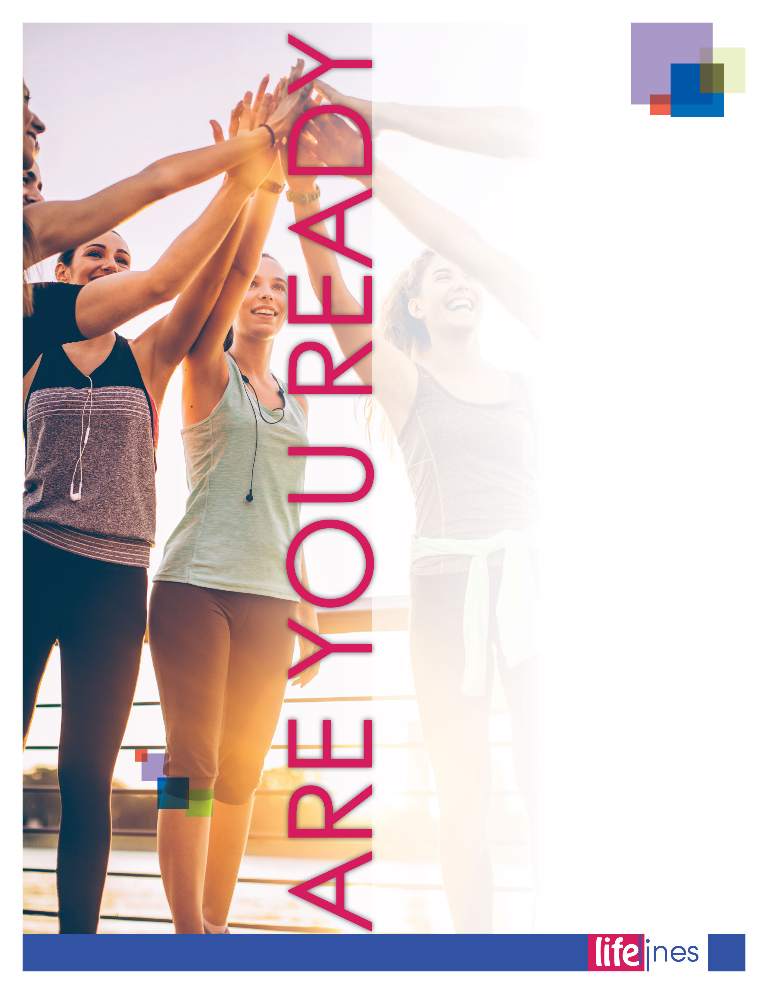

**WINTER 2019**

As you become more fit, you may wish to slowly increase your pace, the length of time you are active, and how often you are active. Before starting a vigorous physical activity program, check with your health care provider if you are a man over age 40 or a woman over age 50, or if you have chronic health problems.

For a well-rounded workout plan, combine *aerobic activity*, muscle-strengthening exercises, and stretching. Do at least 30 minutes per day of moderate-intensity physical activity on most or all days of the week. Add muscle-strengthening activities to your aerobic workout two to three times a week.

If you are trying to lose weight or maintain your weight loss, you may need to do more activity. Aim for 60-90 minutes on most days.

To reduce the risk of injury, do a slow aerobic warm-up, and then stretch before aerobic or strengthening activities. Follow your workout with a few more minutes of stretching.

Aerobic activity is any activity that speeds up your heart and breathing while moving your body at a moderate or vigorous pace. If you have been inactive for a while, you may want to start with easier activities, such as walking at a gentle pace. This lets you build up to more intense activity without hurting your body.

**Regular aerobic activity may help to**

* **Control weight.** Aerobic activity burns calories, which may help you manage your weight.
* **Prevent coronary heart disease and stroke.** Regular aerobic activity can strengthen your heart muscle and lower your blood pressure. It may also help lower *bad* cholesterol (low-density lipoprotein or LDL) and raise *good* cholesterol (high-density lipoprotein or HDL).
* **Maintain strong bones.**Weight-bearing aerobic activities that involve lifting or pushing your own body weight, such as walking, jogging, or dancing, help to maintain strong bones.
* **Improve your outlook.**Aerobic exercise relieves tension and decreases stress. It may also help build your confidence and improve your self-image.

*continued on page 4*

**TO BE EVEN MORE ACTIVE?**

3

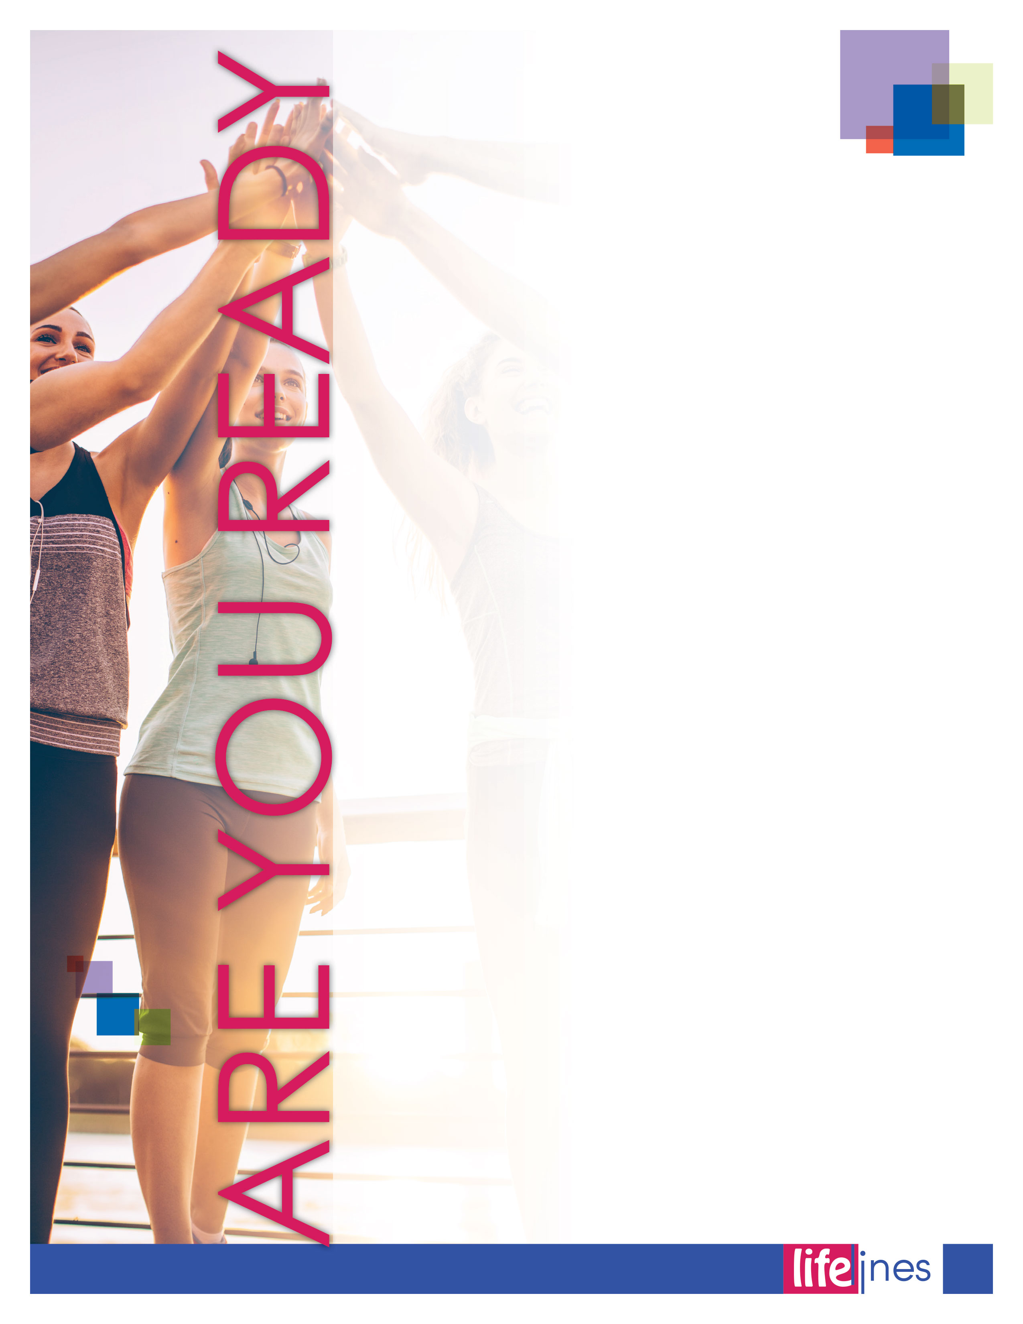

**WINTER 2019**

Choose aerobic activities that are fun. People are more likely to be active if they like what they are doing. It also helps to get support from a friend or a family member. Try one of these activities or others you enjoy:

* Brisk walking or jogging
* Bicycling
* Swimming
* Aerobic exercise classes
* Dancing (square dancing, salsa, African dance, swing)
* Playing basketball or soccer

Strengthening activities include lifting weights, using resistance bands, and doing push-ups or sit-ups. Besides building stronger muscles, strengthening activities may help you

* **Use more calories.**Not only do strengthening exercises burn calories, but having more muscle means you will burn slightly more calories throughout the day—even when you are sitting still.
* **Reduce injury.**Stronger muscles improve balance and support your joints, lowering the risk of injury.
* **Maintain strong bones.**Doing strengthening exercises regularly helps build bone and may prevent bone loss as you age.

*Strengthening exercises* should focus on working the major muscle groups of the body, such as the chest, back, abdominals, legs, and arms. Do exercises for each muscle group two or three times per week. Allow at least one day of rest for your muscles to recover and rebuild before another strengthening workout. (It is safe to do aerobic activity every day.)

*Lifestyle activities* are the day-to-day activities that you do. These activities can really add up and increase the number of calories you burn each day. They may also boost your energy and mood by getting your blood and muscles moving. Examples of lifestyle activities include

* Taking the stairs instead of the elevator
* Walking to your coworker's office instead of using the phone or e-mail
* Gardening and doing household chores
* Walking inside the bank rather than using the drive-through window
* Parking farther from store entrances and walking the extra distance
* Taking short breaks at work to get up, stretch, and walk
* Playing with your children, nieces and nephews, and pets

________________________________________________________________________________  
U.S. Department of Health and Human Services, National Institutes of Health. Weight-Control Information Network (Updated 2012, August). *Better health and you: Tips for adults* (NIH Publication No. 08-4992). Retrieved June 2, 2016, from <http://www.win.niddk.nih.gov>

*continued*

**TO BE EVEN MORE ACTIVE?**

4



________________________________________________  
U.S. Department of Health and Human Services, Office on Women's Health (OWH), GirlsHealth. (Updated 2015, February 19). Boost your self-esteem and self-confidence. In *Your feelings: Being happy*. Retrieved October 17, 2017, from <https://www.girlshealth.gov/>

Do you want to feel better about yourself? You can learn how to build self-esteem and raise your self-confidence. Try these tips:

* **Check out new activities.** You'll feel proud for stretching your wings. Does trying something new on your own seem too intimidating? Maybe see if a friend will go along.
* **Be your own BFF.** Make a list of things you love about you. Are you friendly, funny, creative or hard-working, for example?
* **Celebrate your successes.** Try to really enjoy your achievements. Record them in a journal, tell your friends, or hang up pictures or other reminders.
* **Tell your inner critic to be quiet.** f you have a mean thought about yourself, see if you can change it to something positive instead. For example, if you think, "I'm dumb," try remembering a time you did something smart.
* **Don't compare yourself to others.** Someone else may have tons of online friends or a "great" body, but everyone has strengths and weaknesses.
* **Practice being assertive.** Try to express your thoughts, opinions and needs. It feels great to know you can speak up for yourself! (Of course, you want to do this without stomping on other people's feelings.)
* **Find ways to feel like you're contributing.** It feels great to help. You might do chores at home or volunteer in your community.
* **Set realistic goals.** Aim for a goal that you think you can reach. Then make a plan for how to get there. If you pick something very hard, you may get frustrated and quit.
* **Forgive yourself when you fail.** Nobody is perfect. The important thing is to learn from your mistakes. It's good to know you can pick yourself up and keep going!
* **Find true friends.** Hang out with people who make you feel good about yourself. Real friends like you for you.
* **Honor your background.** It can be great to feel proud of who you are and where you come from. Celebrate your heritage and culture.
* If you try working on your self-esteem for a while and still don't feel good about yourself, reach out for help. Talk to a trusted friend or family member, doctor or counselor, or another person in whom you can confide. Your confidant may be able to suggest other things you can try, and it may help just to talk about how you're feeling. Also, sometimes low self-esteem can increase your risk for depression and other emotional problems. Speaking to someone you trust is the first step to getting support, and that person may be able to help you get treatment if you need it.

Boost Your   
**SELF-ESTEEM** and   
**SELF-CONFIDENCE**

5

**WINTER 2019**

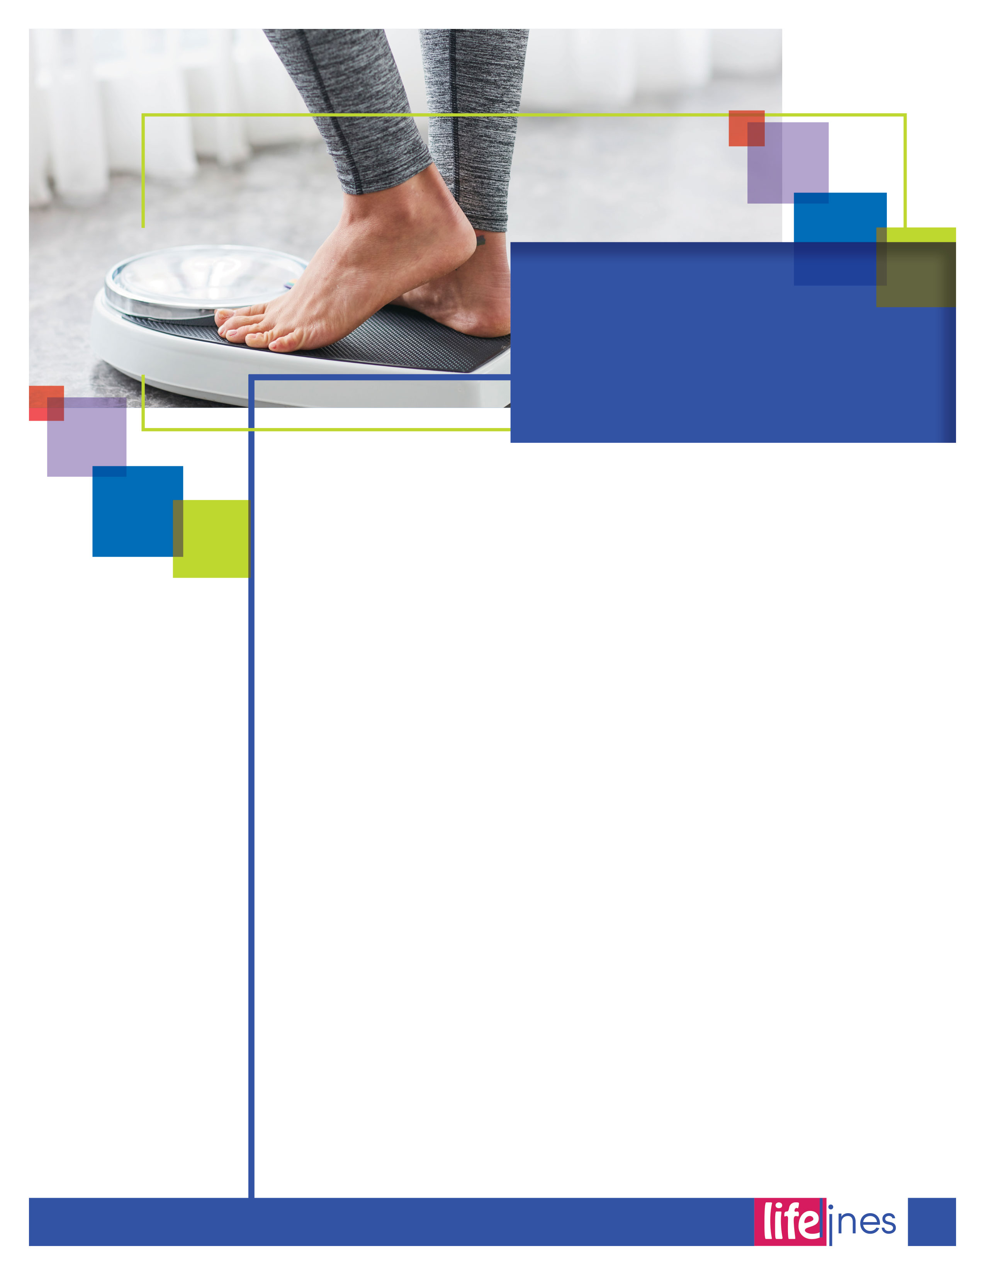

Choose a lifestyle that combines sensible eating with regular physical activity. To be at their best, adults need to avoid gaining weight, and many need to lose weight. Being overweight or obese increases your risk for high blood pressure, high blood cholesterol, heart disease, stroke, diabetes, certain types of cancer, arthritis, and breathing problems. A healthy weight is key to a long, healthy life.

**Evaluate your body weight.**

For adults and children, different methods are used to find out if weight is about right for height. If you have concerns about your child's body size, talk with your health care provider.

If you are an adult, follow the directions below to evaluate your weight in relation to your height, or *Body Mass Index* (BMI). A BMI above the healthy range is less healthy for most people; but it may be fine if you have lots of muscle and little fat. The further your BMI is above the healthy range, the higher your weight-related risk. If your BMI is above the healthy range, you may benefit from weight loss, especially if you have other health risk factors.

BMI's slightly below the healthy range may still be healthy unless they result from illness. If your BMI is below the healthy range, you may have increased risk of menstrual irregularity, infertility, and osteoporosis. If you lose weight suddenly or for unknown reasons, see a health care provider. Unexplained weight loss may be an early clue to a health problem.

**How to Evaluate Your Weight (Adults)**

1. Weigh yourself and have your height measured to find your BMI category. The higher your BMI category, the greater the risk for health problems.
2. Measure around your waist, just above your hip bones, while standing. Health risks increase as waist measurement increases, particularly if the waist is greater than 35 inches for women or 40 inches for men. Excess abdominal fat may place you at greater risk of health problems, even if your BMI is about right.

**Manage your weight.**

Your genes affect your tendency to gain weight. A tendency to gain weight is increased when food is plentiful and when you use equipment and vehicles to save time and energy. However, it is possible to manage your weight through balancing the calories you eat with your physical activity choices.

*continued on page 7*

Aim for a   
HEALTHY   
WEIGHT

6

**winter 2019**

7

Aim for a   
HEALTHY   
WEIGHT

*continued*

To make it easier to manage your weight, make long-term changes in your eating behavior and physical activity. To do this, build a healthy base and make sensible choices. Choose a healthful assortment of foods that includes vegetables, fruits, grains(especially whole grains), skim milk, fish, lean meat, poultry, and beans. Choose foods that are low in fat and added sugars as much as you can. Whatever the food, eat a sensible portion size.

Try to be more active throughout the day. It is recommended that all adults get at least 30 minutes of moderate physical activity most or preferably all days of the week. To maintain a healthy weight after weight loss, adults will likely need to do more than30 minutes of moderate physical activity daily. Over time, even a small decrease in calories eaten and a small increase in physical activity can keep you from gaining weight or help you lose weight.

**Control portion size.**

* If you're eating out, choose small portion sizes, share an entree with a friend, or take part of the food home.
* Check product labels to learn how much food is considered to be a serving, and how many calories, grams of fat, and so forth are in the food. Many items sold as single portions actually provide 2 servings or more. Examples include a 20-ounce container of soft drink, a 12-ounce steak, a 3-ounce bag of chips, and a large bagel.
* Be especially careful to limit portion size of foods high in calories, such as cookies, cakes, other sweets, French fries, fats, oils, and spreads.

The carbohydrates, fats, and proteins in food supply energy, which is measured in calories. High-fat foods contain more calories than the same amount of other foods, so they can make it difficult for you to avoid excess calories. However, low-fat doesn't always mean low calorie. Sometimes extra sugars are added to low-fat muffins or desserts, making them just as high in calories.

Your pattern of eating may be important as well. Snacks and meals eaten away from home provide a large part of daily calories for many people. Choose them wisely. Try fruits, vegetables, whole grain foods, or a cup of low-fat milk or yogurt for a snack. When eating out, choose small portions of foods. If you choose fish, poultry, or lean meat, ask that it be grilled rather than fried.

Like younger adults, overweight and obese older adults may improve their health by losing weight. The guidance of a health care provider is recommended, especially for obese children and older adults. Since older people tend to lose muscle mass, regular physical activity is a valuable part of a weight-loss plan. Building or maintaining muscle helps keep older adults active and reduces their risk of falls and fractures. Staying active throughout your adult years helps maintain muscle mass and bone strength for your later years.

**winter 2019**

_______________________________________________________________________________________________________________________  
U.S. Department of Health and Human Services (HHS). (n.d.). Be physically active each day. In *Aim for fitness*. Retrieved September 29, 2016, from <http://health.gov/>