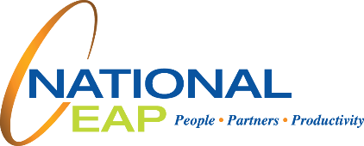

**Promote Yourself**

**Boost your career performance**

Public speaking. New software. Sharpened focus. Team building.   
What new skills could improve your work performance?

Whether you want to earn a new certification, register for an   
online course, or connect with a mentor, we can help you develop strategies to build your professional skills and relationships.   
Learn to move ahead without burning out. Let us tell you more.

**WHATEVER YOU NEED, WE ARE HERE TO HELP.***Just call or log on to get started.*

**TOLL-FREE: 1-800-624-2593**

**WEBSITE: www.nationaleap.com**

**USERNAME: Your Company name**

**PASSWORD: Your Company Name**

**YOUR EMPLOYEE SUPPORT PROGRAM**

Available any time, any day, your Employee Assistance Program is a free, confidential program to help you balance your work, family, and personal life.

**MARCH 2020**