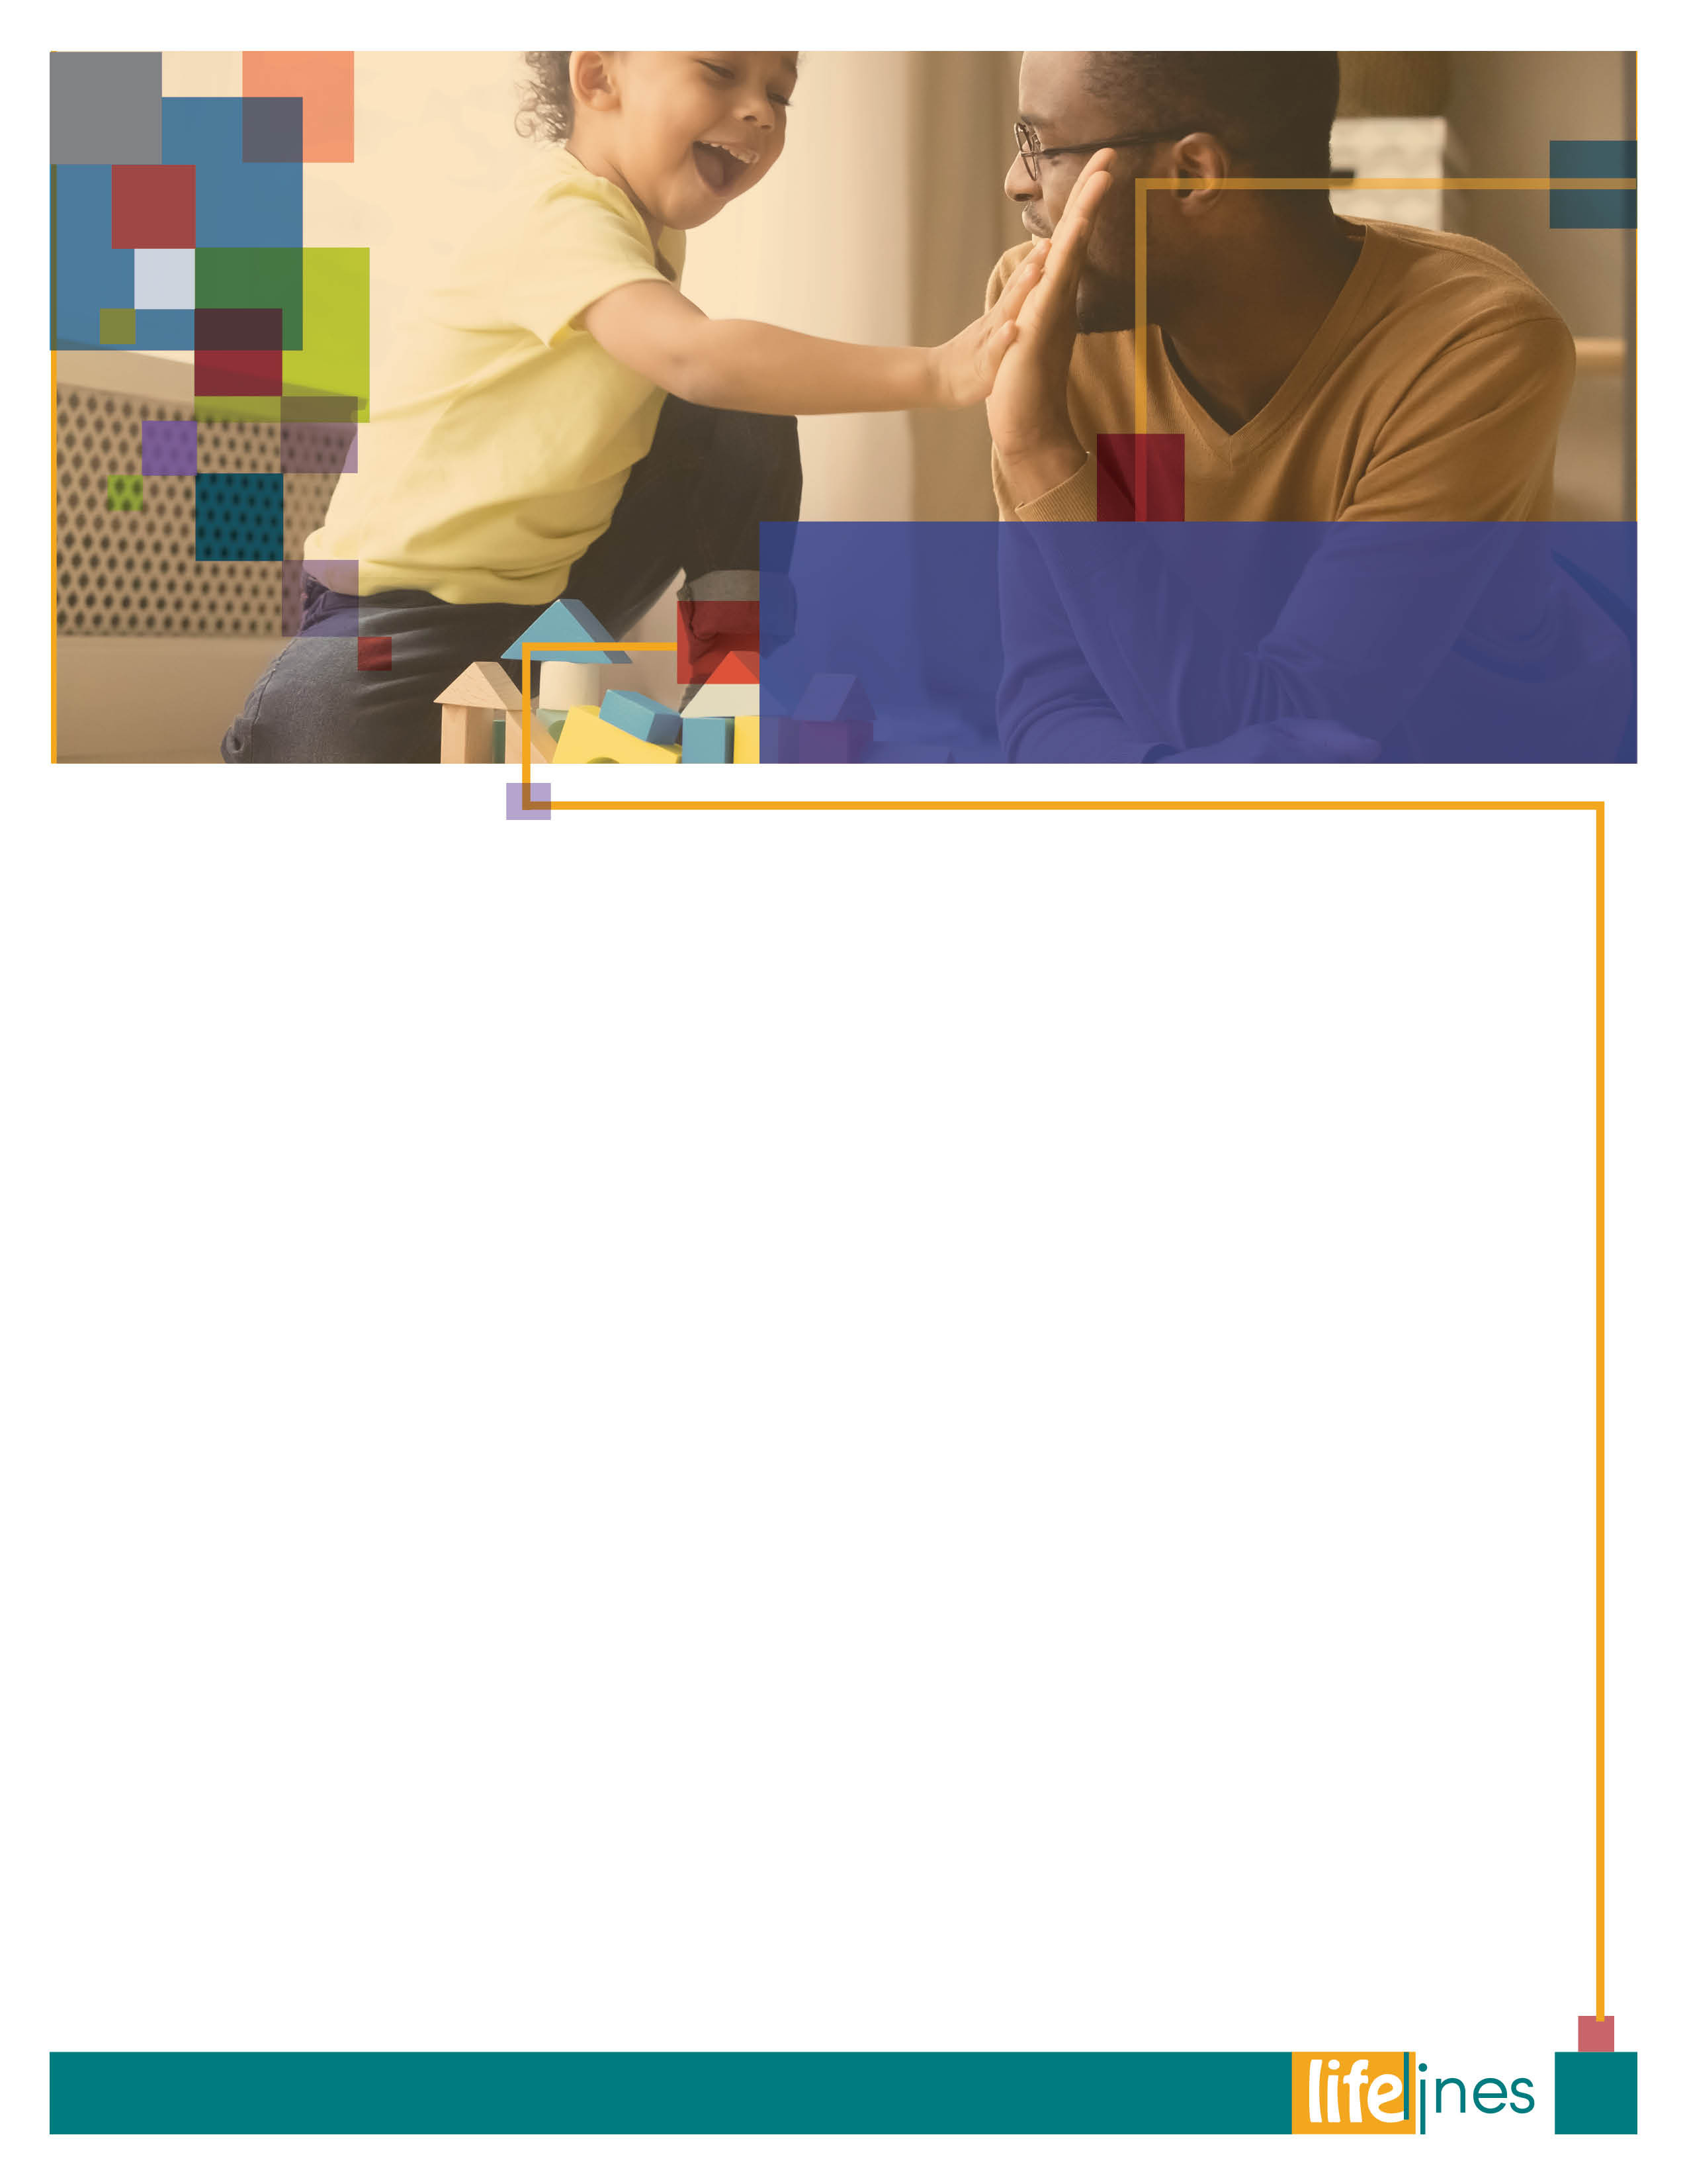

Learn to Disconnect

PG: 2

ASSERTIVENESS SKILLS

PG: 8

CONVERSATION STRATEGIES TO USE WHEN TALKING WITH OLDER ADULTS

# PG: 3

**SPRING  
ISSUE**

# 2020

FOOD SAFETY TIPS

PG: 9

**Contact Us**

TOLL-FREE: **800-624-2593**

www.nationaleap.com

USERNAME: **Your Company Name**

PASSWORD:**Your Company Name**

**WINTER 2019**

* Challenge yourself to the 20-20-20 rule. After 20 minutes of computer use, look at something 20 feet away for 20 seconds.
* Say no to multitasking and allow yourself to do one thing at a time. Read a magazine, talk on the phone, walk to a coworker’s cube to ask a question instead of instant messaging or emailing.
* Change your environment by going on vacation and making it technology free. It may result in a level of relaxation and free-flowing ideas that you never imagined possible.
* Be a part of nature. Go where cell phones don’t work, where there is no internet, or where it is forbidden. For example, visit the ocean or a cave in the mountains, or take a class.

**Feel the freedom of single tasking. This means being comfortable working on one thing at a time, which helps sharpen focus and produce a higher quality, uninterrupted output. Balance is the key. While it is vitally important to be plugged in sometimes, it is equally important to recognize that there is a world beyond the screens surrounding you.**

Richtel, M. (2010, August 15). Outdoors and out of reach, studying the brain. New York Times. Retrieved February 6, 2019, from <https://www.nytimes.com/> National Public Radio (NPR). (2010, August 24). Digital overload: Your brain on gadgets [Audio podcast]. In Gross, T., Fresh Air [Radio show]. Retrieved February 6, 2019, from https://www.npr.org/Goudreau, J. (2010, June 29). Do computers really fry your brain? Forbes. Retrieved February 6, 2019, from <https://www.forbes.com/> Just Stand. (2016, December 6). Prevent eye strain with the 20-20-20 rule. Retrieved February 6, 2019, from <https://www.juststand.org/> Prendergast, B. (2018, January 6). Is your phone harassing you with constant interruption? Make it stop. Retrieved February 6, 2019, from https://medium.com/

* Start slowly. Create time each day, say 30 to 60 minutes, for no interruptions. For example, turn off technology an hour before bed or right before working out; try driving to work with no radio and no cell phone.
* Include the whole family. Limit children’s time on technology. Declare a TV Turnoff Week, with small prizes for contestants at the end of each day and the week.
* Practice mapping a destination, instead of using the GPS.
* Go for a walk or jog without headphones; engage another person to go with you.
* Turn off notifications so you are not tempted to plug in.
* Set aside time for social networking.
* Move apps away from your home screen to avoid constant interruptions.

**Sage advice when it comes to technology, screen time, and multitasking. Continuously being connected without a break can cause anxiety and may inhibit deep thought. A study from the University of Michigan found that multitasking heavily can fatigue the brain, which causes it to lose the ability to focus. Your brain needs a rest from the multitasking.1 Imaging studies have found that major cross sections of the brain become surprisingly active during downtime.2 Just as plugging in and logging on is a habit, so should be taking a break from it. If you are not accustomed to breaking the plugged-in habit, it may take some diligent practice and rewiring on your part. Here are some suggestions for making the break:**

**“Never go to excess, but let moderation be your guide.”**

***—Marcus Tullius Cicero***

2

**SPRING 2020**

**Modify your style.**

When you talk to an older relative, you may find your long-standing style of communication isn't working (or working as well) anymore. Here are some tips that may help:

* **Think about the purpose of the conversation.** Do you want to go over a schedule? Talk about a big social or financial issue? The topic will affect how you approach the conversation. For example, if you’d like your relative to start going to activities at a senior citizen’s center, you might get a calendar of events so that your relative can look at it when you talk.
* **If you need to have more than a routine “check-in” conversation with your relative, say so up front.** Let your relative know the purpose of the conversation. If you’re concerned about the stack of unpaid bills you saw during your last visit, and want to offer to help with the checkbook, say so. Being direct about your concerns will help your relative understand how important the subject is to you.

**It is often a challenge to discuss difficult issues that involve change. Often, family members have concerns regarding the health and safety of an older relative, which the older relative does not share. Be aware of the possible reaction to the role reversal; taking care of someone who has always taken care of you. It is important to respect and honor your loved one’s dignity in all conversations. Also, they may not be at the point of asking or admitting the need for help, so the concern is one-sided. Effective communication strategies include honoring the value and independence of the elder.**

*continued on page 4*

**CONVERSATION STRATEGIES**to Use When Talking With **OLDER ADULTS**

**SPRING 2020**

3

* **Be honest.** A close relative will probably be able to tell when you’re holding something back, and might start to worry that the truth is worse than it is.
* **From time to time in your conversation, repeat what you think you heard your relative say.**This will show him or her that you’ve been listening and will help you make sure you’ve understood.
* **Remember that part of feeling secure is feeling needed.** Sometimes it can still help to talk about your own feelings and let your relative offer you some comfort.
* **If your relative is feeling afraid or anxious, don’t try to minimize the fears**. Let your relative know you understand how he or she is feeling and want to help. For instance, “We’ll work something out together.”
* **Try to avoid arguing.** No matter how hard it is, don’t be drawn into an argument. Try to talk about differences without criticizing each other.
* **If you’re really having problems discussing something, slow down.** Leave it for another day when you aren’t angry or upset.
* **Remember to think about the expression on your face while you’re speaking.** Does it match your words? When you’re trying to sound reassuring, do you look worried?
* **Try to stay calm and focused.** Keep your tone of voice steady and even, sit up tall, and look at your relative when you talk. An angry tone or nervous hand gestures can contradict comforting words.
* **Consider your relationship with your relative.**   
  Have you always been close? Are you able to talk easily? If not, you might ask another family member or friend to join you to help break the ice.

**Talking With Your Older Relative**

* **Listen to your relative at least as much as you talk.** Remember that conversation is a two-way street.
* **Be positive.** Try to make constructive suggestions instead of negative or accusatory statements. “Let’s try having a housekeeper do the heavier work so you can keep things the way you like them,” will probably work better than, “You know you can’t keep the place clean any more.”
* **Treat your relative with respect.** Speak to him or her in a tone of voice that shows how much you respect and care. Instead of saying, “Why didn’t you take your medicine?” you might say, “There are the same number of pills in your medicine bottles last week. Are your pills in a place you can reach?”
* **Remember that your relative still needs to make decisions about his or her own life.** Maintaining someone’s sense of independence and dignity may be as important as having the groceries delivered or making sure he or she has the right medical care.
* **Be patient.** Allow enough time for your relative to complete his or her thoughts without interruption. Some older people need extra time to express themselves.
* **Try to set aside a quiet time and place to talk.**  
  If possible, try to talk during the time of day when your relative is feeling best.

4

*Continued on page 5*

*continued*

**CONVERSATION STRATEGIES**to Use When Talking With **OLDER ADULTS**

**SPRING 2020**

5

* Let your relative reminisce. If he or she does not seem to be aware of the present, it’s OK to occasionally allow the real pleasure of recalling the past with you.

**If Your Relative has Trouble Seeing,  
Hearing, or Speaking**

**You may have some extra concerns if your relative has trouble seeing, hearing, or speaking clearly. Here are some ways to deal with problems in these areas:**

* **If your relative can’t see well, your tone of voice is particularly important.** Someone who can’t make eye contact or see your facial expressions needs to have extra cues to understand what you are trying to say. Show your emotions—happy, concerned, or curious—in your tone of voice. When speaking, try to stand or sit directly in your relative’s line of sight.
* **If your relative wears a hearing aid, or has other hearing problems, speak in a clear, loud,  
  low-pitched voice.** Use short sentences, and speak without eating, drinking, smoking, or covering your mouth. If you need to repeat something, rephrase the sentence—don’t say the same words again. Different words might be easier for your relative to hear.
* **If your relative has trouble speaking, be patient.** Try to understand how frustrating the difficulty can be for him or her. Don’t try to finish sentences for him or her—this may feel that you are rushing or becoming impatient. Instead, speak as slowly and clearly as you can. This gives your relative permission to speak slowly, too.

*Continued on page 6*

* **Don’t hesitate to touch your relative.** Touching can have a soothing effect—as long as both of you are comfortable with it. A soft touch on the hand can often be better than patting someone’s arm.
* **Try not to appear rushed.** Let your relative know that you have enough time for the conversation.
* **Show that you’re paying attention.** Make clear that you’re listening by nodding, looking in your relative’s eyes, or saying things that show you understand what he or she is saying. Your relative may find it reassuring to hear you say, “Yes, I see. You’re right, that must have been hard.”

**If Your Relative Doesn’t Seem to   
Understand You**

**Even if your relative has difficulty understanding or paying attention—for instance, because of memory loss, behavior changes, or Alzheimer’s disease—there may still be things you can communicate to him or her. Remember to think about the expression on your face while you’re speaking. Does it match your words? When you’re trying to sound reassuring, do you look worried?**

Speak as you would to any other responsible adult. Try not to sound demeaning or patronizing.

* Don’t shut your relative out of all conversations. Occasionally, try to include your relative in a conversation, and encourage other people to do  
  the same.
* Sit next to your relative, and look at him or her. Sitting across from your relative may seem threatening.

**CONVERSATION STRATEGIES**to Use When Talking With **OLDER ADULTS**

*Continued*

**SPRING 2020**

**When You Need a Family Meeting**

**Often a doctor or social worker will recommend a family meeting to help you understand an illness and its progression, discuss how your family will divide the tasks and responsibilities of caring for your relative, or resolve conflicts. Having a professional guide the meeting can be very helpful. Here are some suggestions for a simple family meeting.**

* **Try to include your older relative**. If this does not occur at the first meeting, then try to include him or her at the next one.
* **Think of your family in broad terms.** Include anyone who cares about or feels responsible for your relative—a friend or neighbor, or even a religious leader, social worker, or health professional.
* **Begin the meeting by talking about the specific concerns that have brought you together.** It might be deciding if your relative needs some household help, discussing a hospitalization or health concern, or getting ready to move to a nursing home.
* **Set your priorities.** Decide what you need to talk about right away. It’s generally best not to try to solve everything at your first meeting.
* **Focus on the present.** It can be easy for any family to revisit old conflicts. Keep in mind that you’ve called the meeting for a specific purpose, and, if necessary, remind people of it.
* **Make sure everyone at the meeting has a chance to talk about ideas and solutions.** Try to be honest about what each person in the family can or cannot do. Talk openly about what everyone can reasonably offer.
* Agree that one person will be the family contact with the doctors and others who provide care.
* **Write down any plans you’ve agreed to and set some limits.** If you’d like your relative to try adult day care, you might say, “OK, let’s try adult day care for two weeks, and if you don’t like it, we’ll try something else.”
* **Set up a date to meet again.** Pick a time when you will talk together about how successful your plans have been and what else you may need to do.
* **Above all, be sure to listen to your relative’s wishes and plans.** Let your relative know that the family is involved because everybody cares and wants to work together to carry out those wishes and plans in the best way possible.

**Talking on the Telephone**

**Many families move around a lot, and you and your relative may live far apart. Here are a few ideas you can use for important long-distance conversations:**

* **Make a list of the things you want to discuss before you call.** If some are more important than others, list them in the order you want to talk about them.
* **Be realistic in your expectations.** Plan to cover just one or two things in each telephone conversation.
* **Speak calmly and clearly.** Lowering the pitch of your voice can often make you sound calmer (and can make it easier for someone with hearing loss to understand you).

**CONVERSATION STRATEGIES**to Use When Talking With **OLDER ADULTS**

*Continued*

**SPRING 2020**

6

Lessons learned from parents or caregivers contribute to your beliefs about the legitimacy of your personal rights. This can cause you to act passively to conform to these beliefs. A few examples include the right to decide how to lead your life, the right to pursue goals and dreams, the right to a valid opinion, the right to say how you want to be treated, the right to say “no,” the right to change your mind, the right to privacy, the right to ask for help, and many more. Acting to assert any of these rights leads many people to think they are acting selfish.

**Is assertiveness selfish?**

Selfish means being concerned excessively or exclusively with oneself. This is not assertiveness. Being assertive does not dismiss or ignore the needs of others. Assertiveness focuses legitimate or important needs.

**What is Assertiveness?**

Assertiveness is the ability to state positively and constructively your rights or needs without violating the rights of others. When you use direct, open, and honest communication in relationships to meet your personal needs, you feel more confident, gain respect from others, and live a happier, fulfilled life.

**Benefits of Assertiveness**

Acting assertive helps maintain honesty in relationships, allows you to feel more in control of your world, and improves your ability to make decisions

**Roadblocks to Assertiveness**

Fear that you will harm others, or that you will experience rejection and feel shame, may prevent you from acting assertive. This is based upon a belief that other people’s needs, opinions, and judgments are more important than your own. Believing assertiveness hurts another person can keep you from meeting your legitimate physical and emotional needs. As a result,   
you feel hurt, anxious, and angry about life.

7

*Continued on page 8*

**ASSERTIVENESS SKILLS**

**SPRING 2020**

(3) how you responded; what you said; (4) what you did well in this situation; and (5) reminders to yourself about what you will do next time to be assertive if this situation is repeated.

**A Few Assertiveness Tips**

Assertiveness frequently means using “I statements” combined with a word that describes what you want. For example, “I want,” “I need,” “I would prefer,” “I do not like,” “I am upset about,” and so on. Be careful not to minimize such statements by couching them with questions that subordinate your needs. Example: “I don’t want to go to the store with you—do you mind?” or “I’m tired, can you do the dishes tonight—is that OK with you?”

**What the Employee Assistance Program  
(EAP) Can Do**

Being assertive isn’t easy for everybody. You may have a personal history or childhood experiences that serve as strong roadblocks to the changes you want to make. The EAP can find resources, especially professional counseling assistance, to help you make faster progress in being assertive.

**Is assertiveness aggressive?**

Assertiveness is not aggression. Aggressive means that you express your rights at the expense of another or forcibly deny the rights of others. If you struggle with being assertive, you may have mislabeled assertive behavior by others as aggressive. This may help you feel justified about not being assertive. However, believing assertiveness is aggressive can prevent you from taking steps to improve your assertiveness skills.

**Practice makes better.**

Recognizing what causes your lack of assertiveness is helpful but committing to change is more important. Practicing assertiveness skills helps you confront old ways of thinking, helps you become more naturally assertive, and is self-reinforcing. Keeping track of your progress is helpful. Be patient. In the beginning, you won’t be assertive at every opportunity, and you might be assertive in some situations where it isn’t necessary. It’s all part of the process of growing to be more assertive. Notice the general trend of your success and give yourself a pat on the back as things change.

**Simple Assertiveness Formula**

Each time an opportunity occurs to be assertive, make notes in a small notebook. Consider keeping it in your pocket or purse. Record: (1) the specific event that called for an assertiveness response; (2) what personal right was involved (i.e., the right to say “no”);

8

U.S. Army, Fort Derrick. (2007). Assertiveness skills. Retrieved October 2, 2018, from http://www.detrick.army.mil/

*Continued*

**ASSERTIVENESS SKILLS**

**SPRING 2020**



**Separate: Don’t cross contaminate.**

Cross-contamination is how bacteria can be spread. When handling raw meat, poultry, seafood, and eggs, keep these foods and their juices away from ready-to-eat foods. Always start with a clean scene—wash hands with warm water and soap. Wash cutting boards, dishes, countertops, and utensils with hot soapy water.

* Separate raw meat, poultry, seafood, and eggs from other foods in your grocery shopping cart, grocery bags, and in your refrigerator.
* Use one cutting board for fresh produce and a separate one for raw meat, poultry, and seafood.
* Never place cooked food on a plate that previously held raw meat, poultry, seafood, or eggs.
* Keep books, backpacks, or shopping bags off the kitchen table or counters where food is prepared or served.

**Clean: Wash hands and surfaces often.**

Bacteria can be spread throughout the kitchen and get onto hands, cutting boards, utensils, counter tops, and food.

* Wash your hands with warm water and soap for at least 20 seconds before and after handling food and after using the bathroom or changing diapers.
* Wash your hands after playing with pets or visiting petting zoos.
* Wash your cutting boards, dishes, utensils, and counter tops with hot soapy water after preparing each food item and before you go on to the next food.
* Consider using paper towels to clean up kitchen surfaces. If you use cloth towels wash them often in the hot cycle of your washing machine.
* Rinse fresh fruits and vegetables under running tap water, including those with skins and rinds that are not eaten.
* Rub firm-skinned fruits and vegetables under running tap water or scrub with a clean vegetable brush while rinsing with running tap water.
* Keep books, backpacks, or shopping bags off the kitchen table or counters where food is prepared or served.

*Continued on page 10*

Food **SAFETY TIPS**

9

**SPRING 2020**



Food **SAFETY TIPS**

* Make sure there are no cold spots in food (where bacteria can survive) when cooking in a microwave oven. For best results, cover food, stir and rotate for even cooking. If there is no turntable, rotate the dish by hand once or twice during cooking.
* Bring sauces, soups, and gravy to a boil when reheating. Heat other leftovers thoroughly to 165°F.
* Use microwave-safe cookware and plastic wrap when cooking foods in a microwave oven.

**Chill: Refrigerate promptly!**

* Refrigerate foods quickly because cold temperatures slow the growth of harmful bacteria. Do not overstuff the refrigerator. Cold air must circulate to help keep food safe. Keeping a constant refrigerator temperature of 40°F or below is one of the most effective ways to reduce the risk of food borne illness. Use an appliance thermometer to be sure the temperature is consistently 40°F or below. The freezer temperature should be 0°F or below.

**Cook: Cook to proper temperatures.**

* Food is safely cooked when it reaches a high enough internal temperature to kill the harmful bacteria that cause food borne illness. Use a food thermometer to measure the internal temperature of cooked foods.
* Use a food thermometer, which measures the internal temperature of cooked meat, poultry, and egg dishes, to make sure that the food is cooked to a safe internal temperature.
* Cook beef roasts and steaks to a safe minimum internal temperature of 145°F. Cook pork to a minimum of 160°F. All poultry should reach a safe minimum internal temperature of 165°F throughout the bird, as measured with a food thermometer.
* Cook ground meat to 160°F. Information from the Centers for Disease Control and Prevention (CDC) links eating undercooked ground beef with a higher risk of illness. Remember, color is not a reliable indicator of doneness. Use a food thermometer to check the internal temperature of your burgers.
* Cook eggs until the yolk and white are firm, not runny. Don’t use recipes in which eggs remain raw or only partially cooked. Casseroles and other dishes containing eggs should be cooked to 160°F.
* Cook fish to 145°F or until the flesh is opaque and separates easily with a fork.

*Continued*

*Continued on page 11*

10

**SPRING 2020**



Food **SAFETY TIPS**

To keep lunches cold away from home, include a small frozen gel pack or frozen juice box. Of course, if there’s a refrigerator available, store perishable items there upon arrival. Insulated, soft-sided lunch boxes or bags are best for keeping food cold, but metal or plastic lunch boxes and paper bags can also be used. If using paper lunch bags, create layers by double bagging to help insulate the food.

Some food is safe without a cold source. Items that don’t require refrigeration include whole fruits and vegetables, hard cheese, unopened canned meat and fish, chips, breads, crackers, peanut butter, jelly, mustard, and pickles

**Keep hot lunches hot.**

Use an insulated container to keep food like soup, chili, and stew hot. Fill the container with boiling water, let stand for a few minutes, empty, and then put in the piping hot food. Keep the insulated container closed until lunchtime to keep the food hot—140°F or above.

* Refrigerate or freeze meat, poultry, eggs, and other perishables as soon as you get them home from the store.
* Never let raw meat, poultry, eggs, cooked food, or cut fresh fruits or vegetables sit at room temperature more than two hours before putting them in the refrigerator or freezer (one hour when the temperature is above 90°F).
* Never defrost food at room temperature. Food must be kept at a safe temperature during thawing. There are three safe ways to defrost food: in the refrigerator, in cold water, and in the microwave using the defrost setting. Food thawed in cold water or in the microwave should be cooked immediately.
* Always marinate food in the refrigerator.
* Divide large amounts of leftovers into shallow containers for quicker cooling in the refrigerator.
* Use or discard refrigerated food on a regular basis.

**Keep cold lunches cold.**

* Prepare cooked food, such as turkey, ham, chicken, and vegetable or pasta salads, ahead of time to allow for thorough chilling in the refrigerator. Divide large amounts of food into shallow containers for fast chilling and easier use. Keep cooked food refrigerated until time to leave home.

U.S. Department of Agriculture (USDA). (n.d.). *Food safety advice.* Retrieved April 29, 2015, from <http://www.choosemyplate.gov/>

*Continued*

**SPRING 2020**

11

**winter 2019**