

**Still stressed? Need additional support?**

**EAP Counselors are here for you 24/7 365.**

**Always available, Always confidential.**

CALL: **800-624-2593**

EMAIL: **info@nationaleap.com**Log on to: **www.nationaleap.com**

Username: **YOUR COMPANY NAME**

Password: **YOUR COMPANY NAME**

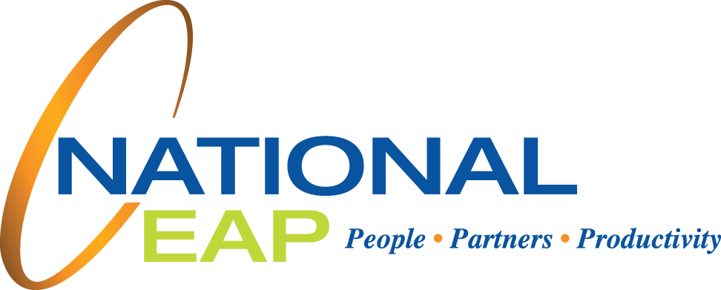

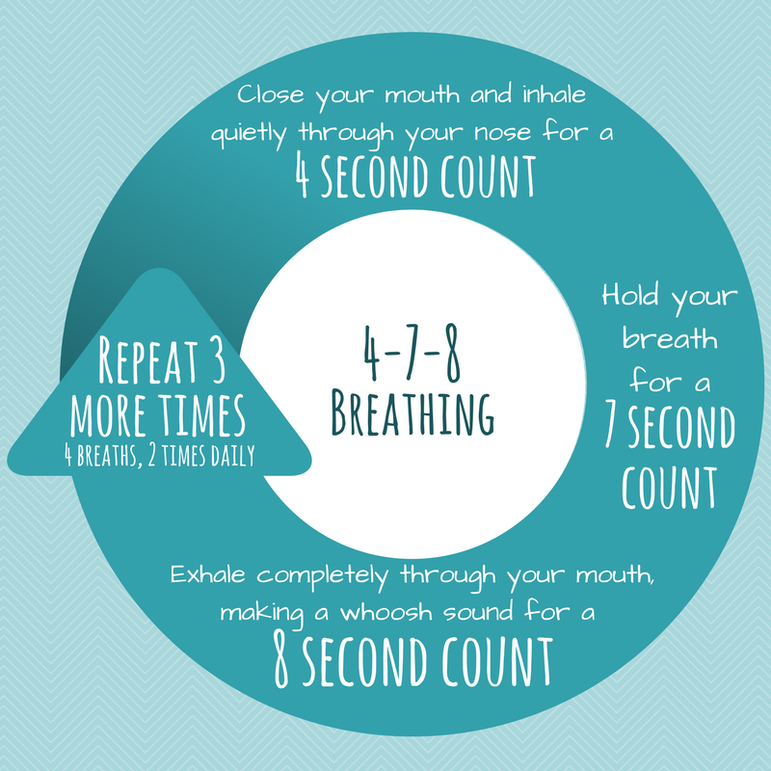

Are you stressed during the COVID-19 Pandemic? Struggling to unwind? Resiliency is key. Resiliency describes the process of coping with stressful

situations like these and then moving on from them. Strong relationships, good communication and problem solving skills, and a positive outlook are all traits of resilient people.

**National EAP is here to provide you with strategies on how to manage stress. But first, we need to identify our stressors. Second, we need to consider – what is in our control? During this time of uncertainty, it is important to focus on what we can control. Manage your stress and maintain a positive mindset using the strategies identified below:**

• Build regular exercise into your life. Gyms are closed? Can’t get outside? Try searching on YouTube or Social Media websites for online workouts

you can complete from the comfort of your home.

• Maintain a regular, well-balanced diet. Don’t eat all those quarantine snacks in one sitting!

• Practice calming techniques such as controlled breathing and

progressive muscle relaxation to train your mind and body

to become more relaxed,

• Use your natural supports such as peers, family, and

coworkers to de-stress. Talk to people about how you

are feeling. Do NOT hold it all in. Asking for help is a

strength, not a weakness.

• Reframe negative thinking – try to find the positive.

• Pratice gratitude and be kind to yourself

and others during these challenging times.

STRESS:

Learn To Be Resilient

EMPLOYEE ASSISTANCE PROGRAM