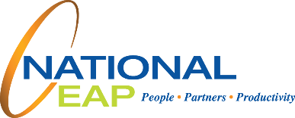

**Visit your home page starting October 20th**

**TOLL-FREE: 1-800-624-2593**

**WEBSITE: www.nationaleap.com**

**USERNAME: Your Company Name**

**PASSWORD: Your Company Name**

**WHATEVER YOU NEED, WE ARE HERE TO HELP.***Just call or log on to get started.*

Your Employee Assistance Program is there 24/7 with   
information and resources to help you work better, together.

**The Mental   
Strength Workout**

**ONLINE SEMINAR**

Our mind is our most powerful tool that we have during times of adversity. You can learn skills and strategies to exercise the power of your mind and increase your mental fortitude.

**OCTOBER 2020**