

**FALL  
ISSUE**

# 2018

**MOVE YOUR BODY AS MUCH AS POSSIBLE**

# PG: 7

**FREQUENTLY ASKED QUESTIONS ABOUT COUNSELING**

# PG: 6

**BE A HEALTHY ROLE MODEL FOR CHILDREN**

# PG: 4

**POLISHING YOUR PEOPLE SKILLS**

# PG: 2

**Contact Us**

TOLL-FREE: **800-000-0000**

TTY/TTD: **866-228-2809**

[**www.websiteinformation.com**](http://www.websiteinformation.com)

USERNAME: **username**

PASSWORD: **password**

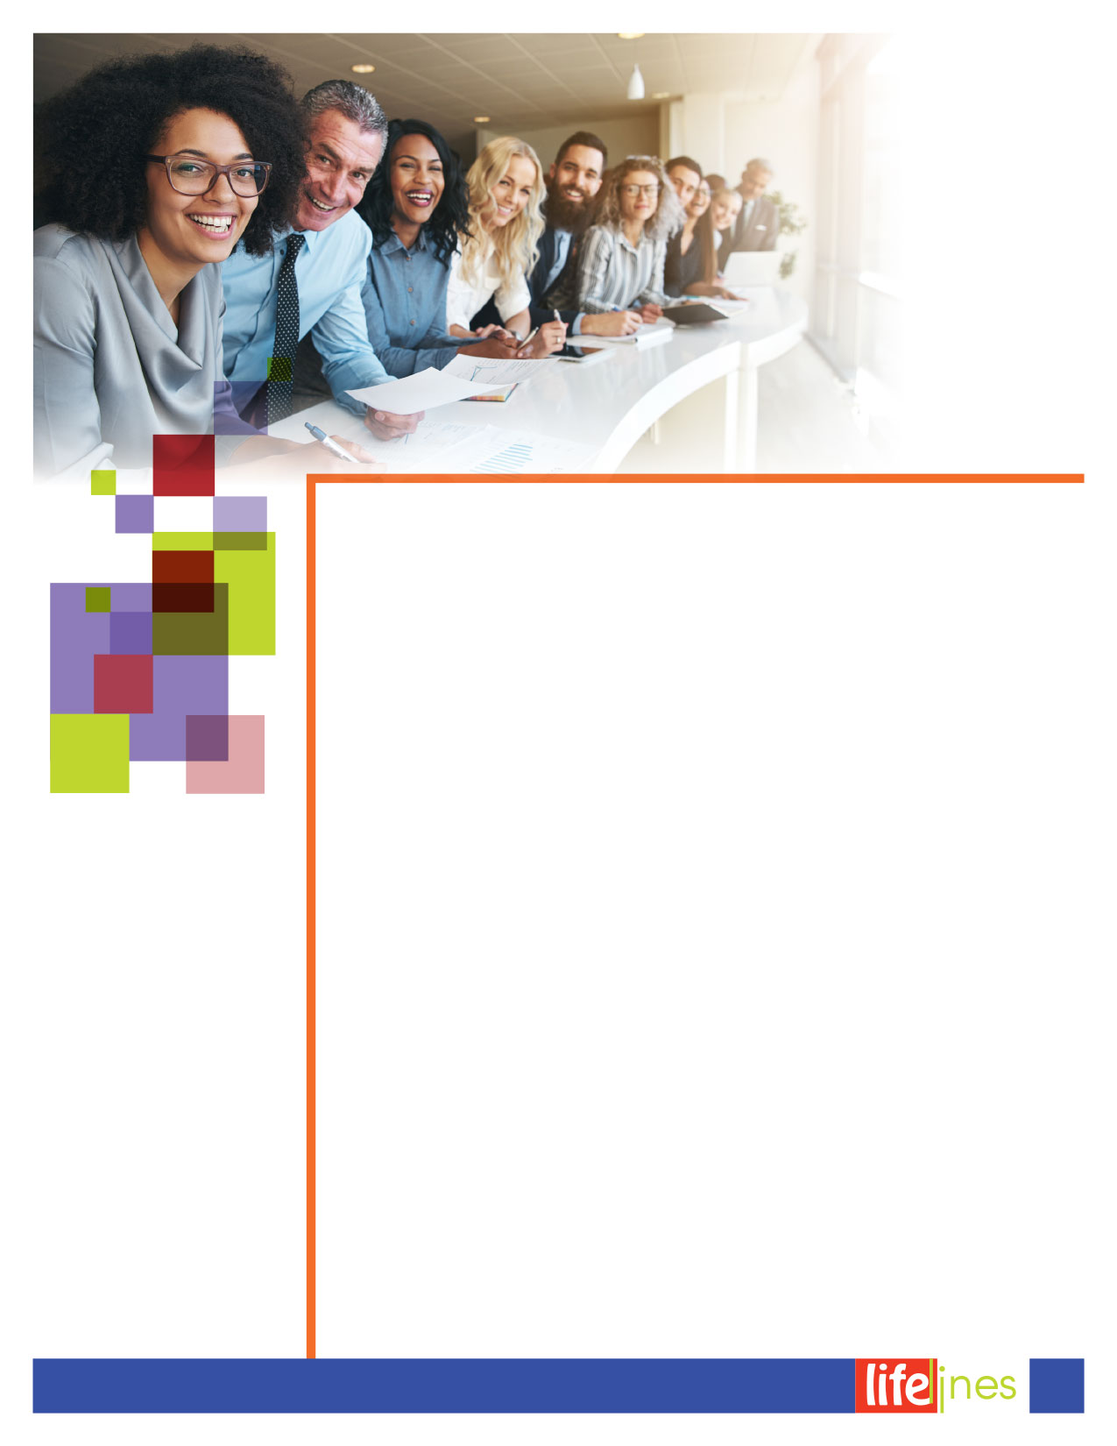

*continued on page 3*

**Polishing Your   
People Skills**

It doesn't mean sloppy, unkempt, or  
—worse yet—revealing. That said, you can lighten up when your company permits.

"I will pay more for the ability to deal with people than for any other ability under the sun," John D. Rockefeller once said. The legendary industrialist knew his stuff.

People skills are the grease that keeps relationships humming. And the ability to maintain good relationships is the cornerstone of good business.

People skills begin with good manners—manners that transcend white gloves and fish forks and reflect a genuine commitment to making interactions positive, productive, and pleasant. One longtime corporate trainer has seen businesses bleed clients and revenues because of unintended slights, clumsy interactions, and out-and-out rudeness. Within a company, such gaffes can breed hostility, confusion, and inefficiency. That hurts the bottom line and makes office life miserable.

Modern business etiquette isn't complicated—it's built on the time-honored values of kindness and common sense. But many people seem to struggle with the basics.

Here are some typical questions:

**Ever since our company adopted a casual dress policy, people are wearing all kinds of outfits. In the summer, it gets even looser, with employees sporting shorts, tank tops, and showing lots of bare skin. I'm a little uncomfortable with this kind of dress but don't want to appear too stuffy. Are there rules for casual dress?**

When did *appropriate* become a euphemism for *stuffy*? You're right: What passes for business casual has gotten out of hand, particularly when summer arrives. Bare midriffs, short shorts, and   
T-shirts are no more appropriate in the office than suits and ties would be on the beach. In fact, many companies are giving their employees remedial dress lessons to rein in the overly casual.

Casual means informal or relaxed. It doesn't mean sloppy, unkempt, or—  
worse yet—revealing. That said, you can lighten up when your company permits. Like an actor, ask yourself what your role, stage, and audience will be each day. Will you be taking clients to dinner? Catching up on phone calls behind closed doors? What message do you want to convey to that day's audience? Your clothes, like it or not, send a message.

You can't go wrong by emulating the   
boss: If he's a suit-and-tie guy all year, follow his lead, no matter what your peers wear. But if he breaks out the khakis and polo shirts come June, feel free to do the same.

**FALL 2018**

2



*Mitchell, M. (Reviewed 2018). Polishing your people skills. Raleigh, NC: Workplace Options.*

Whatever the weather, make sure you're well groomed. Don't show too much skin, and don't wear any fabric you can see through.

**Gift giving at our office has gotten out of hand. Every time I look up, someone seems to be collecting money for new babies, family funerals, retirements, you name it. I'm no Scrooge, and I appreciate the importance of these occasions, but I can't afford it, especially for people I barely know! Is there a gracious way to opt out when someone passes the hat?**

There's no shame in being financially prudent. And you are probably voicing what others are feeling. If it's possible to change the pattern, do so. You might simply tell others about your concerns and suggest a modest contribution limit that is within most people's budget.

If you can't change the policy, create your own. Pleasantly and matter-of-factly, say, "I've decided to curtail giving at the office. It's just not an expense that I can budget." But go the extra mile and write personal notes or cards to those people you know to commemorate their special occasions.

**I'll be starting a new job soon and want to put my best foot forward. How do I make sure my nervousness doesn't show through?**

Congratulations on your new position! With a positive attitude like yours, you're sure to do well. In fact, a great attitude is your biggest asset on the job. Negative attitudes corrode the work environment. In fact, negative attitudes were the top complaint from executives when my company surveyed them about obstacles to doing business.

The executives' other pet peeves:

* Sloppy message taking and giving someone the runaround
* Making people wait
* Criticizing people publicly
* Disregarding social courtesies for business functions
* Committing errors with names
* Failing to make introductions
* Using vulgar language and wearing inappropriate clothes

Steer clear of these blunders, and you'll do fine.

**My new coworkers have been asking me to meet them for happy hour after work. They seem nice, and I wouldn't mind joining them occasionally, but I don't drink alcohol and I dislike being in a drinking crowd. I also feel unsure how to behave on these outings: I never know whether to bring my "business" self or my "social" self. Do you have any advice?**

You're wise to ask. Too many people treat these occasions as let-it-all-hang-out sessions with old friends. They end up drinking too much or telling inappropriate jokes. Those are serious mistakes that can haunt you on the job for a long time. On the other hand, you don't want to be overly formal or serious when everyone else is trying to unwind. As you've sensed, this is a hybrid situation: not quite business, not quite pleasure.

The same is true of office parties. The rule of thumb: Put the "office" before the "party." In other words, err on the side of business.

First and foremost, no one ever has to drink alcohol or to apologize for not drinking. If everyone else is ordering alcohol, just say, "I'm not having any wine or beer today, thanks, but please go ahead and enjoy whatever you want." Saying "today" removes any sound of judgment about alcohol consumption.

Then cheerfully place your order for bottled water or a soft drink. Let your voice reflect that this is your sincere preference.

No matter what you're drinking, stick to a two-drink limit. Make it one drink of alcohol if you're tired and stressed out. And never drink on an empty stomach.

Stay upbeat, keep your ears open and your manners intact, and enjoy. This is a good opportunity to get to know your new colleagues.

Finally, if you're just not comfortable with bar scenes, why not suggest lunch? There's a natural time limit on it, and you can enjoy the food and lighter conversation without feeling pressured to drink—or subjecting yourself to others who overindulge.

**When I write an email, what's the proper salutation for someone I don't know personally?**

"Dear Mr. Smith:" is fine. If you've met someone a few times but don't know him or her well enough to write "Dear John," use the full name, as "Dear John Zachary:"

You also can put in an email: "Ms. Jones:" (without the "Dear").

If it's someone with a title, you can simply put the name and title: "Dr. Reynolds:" or "Ambassador Jenkins:"

Remember, it's better to err on the side of formality than to assume a first-name basis with someone. Let the other person be the one to say, "Please just call me Jane."

*continued*

**Polishing Your   
People Skills**

3

**FALL 2018**

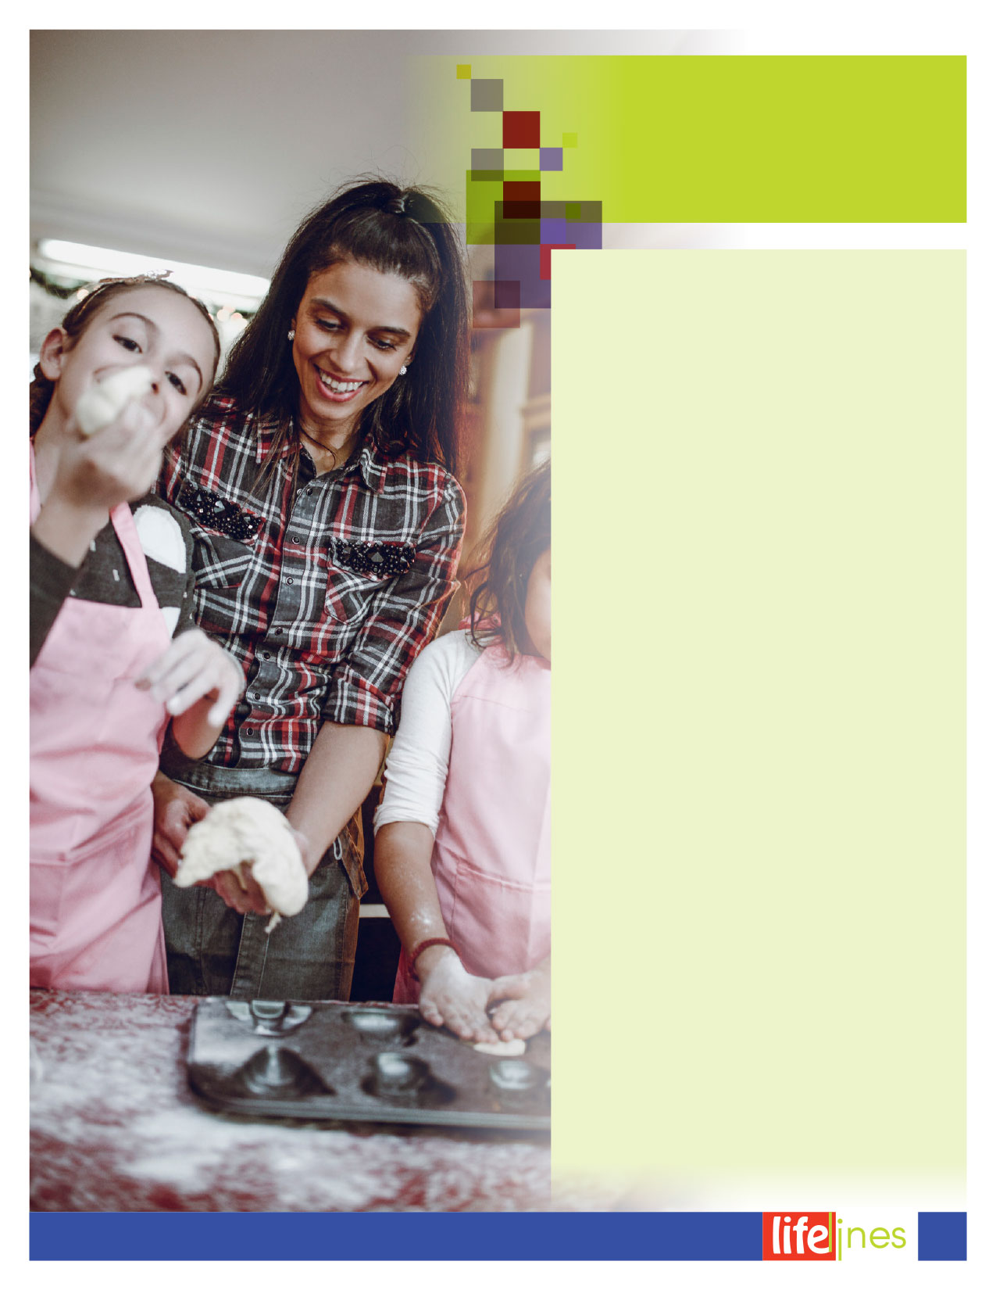

5

4

3

2

1

**SHOW BY EXAMPLE.**  
Eat vegetables, fruits, and whole grains with meals or as snacks. Let your child see that you like to munch on raw vegetables.

**GO FOOD SHOPPING TOGETHER.**  
Grocery shopping can teach your child about food and nutrition. Discuss where vegetables, fruits, grains, dairy, and protein foods come from. Let your children make healthy choices.

**GET CREATIVE IN THE KITCHEN.**  
Cut food into fun and easy shapes with cookie cutters. Name a food your child helps make. Serve "Janie's Salad” or "Jackie's Sweet Potatoes” for dinner. Encourage your child to invent new snacks. Make your own trail mixes from dry whole-grain, low-sugar cereal and dried fruit.

**OFFER THE SAME FOODS FOR EVERYONE.**  
Stop being a "short-order cook” by making different dishes to please children. It's easier to plan family meals when everyone eats the same foods.

**REWARD WITH ATTENTION, NOT FOOD.**  
Show your love with hugs and kisses. Comfort with hugs and talks. Choose not to offer sweets as rewards. It lets your child think sweets or dessert foods are better than other foods. When meals are not eaten, kids do not need "extras”—such as candy or cookies—as replacement foods.

**Ten Tips for Setting Good Examples**

You are the most important influence on your child. You can do many things to help your children develop healthy eating habits for life. Offering a variety of foods helps children get the nutrients they need from every food group. They will also be more likely to try new foods and to like more foods. When children develop a taste for many types of foods, it's easier to plan family meals. Cook together, eat together, talk together, and make mealtime a family time!

**Be a Healthy**

**Role Model for Children**

4

**FALL 2018**

*continued on page 5*

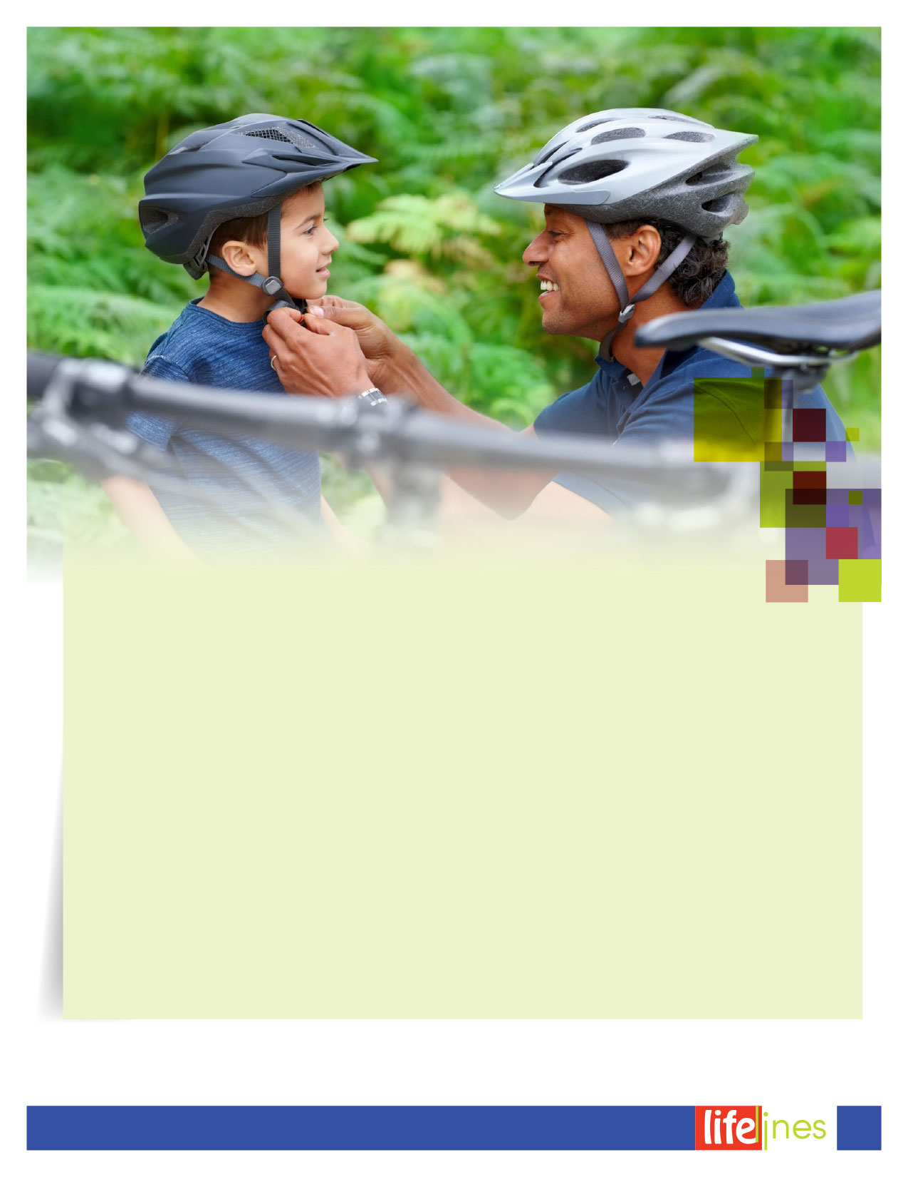

**Be a Healthy**

**Role Model for Children**

***(continued)***

U.S. Department of Agriculture (USDA). (Updated 2017, March 8). *10 tips nutrition education series: Be a healthy role model for children* (DG Tipsheet No. 12). Retrieved July 19, 2018, from http://www.choosemyplate.gov/

10

9

8

7

6

**FOCUS ON EACH OTHER AT THE TABLE.**  
Talk about fun and happy things at mealtime. Turn off the television. Take phone calls later. Try to make eating meals a stress-free time.

**LISTEN TO YOUR CHILD.**  
If your child says he or she is hungry, offer a small, healthy snack—even if it is not a scheduled time to eat. Offer choices. Ask "Which would you like for dinner: broccoli or cauliflower?” instead of "Do you want broccoli for dinner?”

**LIMIT SCREEN TIME.**  
Allow no more than 2 hours a day of screen time like TV and computer games. Get up and move during commercials to get some physical activity.

**ENCOURAGE PHYSICAL ACTIVITY.**  
Make physical activity fun for the whole family. Involve your children in the planning. Walk, run, and play with your child—instead of sitting on the sidelines. Set an example by being physically active and using safety gear, like bike helmets.

**BE A GOOD FOOD ROLE MODEL.**  
Try new foods yourself. Describe its taste, texture, and smell. Offer one new food at a time. Serve something your child likes along with the new food. Offer new foods at the beginning of a meal, when your child is very hungry. Avoid lecturing or forcing your child to eat.

5

**FALL 2018**



Perry, L. (Reviewed 2018). *Frequently asked questions about counseling.* Raleigh, NC: Workplace Options.

**WHAT QUALIFICATIONS DOES A COUNSELOR HAVE?**

**A:** A counselor is a mental health professional who has, at a minimum, a master's degree in social work, psychology, counseling, or another related field. Additionally, the counselor has undergone a rigorous process to obtain licensure or registration in order to independently deliver counseling services. The counselor is also required to take a certain number of continuing education classes to remain updated on the most current counseling modalities and techniques.

**I CAN TELL THE COUNSELOR ANYTHING, AND HE OR SHE CANNOT TELL ANYONE ELSE, RIGHT?**

**A:** The short answer is *yes*. More specifically, everything you discuss with the counselor is confidential, unless you state that you're having suicidal or homicidal thoughts, or if you disclose that a child or adult is being abused.

**IS COUNSELING COVERED BY MY INSURANCE?**

**A:** Health insurance benefits vary, so contact your health insurance company directly to discuss your mental health benefits.

**WHAT EXACTLY IS COUNSELING?**

**A:** Very simply put, *counseling* is talking with a trained mental health professional to collaboratively work through a problem. Counseling is commonly referred to as *talk therapy*, because it involves an open dialogue between you and the counselor

**WHY SHOULD I GO SEE A COUNSELOR? I'M NOT MENTALLY ILL OR CRAZY.**

**A:** People choose to visit a counselor for many reasons. These include getting assistance with achieving work-life balance, stress management, feeling depressed, conflict at work, parenting support, relationship issues, and grief. Talking to friends and family about a problem can be helpful. However, a counselor is going to be neutral and provide a different perspective on the issue.

**I THINK I HAVE DEPRESSION AND WANT MEDICATION. CAN'T THE COUNSELOR WRITE ME A PRESCRIPTION?**

**A:** This is a very common misconception! A counselor is a trained mental health professional who is qualified to provide counseling. Counselors cannot prescribe medication. However, the counselor might recommend that you be evaluated for medication by a *psychiatrist*. A psychiatrist is a medical doctor with specialized training in the medical treatment of people with mental health disorders. A psychiatrist can prescribe medication.

Q

Q

Q

Q

Q

Q

**Frequently Asked Questions About Counseling**

6

**FALL 2018**

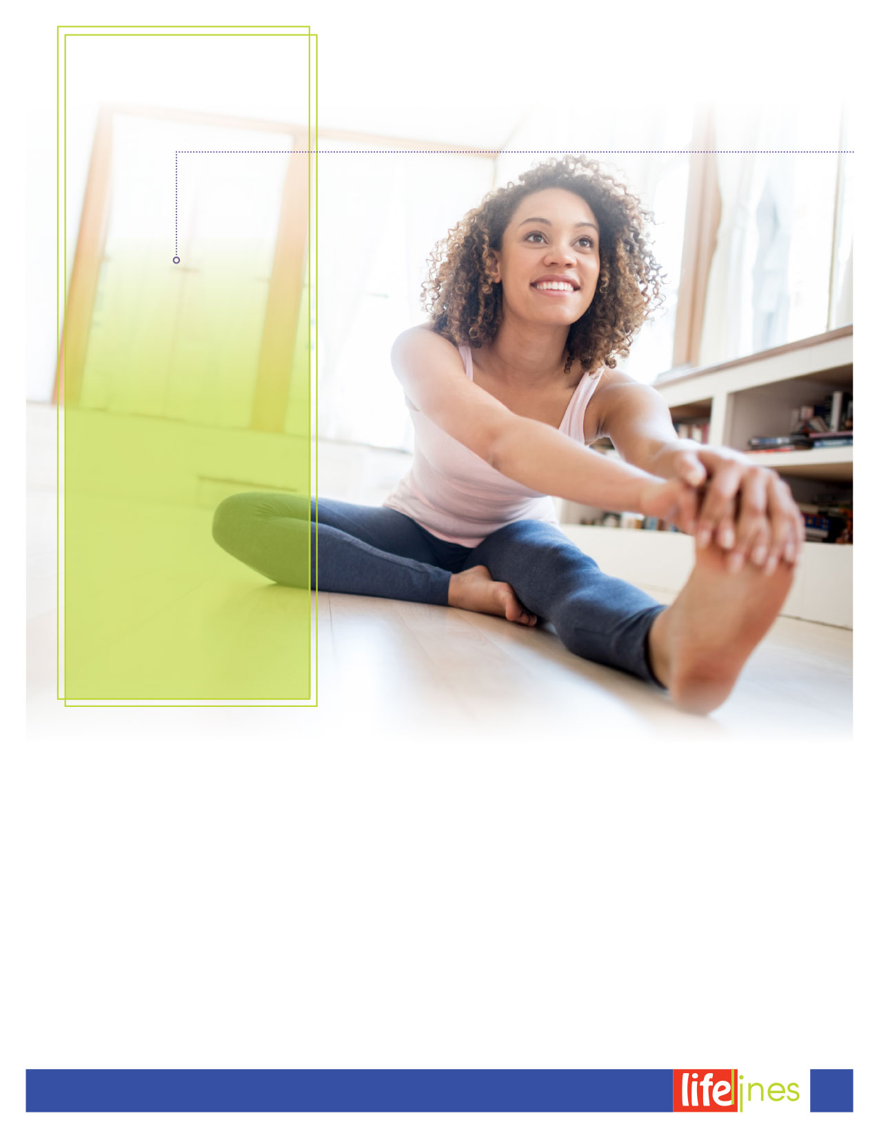

*continued on page 8*

The key to increased activity is to move anytime the opportunity presents itself. Here are some simple things you can try at home:

* Take the stairs whenever you can, adding a little extra movement: Go up two steps, down one; up three steps, down two, and so on.
* Wiggle in your chair; swing your feet if they don't touch the ground.
* Sit in hard-backed chairs rather than overstuffed chairs. (It takes more energy, or calories, to sit up straight than slouch.) Try sitting instead of reclining, standing instead of sitting, or walking instead of standing. The less comfortable you are, the more energy you use.
* Put on music and dance around the room.
* Dance around the bathroom or bedroom while you towel off vigorously after a shower.
* Try some knee bends (but don't let your behind drop below your knees), or swing one leg at a time to the side while brushing your teeth or drying your hair.
* Use a nonmotorized push mower for your lawn.
* Use fewer labor-saving devices like electric can openers, remote controls, or self-propelled vacuum cleaners.
* Move around while you're talking on the phone. Stand and swing your legs, flex your feet, or walk around.

*Try sitting instead of reclining, standing instead of sitting, or walking instead of standing. The less comfortable you are, the more energy you use.*

**Much as Possible**

Move Your   
Body as

7

**FALL 2018**

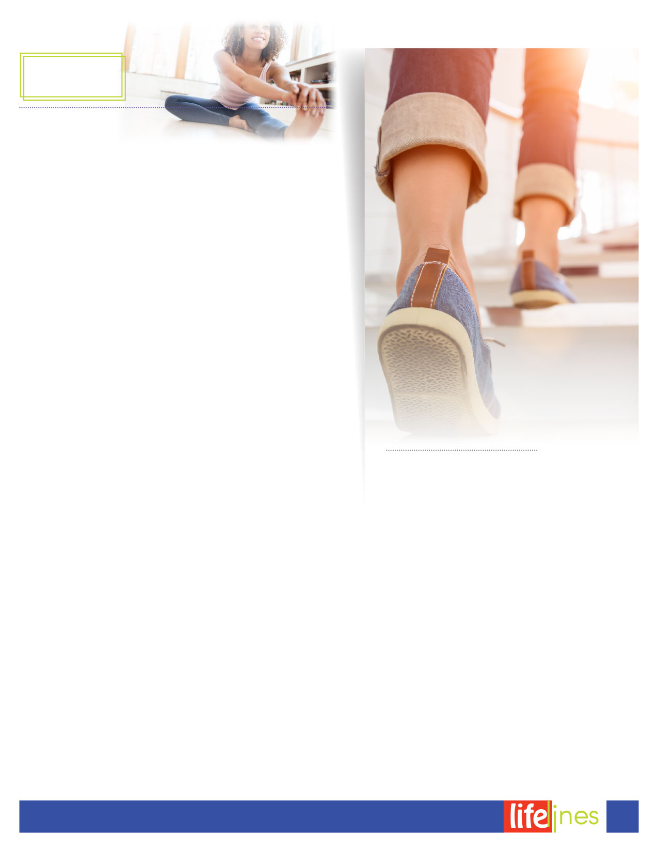

*continued*

*Workplace Options. (Reviewed 2017). Move as much as possible. Raleigh, NC: Author.*

Choose activities you like to do, and decide how many days each week you can reasonably expect to do them. Don't say you're going to do an activity five times a week when you know your schedule will only allow you to do it twice. And don't try dashing up six flights of steps the first time you decide to skip the elevator. Walk up one or two flights, adding more and more of them and moving more rapidly on a gradual basis.

In fact, try to increase all of your activities gradually. If you perform an activity for 3 minutes today, try for 4 minutes tomorrow or the next day. If you take 20 steps when you march in place at your desk, next time try 30 steps.

Set a new, reasonable goal to reach by the end of each week. Consider rewarding yourself—with an activity or treat (other than food)—each time you reach one of your goals.

* You can also look for opportunities in your workday to move around more:
* Keep light (1- or 2-pound) hand weights in your desk. Here is a test in coordination: While you talk, hold the phone with one hand and pick up a weight with the other hand, bend your elbow slightly, and lift the weight in front of you or out to the side. Try doing it six times in each direction and then switch hands.
* Plan a coffee break dance at work—a mood lifter for sure.
* A speakerphone will give you some freedom to turn your office into a track. As you talk, keep moving.
* Tone your legs. As you sit in your chair, knees bent and feet on the floor, slowly lift your feet so that your legs are almost straight—but don't lock your knees.
* Sit up straight in your chair and use those abdominal muscles. Pull in your stomach and hold it while slowly counting to 15. Each time you do this it is almost equivalent to doing one seated crunch.
* Try head, neck, and shoulder rolls to relieve neck and shoulder tension.
* If you need to have a short discussion with a coworker, suggest that you do it while walking through the hall or up and down the stairs if you don't need privacy.
* Walk to where you're going for lunch instead of driving or riding.
* Ask coworkers to take a walk with you at lunchtime.
* If you're looking for a more organized exercise program, look for gyms that are closer to your workplace than your home. It's tempting to think you'll go home, change, and go back to the gym—but once you're home, you may never go back out until it's time for work the next day. And you should check with your physician before beginning any kind of exercise program.

**Much as Possible**

**smart goals**

Move Your   
Body as

8

**FALL 2018**