

**YOUR EMPLOYEE**

**ASSISTANCE PROGRAM**

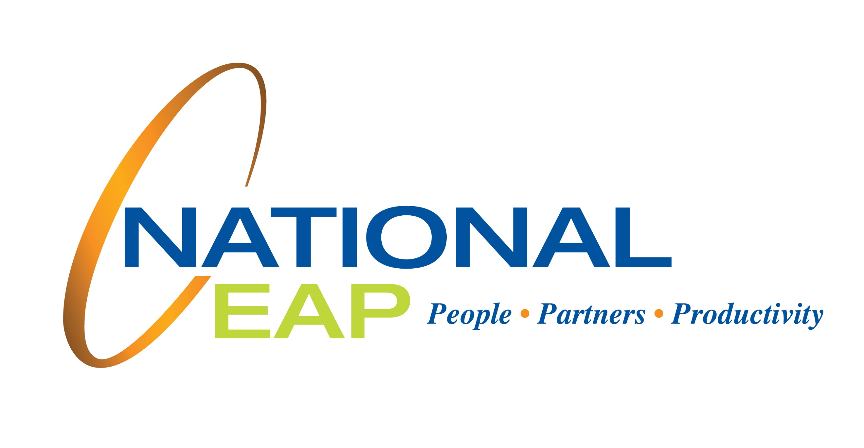

**APRIL 2021**

Visit your home page starting April 20th

WEBSITE: www.nationaleap.com

*Click on “Member Website” at the top of the web page.*

USERNAME: YOUR COMPANY NAME

PASSWORD: YOUR COMPANY NAME

LET US HELP

The Steps to Financial Security

ONLINE SEMINAR

Feel secure about   
your finances

Understand the practical ways you can feel more secure and more stable in your finance management.

Always Available | Free | Confidential

**APRIL 2021**

**YOUR EMPLOYEE**

**ASSISTANCE PROGRAM**