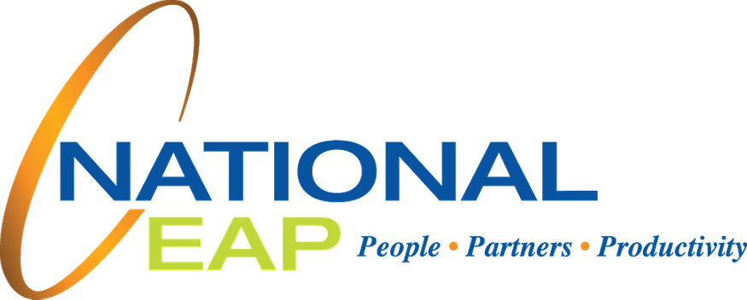JUNE

A Regular Publication by National EAP, Inc.
"THRIVE"
WITH NATIONAL EAP

UPCOMING WEBINARS:
The Truth About Self-Care: Debunking Myths
Self-care may be a familiar phrase to you but the practice of implementing self-care in your daily routine may be something more foreign. If you find yourself contemplating whether you delegate enough time for self-care, then this workshop is for you! Join us on June 22nd at 12 pm EST for a conversation about debunking the myths about self-care and learn strategies you can incorporate in your daily routine that will leave you feeling relaxed, rejuvenated, and ready to tackle life’s challenges!

Cultivating the Leadership Mindset: It's Not a Title, It's A Way of Being
Leadership is not about a title; it is a way of thinking and behaving. Influential leaders at all levels of organizations cultivate relationships and understand how to engage and motivate their colleagues. Join this Performance Coaching session on June 24th at 12 pm EST to gain insight into the leadership mindset and reflect on your growth opportunities to strengthen your leadership skills.

To register for either of these webinars, click here

TRAINING SPOTLIGHT
Supporting Employees in Crisis
Having empathetic leaders who understand and are prepared to support an employee having a mental health crisis is needed now more than ever. Supporting someone who is having a mental health crisis can be a scary and stressful time in any leader’s career.

This interactive seminar will equip management with the skills needed to support an employee during their time of need. Leaders will learn how to support an employee in the moment, understand supports available to them, and learn when to contact EAP.

During this session, leaders will get to practice the skills they learn and decide how they would respond to hypothetical crisis situations.

To book a Supporting Employees in a Crisis session with your leaders, Click Here
STRESSED ABOUT GOING BACK TO THE OFFICE?
Since the global pandemic lockdown in 2020, many individuals were forced to leave the workplace and to work remotely. Thankfully, since the release of the vaccine, the world has slowly started going back to normal and employers began asking their teams to return to the office. While some are delighted to be back on-site, others are left feeling overwhelmed and anxious.

If you are one of those feeling anxious about the return from quarantine, National EAP is here to help make the transition back to the office as smooth as possible. We are available 24/7 to assist with any feelings of anxiety and stress and will continue to support our clients during these times of change.

Please contact us at 800.624.2593 or at info@nationaleap.com to speak with a licensed professional today!

WHATEVER YOU NEED, WE ARE HERE TO HELP.

Call or log on to get started. TOLL-FREE: 1-800-624-2593

WEBSITE: www.nationaleap.com USERNAME: Your Company Name PASSWORD: Your Company Name

JUNE IS NATIONAL PRIDE MONTH
To live authentically in our skin is something we all strive for throughout our lives. Historically, it has been easy for some to "fit in" and attain the culturally acceptable look, life, or way of being in the world but, for others, the issue is more complicated. Many Individuals don't want to "fit in" and they are leading the charge to question what “fitting in,” means. They are honoring a broadening definition of self and identity. The PRIDE Campaign reminds us how mindfulness can help us be our authentic self through acceptance and it supports us on a quest to improve the world.

eM Life offers access to interactive, live and on-demand mindfulness programs led by expert teachers for everyday life. With every minute of mindfulness you practice, they donate to the charity of your choice.

eM Life has several programs that can help honor your authentic self, create acceptance and allow for personal support.

7 Days of Flourishing and Joy 7 Days of Loving Yourself
Mindfully Managing Loneliness

There are many ways to mindfully manage your space in the world. Sign up for eM Life to choose the program that is right for you!

To enroll in eM Life, Click here

SPECIAL WEBINAR EVENT

EM LIFE DEMO
Last month National EAP launched its new Mindfulness Online Platform - eM Life. This virtual mindfulness tool is available to help you create healthier connections with yourself and others while building skills to manage stress, anxiety, improve focus, and enhance your overall well-being.

To help you better understand how to enroll and use this new program, National EAP has scheduled a demo webinar to learn the ins and the outs of the program so you can find the best content to fit your personal needs. The 20 minute demo will be offered on June 15th at 9 am ET, June 16th at 12 pm ET, and June 17th at 4 pm ET. Following the demo, you will have time to ask our trainers questions.

We encourage all members to download the mobile app for eM Life to their mobile devices so that they can access their programming easily, wherever they are.

For a step by step guide to register on the web or download the mobile app for eM Life, Click here

To register for this event, click here

