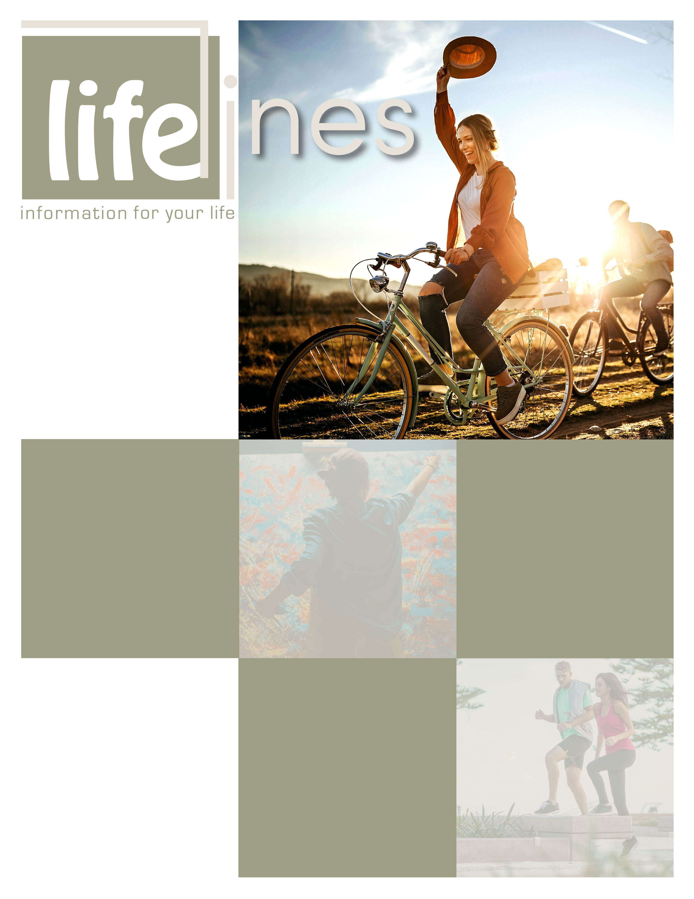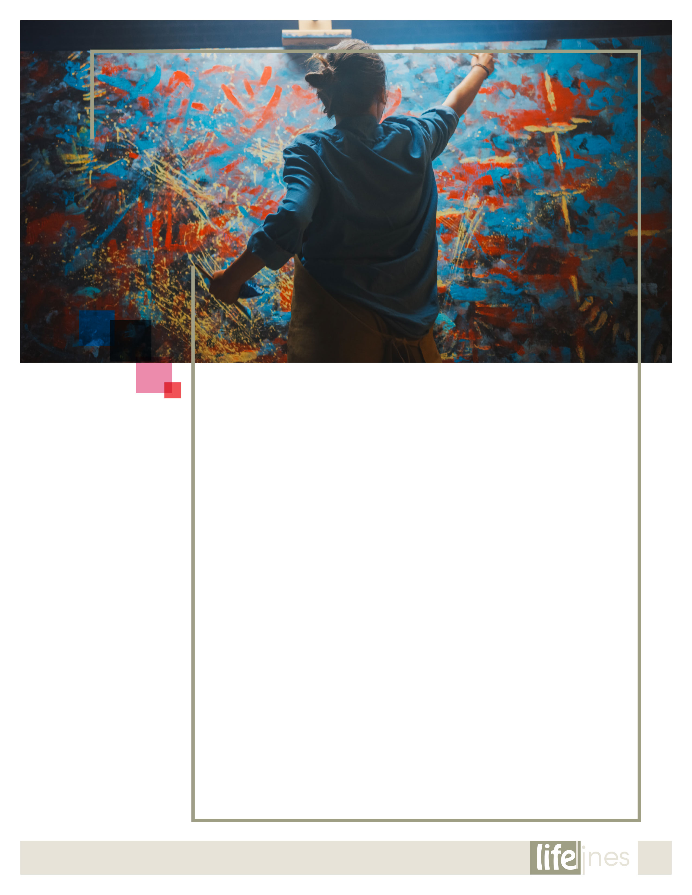

# PRACTICING LISTENING SKILLS

# PG: 5

**The Art (and Science) of Creativity**

# **PG: 2**

RETIREMENT LIFESTYLE PLANNING

# PG: 7

**EMOTIONAL WELLNESS TOOLKIT**

# **PG: 8**

# 2021

**Contact Us**

TOLL-FREE: **800-624-2593**

www.[**nationaleap.com**](http://www.websiteinformation.com)**.com**

USERNAME: **Your Company Name**

PASSWORD: **Your Company Name**

**SPRING  
ISSUE**

**The Art   
(and Science)   
of Creativity**

**2**

How does creativity work? How do you become creative? Can failure be productive? How is this important to the creative process? The creative process is cloaked in mystery, not just to the audience but also, in many cases, even to the creator.

Creativity isn't only restricted to making traditional art, like a painting. In everyday life, creativity is also used in the workplace and leisure time. Whether someone is playing a video game or sport, solving a complex logistical problem, or trying out a recipe, creativity is at work. Artists and other creative professionals across various disciplines have diverse thoughts on what creativity means to them, how it can be encouraged and what they find as inspiration.

**Maria Popova is the editor of the website Brain Pickings.** "Creativity is simply our ability to combine all the existing pieces in our head — memories, ideas, knowledge, inspiration — into incredible new things." What is her advice on fostering your own creativity? "Be curious. Be constantly, consistently, indiscriminately curious."

**Director and playwright Mary Zimmerman** feels that imagination is the building block of creativity. "I'm absolutely of the opinion that … just being left on your own [as a child] to make up a world is absolutely a key ingredient in creativity."

**Pat Courtney Gold is a basket weaver** for the Wasco Nation of the Confederated Tribes of Warm Springs, Oregon, and her craft is influenced by nature and the world around her.

**Game designer Colleen Macklin** feels that games, just like art, give people an opportunity to try things differently and to see things in new ways.4 "Games and works of art share the same inherent power to reframe one's way of thinking. The arts — and by extension, the creative process — and games also have something else in common: the need for constraints." She says that the presence of rules and limitations "force one to problem-solve and oftentimes come up with unusual solutions."

Games also teach another important aspect of creativity: failure. "You actually are learning by failing. You turn the game on, and you mess up ... over and over again until you understand the rules of that system and until you get better."

**David Harrington, founder of the Kronos Quartet,** feels that "Kronos' collaborations are equally about musical and human connections. Each collaboration presents unique challenges, sometimes requiring Kronos and its creative partners to bridge significant communication gaps." An equally important lesson in creativity that Harrington carries with him is the importance of living a vivid, engaged life. "I try to read several newspapers every day, keep my ears open and stay alert," he describes. "You can learn a lot by walking down the street and just listening to people, watching children, watching very old people. There are so many lessons to learn, and life is very, very short. You want to use your time to its best advantage."

**Visual artist Kerry James Marshall** feels creativity comes from repetition: "It's in the doing and doing again."

Actor, writer and director Cheryl Lynn Bruce says that "performance needs collaborators. In performance, most performers don't feel they're doing much without an audience, and that audience is the important ingredient."

**Harvard University professor Dr. David Edwards** speculates that scientists and artists are more alike than different. What do they have in common? Creativity. According to Edwards, creativity is a combination of both artistic and analytic thinking, what he calls "artscience." He feels that the scientific process is applied even in creative processes. In the best collaborations, the distinction between "art" and "science" disappears, and the creator is free to develop an idea without having to label it one way or the other.

U.S. National Endowment for the Arts (NEA). (2010, Revised 2016 [Ed.]). The art (and science) of creativity (B. Schuette, Ed.). NEA Arts Magazine, Number 3. Retrieved October 14, 2016, from https://www.arts.gov/

**Artists and other creative professionals across various disciplines have diverse thoughts on what creativity means to them, how it can be encouraged and what they find as inspiration.**

*continued on page 3*

**SPRING 2021**

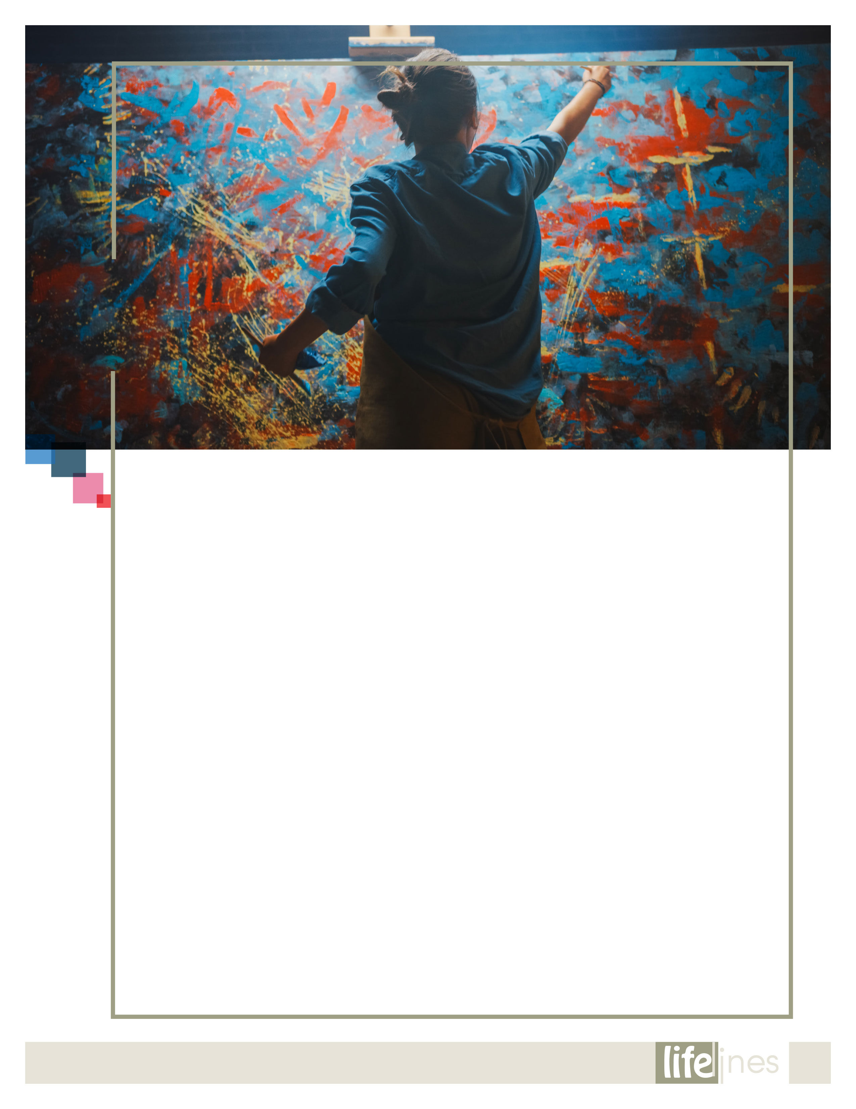

**The Art (and Science)   
of Creativity** (Contd.,)

**SPRING 2021**

**3**

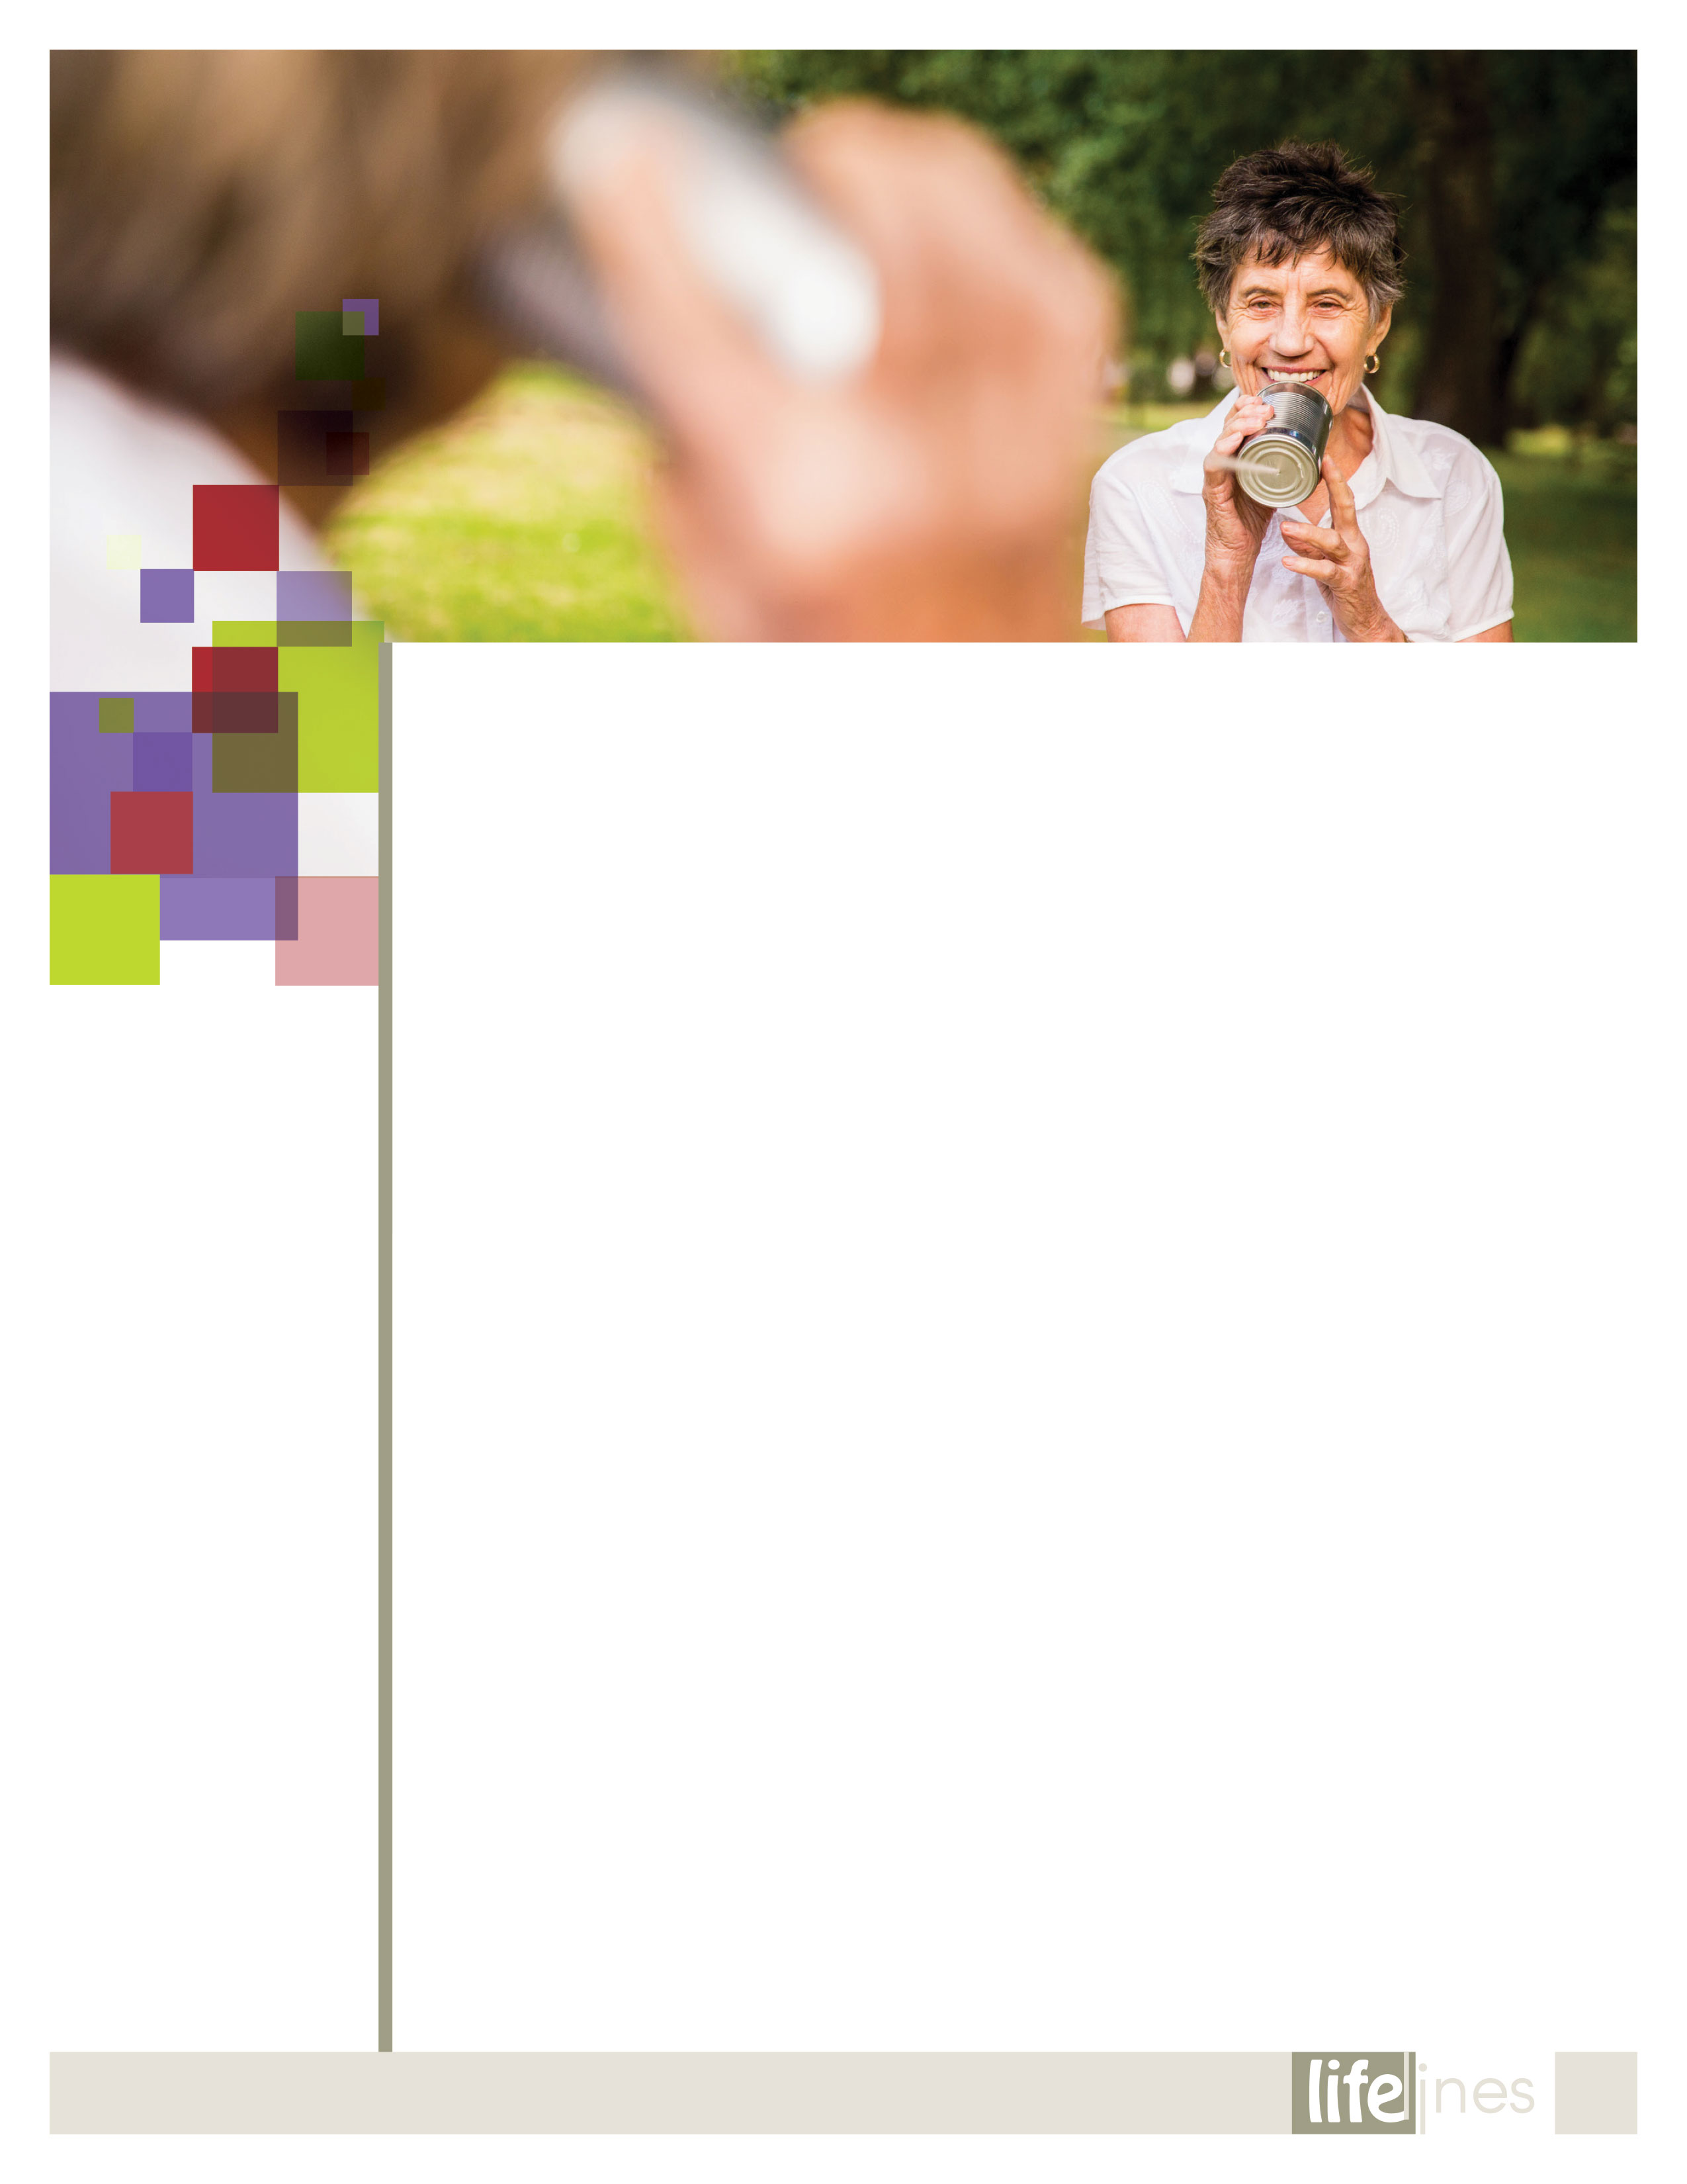

Listening is an art, a skill, and a discipline. Like other skills, it requires self-control. You must understand what is involved in listening and develop the necessary techniques to be silent and listen. You must ignore your own needs and focus attention on the person speaking. Hearing becomes listening only when you pay attention to what is said and follow it very closely.

Ways You Demonstrate That You Are Listening

* Your body language
* Making eye contact
* Keeping your body open
* Echoing words
* Nods of your head
* Leaning toward the speaker

You Listen in Order to...

* Show your support and help the other person(s) relax.
* Show you are accepting them and are open to them.
* Enable each one to speak and be heard.
* Be able to ask questions to clarify.
* Check assumptions.
* Clear up misperceptions.
* Restate or paraphrase.
* Find the key points or issues.
* Provide the silence necessary to encourage speech.
* Know when to bring to closure and when to test for agreements.

You need to show that you are listening carefully. This is called *attending*. Attending skills build rapport and help people feel at ease.

* Listen without interrupting.
* Pay attention.
* Use supportive body language.
* Paraphrase facts and feelings.

You also need to practice reacting and responding in positive ways. Using good responding skills helps people understand the things you care about. It also helps you collect information about the situation.

* Ask clarifying questions.
* Ask probing questions.
* Restate what the other person is saying, catching the essence but trying to take out the volatile phrases or language. This is called laundering language, and it can reduce friction.
* Summarize facts and feelings.
* Reframe issues. Focus on the interests, not positions.
* Try to always use "I" language instead of "you" language. For example, don't say, "When you do that, you make me feel..." Instead you can say, "When you do that I feel..."
* Try to communicate directly with the other person.
* Be forward thinking. Try to focus on the future.

Use *brainstorming* to find as many options or solutions as possible. The ground rules to brainstorming are that the people in the meeting are just throwing out ideas. At this point in the process, do not eliminate any ideas. The other ground rule is that mere mention of an idea does not mean that either person is agreeing to that idea. It's just an idea thrown out for purposes of the brainstorming session. Brainstorming helps turn good ideas into a plan of action. Look for points of agreement that the persons have in common and mention them.

You listen by paying attention.

Paying attention and listening without interruption allows the other person to "let off steam." Before any serious resolutions can occur, you need to let the other person know that you understand where they are coming from and you understand that they feel strongly about the issues you are discussing with them. Their intense emotions must be acknowledged and affirmed before serious solutions can be discussed. You should encourage the other person to let off steam and explain their concerns by using verbal cues such as these:

* "I see."
* "I understand."
* "That's a good point."
* "I can see that you feel strongly about that."
* "I can understand how you could see it like that."

These nonverbal actions also show the other person that you hear what they are saying:

* Squarely face the other person.
* Adopt an open posture.
* Lean discreetly, not threateningly, toward the other person.
* Maintain eye contact. Take cues from the other person as to the extent of eye contact with which he or she is comfortable.
* Try to relax as you interact with the other person.

Of course, for the other person to know that you are listening, you must make a response. The effectiveness of your listening will be determined by the style and quality of your response.

________________________________________________________U.S. Department of Veteran's Affairs, Alternative Dispute Resolution. (Updated 2015, August 15). *Practicing listening skills*. Retrieved September 12, 2019, from http://www.va.gov

**Practicing Listening Skills**

*continued on page 5*

**4**

**SPRING 2021**

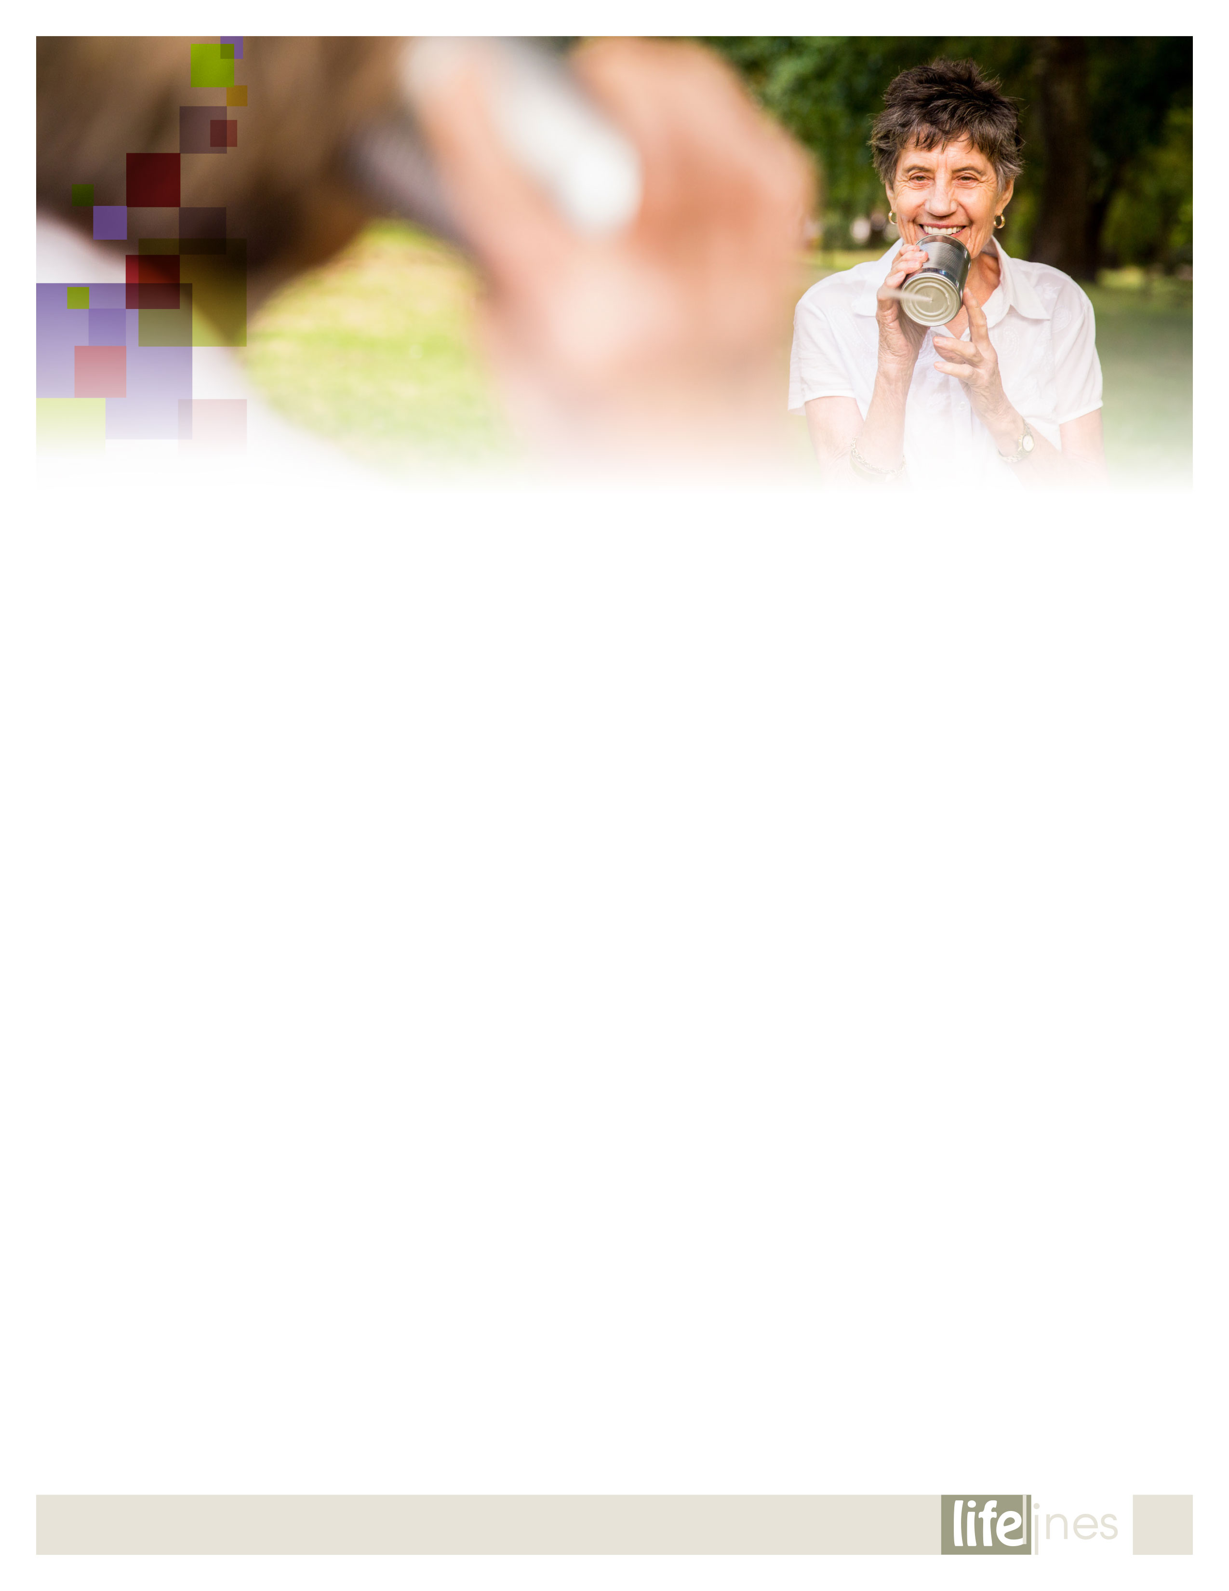

**Practicing Listening Skills** (Contd.,)

**5**

**SPRING 2021**

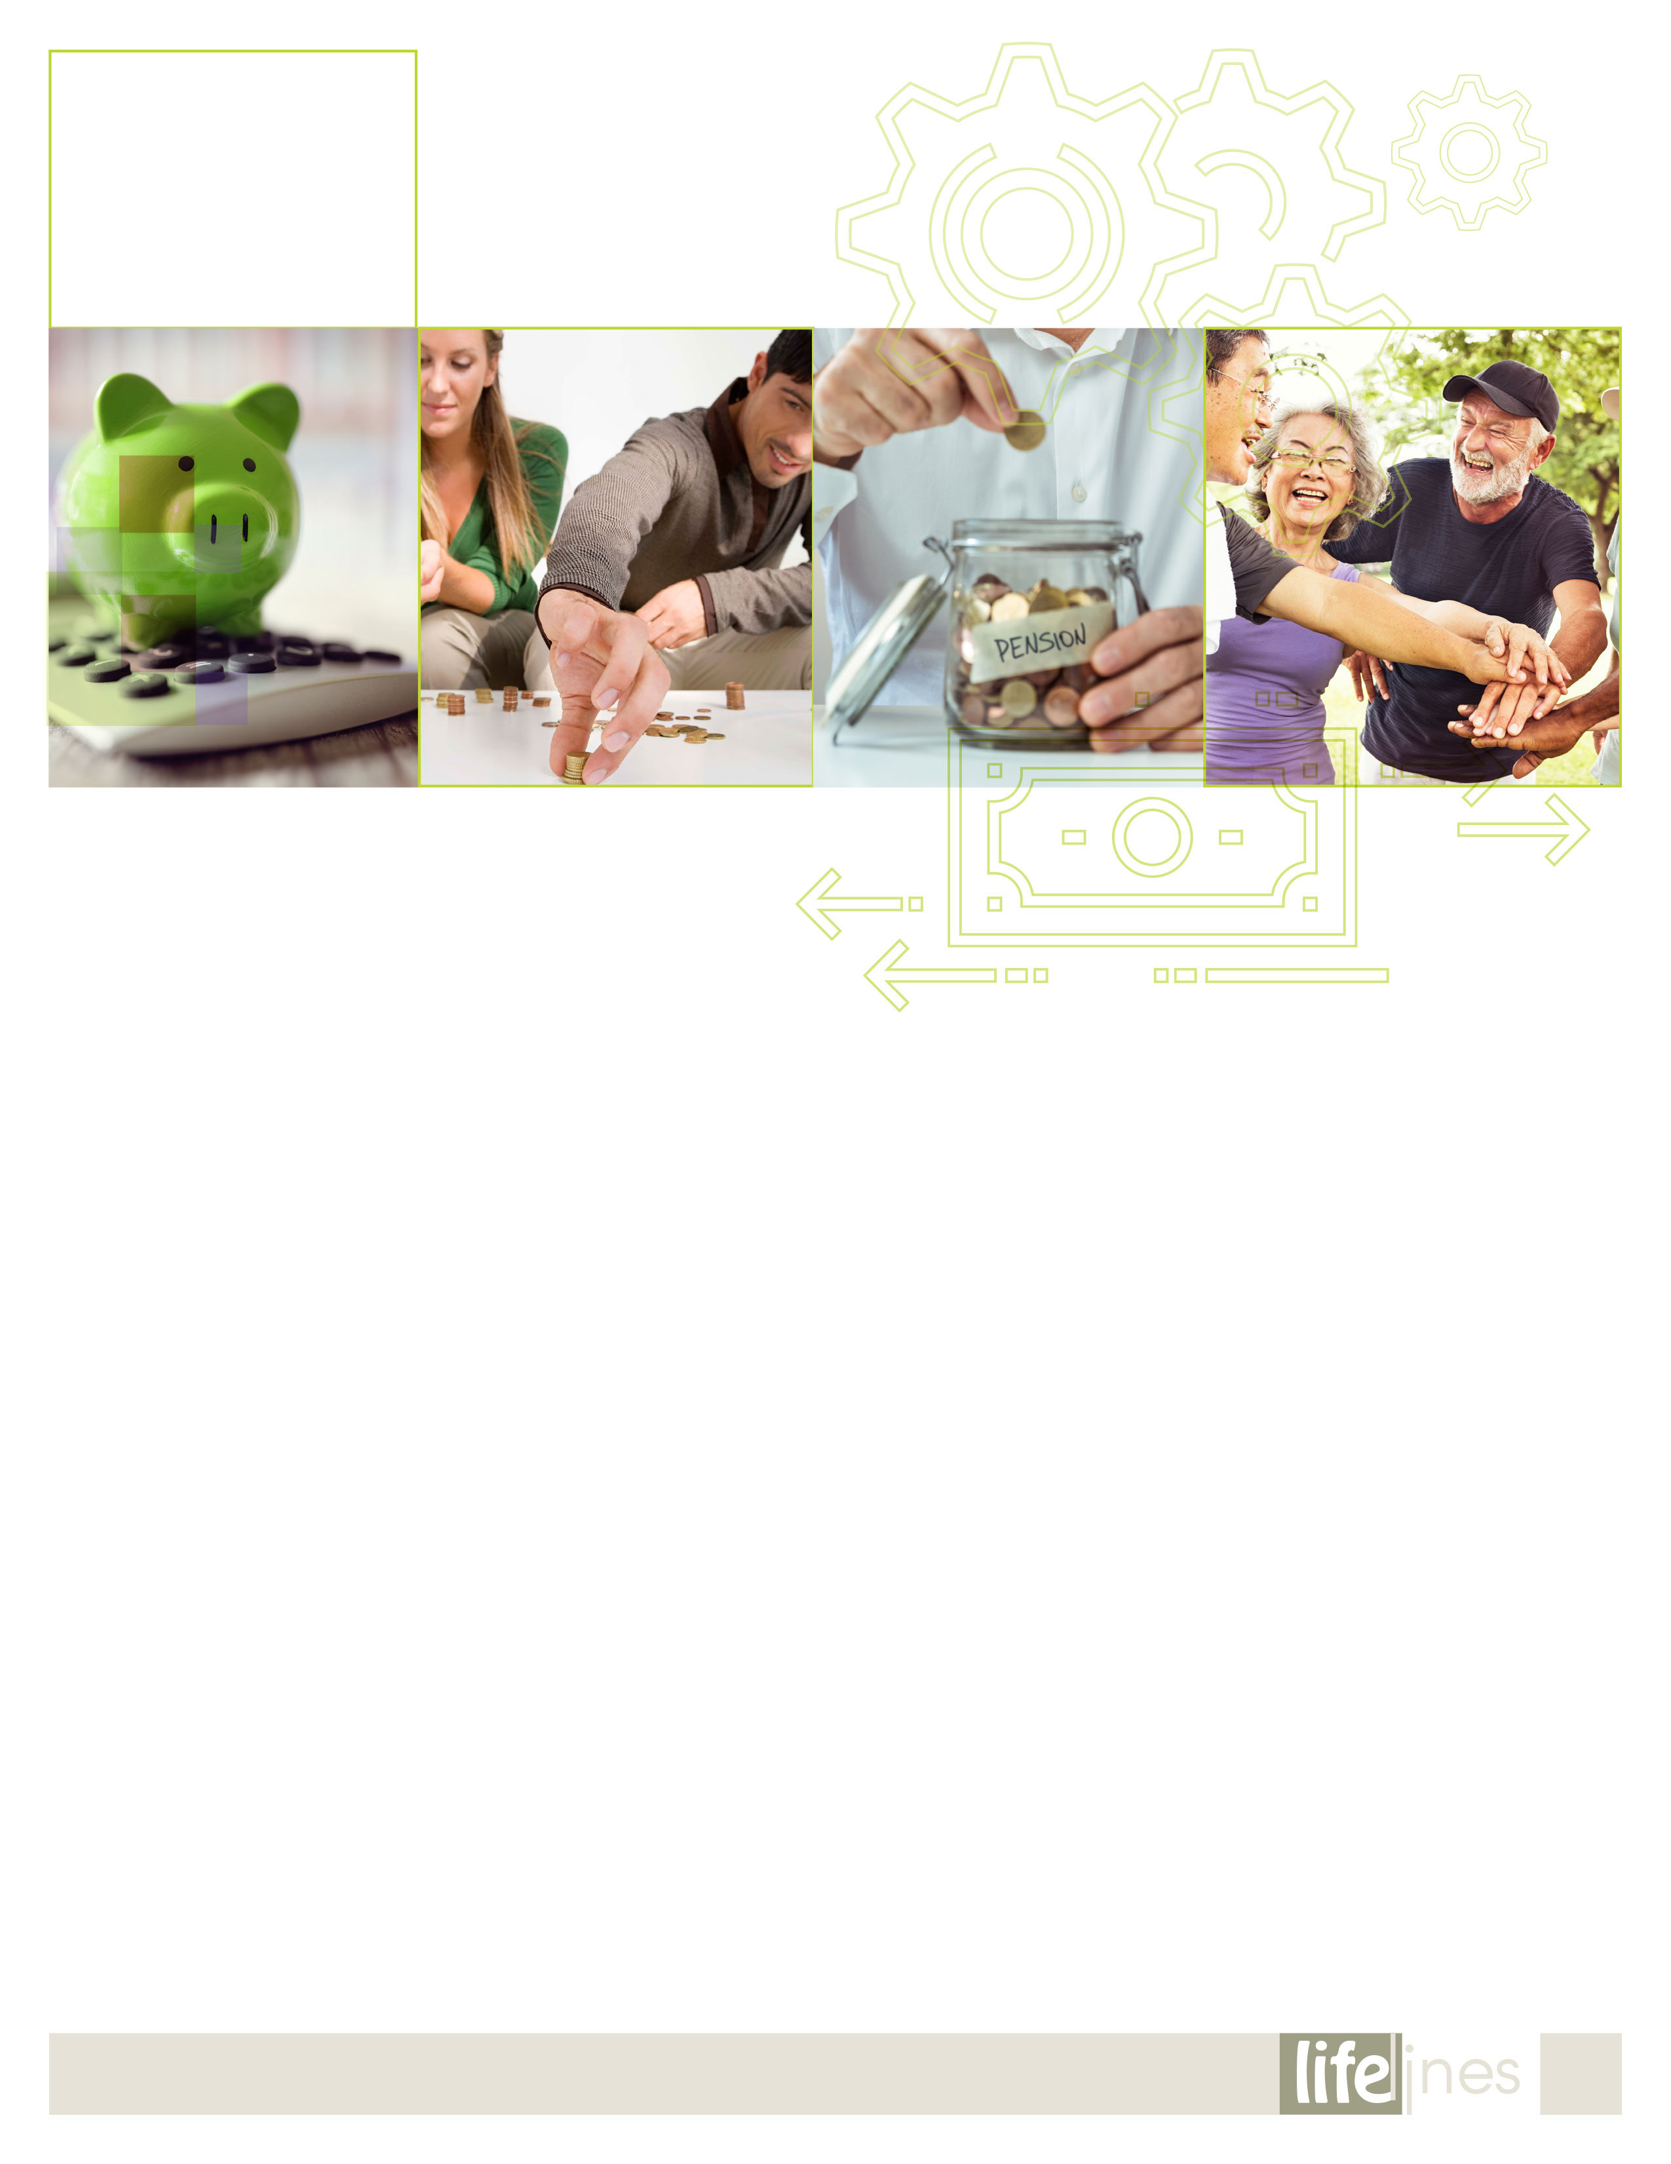

*continued on page 7*

More people in the United States are retired or approaching retirement than ever before. A lot of these people plan and save to ensure their financial stability during retirement, but too many fail to develop strategies for exactly what they'll do with their lives during those years.

It's never too early or too late to begin a life plan for retirement. You'll probably revise it many times before you reach retirement age, whether that's in 5 years or 25. No matter when you kick off your plan, you're less likely to have difficulty adjusting to retirement if you've thought in advance about what you want it to be like. Planning offers several benefits:

* Gathering information for your retirement helps clarify your options and may lead to some surprising opportunities.
* Having a plan can help you deal with the loss of a career and a work identity.
* Planning is an exercise in goal setting that can help you accomplish more and feel fulfilled.

Thinking about what you want to do, where you want to live, what you want your relationships to be like, and what you want your lifestyle to be are all good places to start your planning. Write down your goals in each of these areas, and keep them with your financial plan. Change them as necessary.

Phases of Retirement

Like going through adolescence or becoming a parent, retirement is a time of change that can cause turmoil and stress—as well as tremendous personal growth. Retirement changes your lifestyle, your perceptions of yourself, and what you do with your time.

As with any period of change, retirement is different for every person. However, there are some general stages that most people go through:

* **Preretirement—**As you enter this phase, you'll face the realization that retirement isn't just some far-off time in your future; it's imminent. During this phase, primary tasks involve getting ready for retirement.
* **The honeymoon—**This phase provides a time for you to enjoy yourself as well as plan for the routines and life that will follow. It's a good time to start considering the big picture.
* **Disenchantment—**For some people, a period of disenchantment and sometimes depression follows the honeymoon. During this time, the main tasks are adjustment and reflection. (Taking the time to adequately plan for retirement can help you avoid disenchantment.)
* **Reorientation—**This is when you develop ideas and start moving toward a more balanced life and diversified set of interests, relationships, and routines. The tasks of this phase involve balancing and diversification.
* **Stability—**In this phase, you're not just thinking about and planning for your retirement, you're living it. Here, the final goals are to determine for yourself who you want to be, what you want to do, and how you want to do it.

Holistic Retirement Planning

There are six basic areas of retirement planning. They are

1. Letting go of work
2. Activities
3. Health
4. Finances
5. Relationships
6. Lifestyle

**Considerations**

* Think about each of the six retirement planning areas with these aims in mind:
* Learning about yourself
* Learning about your options
* Setting tentative goals
* Implementing your goals
* Evaluating your situation as you approach your goals
* Revising and refining your goals

**Include physical and mental health in your plans.**

Plan on staying active physically and mentally. It's crucial to aging successfully. Eating well, exercising regularly, and getting regular physical exams are all ways you can make sure you're in top shape to enjoy retirement. You might also consider thinking about what your priorities will be after you're finished working full-time. Maybe you'll want to become a fitness instructor or run a water aerobics class. You can begin working toward those goals before retirement.

For example, consider

* Researching your family history
* Joining a religious or spiritual group
* Training for a 5-kilometer walk or run
* Starting a business
* Volunteering

**Follow your interests to new challenges.**

Think carefully about each of these questions. The answers can serve as your retirement map.

* What would you like to accomplish in the years ahead?
* What's really important to you? If you knew you had just a few weeks or months to live, how would you use them?
* What's missing from your life right now?
* What sort of choices are you facing now and what sort of decisions are you making?

**As you make your decisions**

* Think of all your possible choices, including the outlandish ones. Be creative.
* Review the list and eliminate or adjust choices that are physically impossible. For example, you probably won't become a soloist with a ballet company, but you might start taking ballet lessons.
* Evaluate your choices. Now think about the choices that seem most realistic. As in the previous step, try to be creative. You may not be able to run for the U.S. Senate, but how about the local school board?
* Lay out the consequences. What are the down sides to your possible choices? Who'll be affected by your choice, and how? How will your possible choices affect your life or your finances?

**SPRING 2021**

**6**

RETIREMENT

Lifestyle Planning

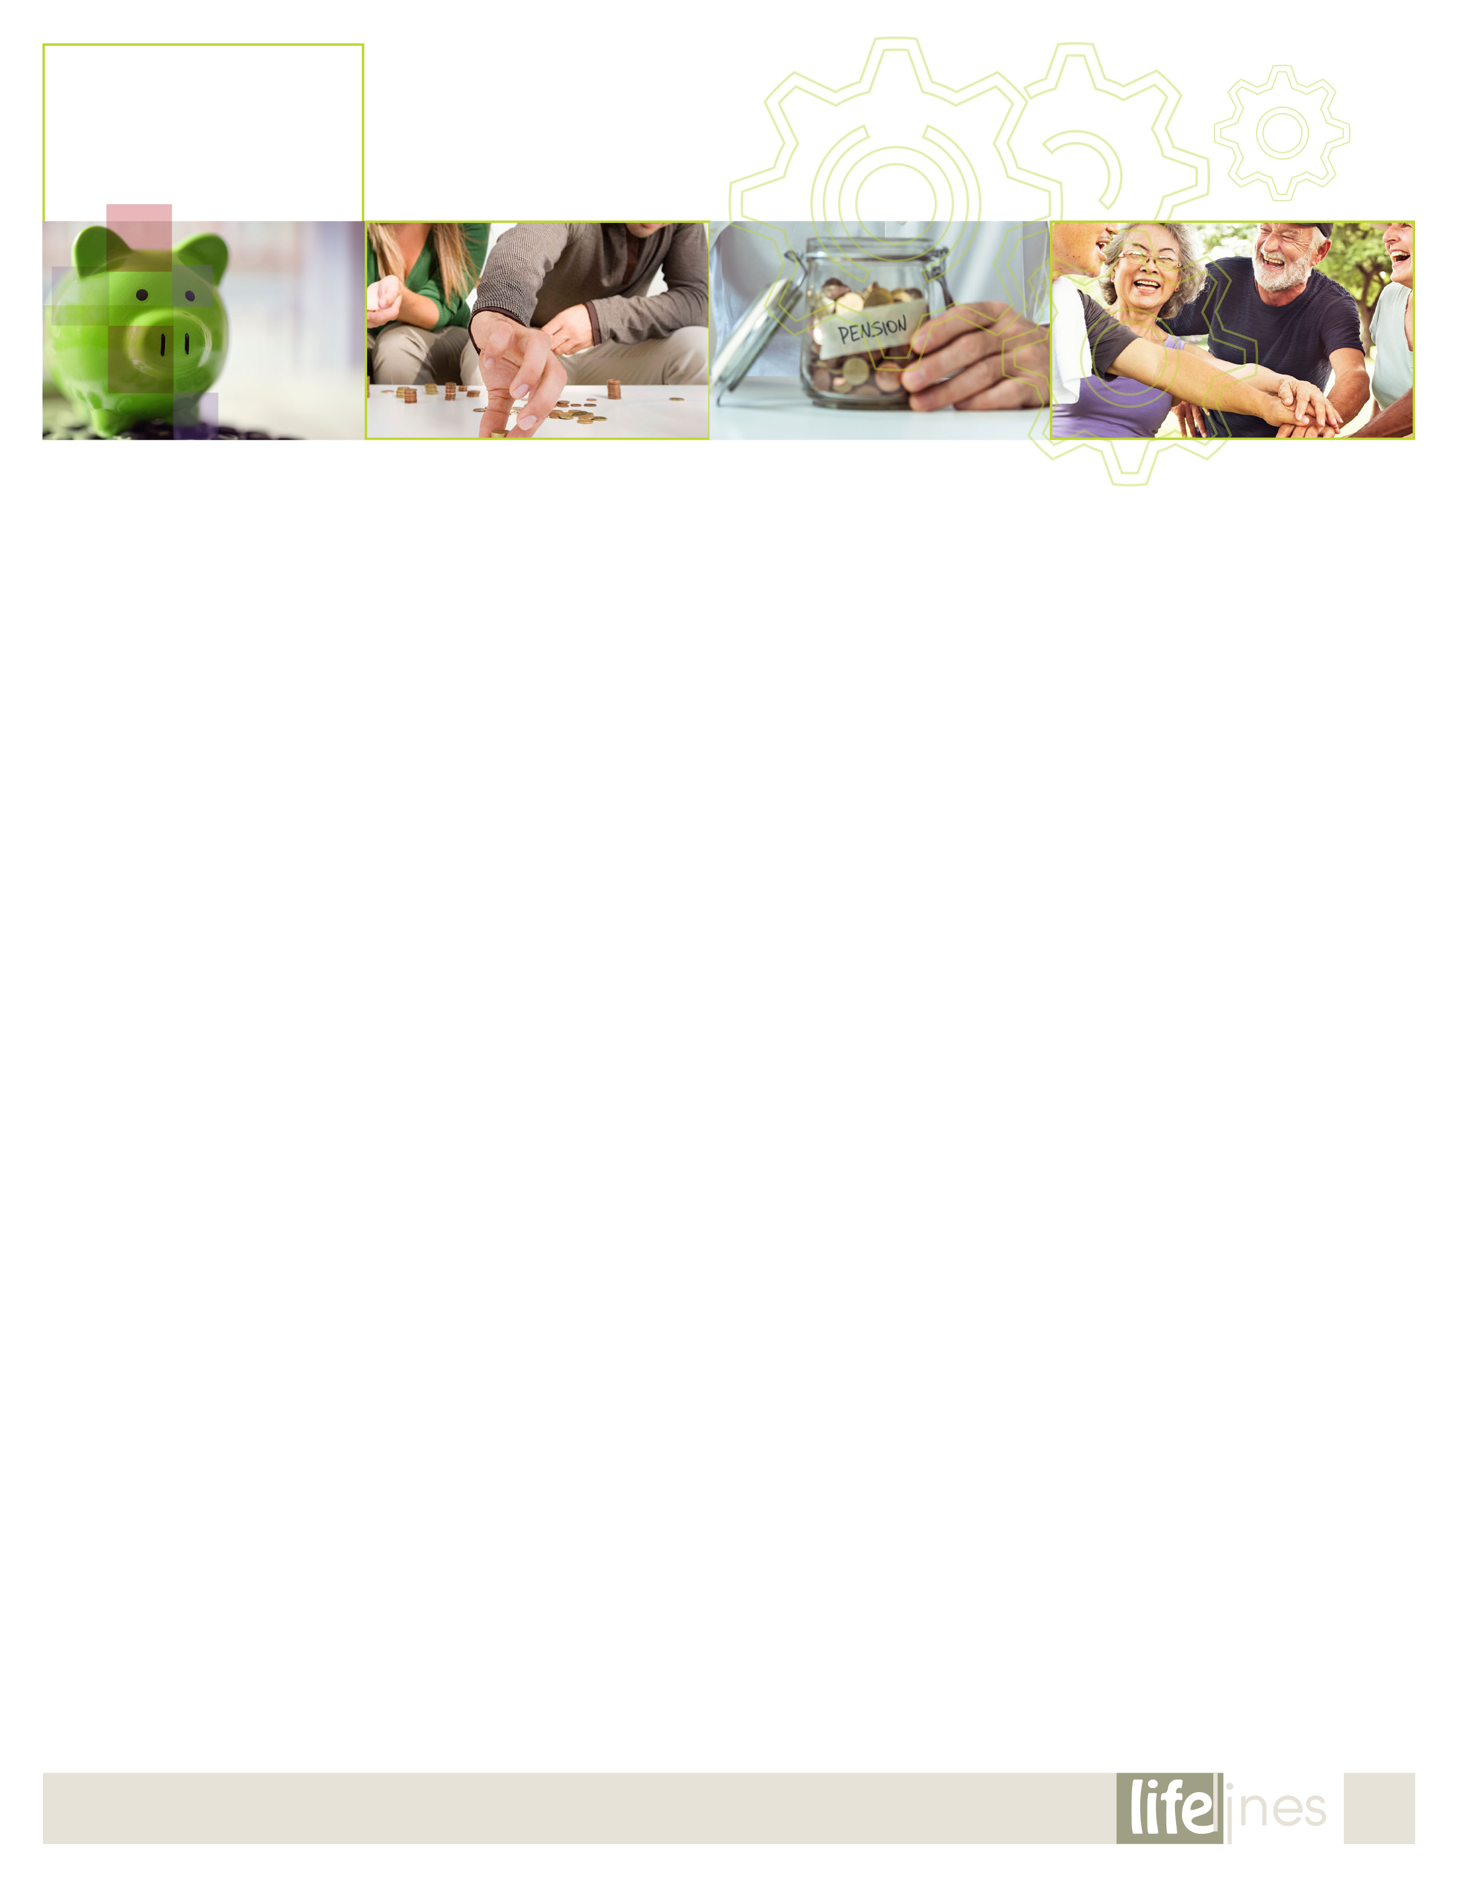

*continued on page 8*

**7**

**SPRING 2021**

RETIREMENT

Lifestyle Planning (Contd.,)

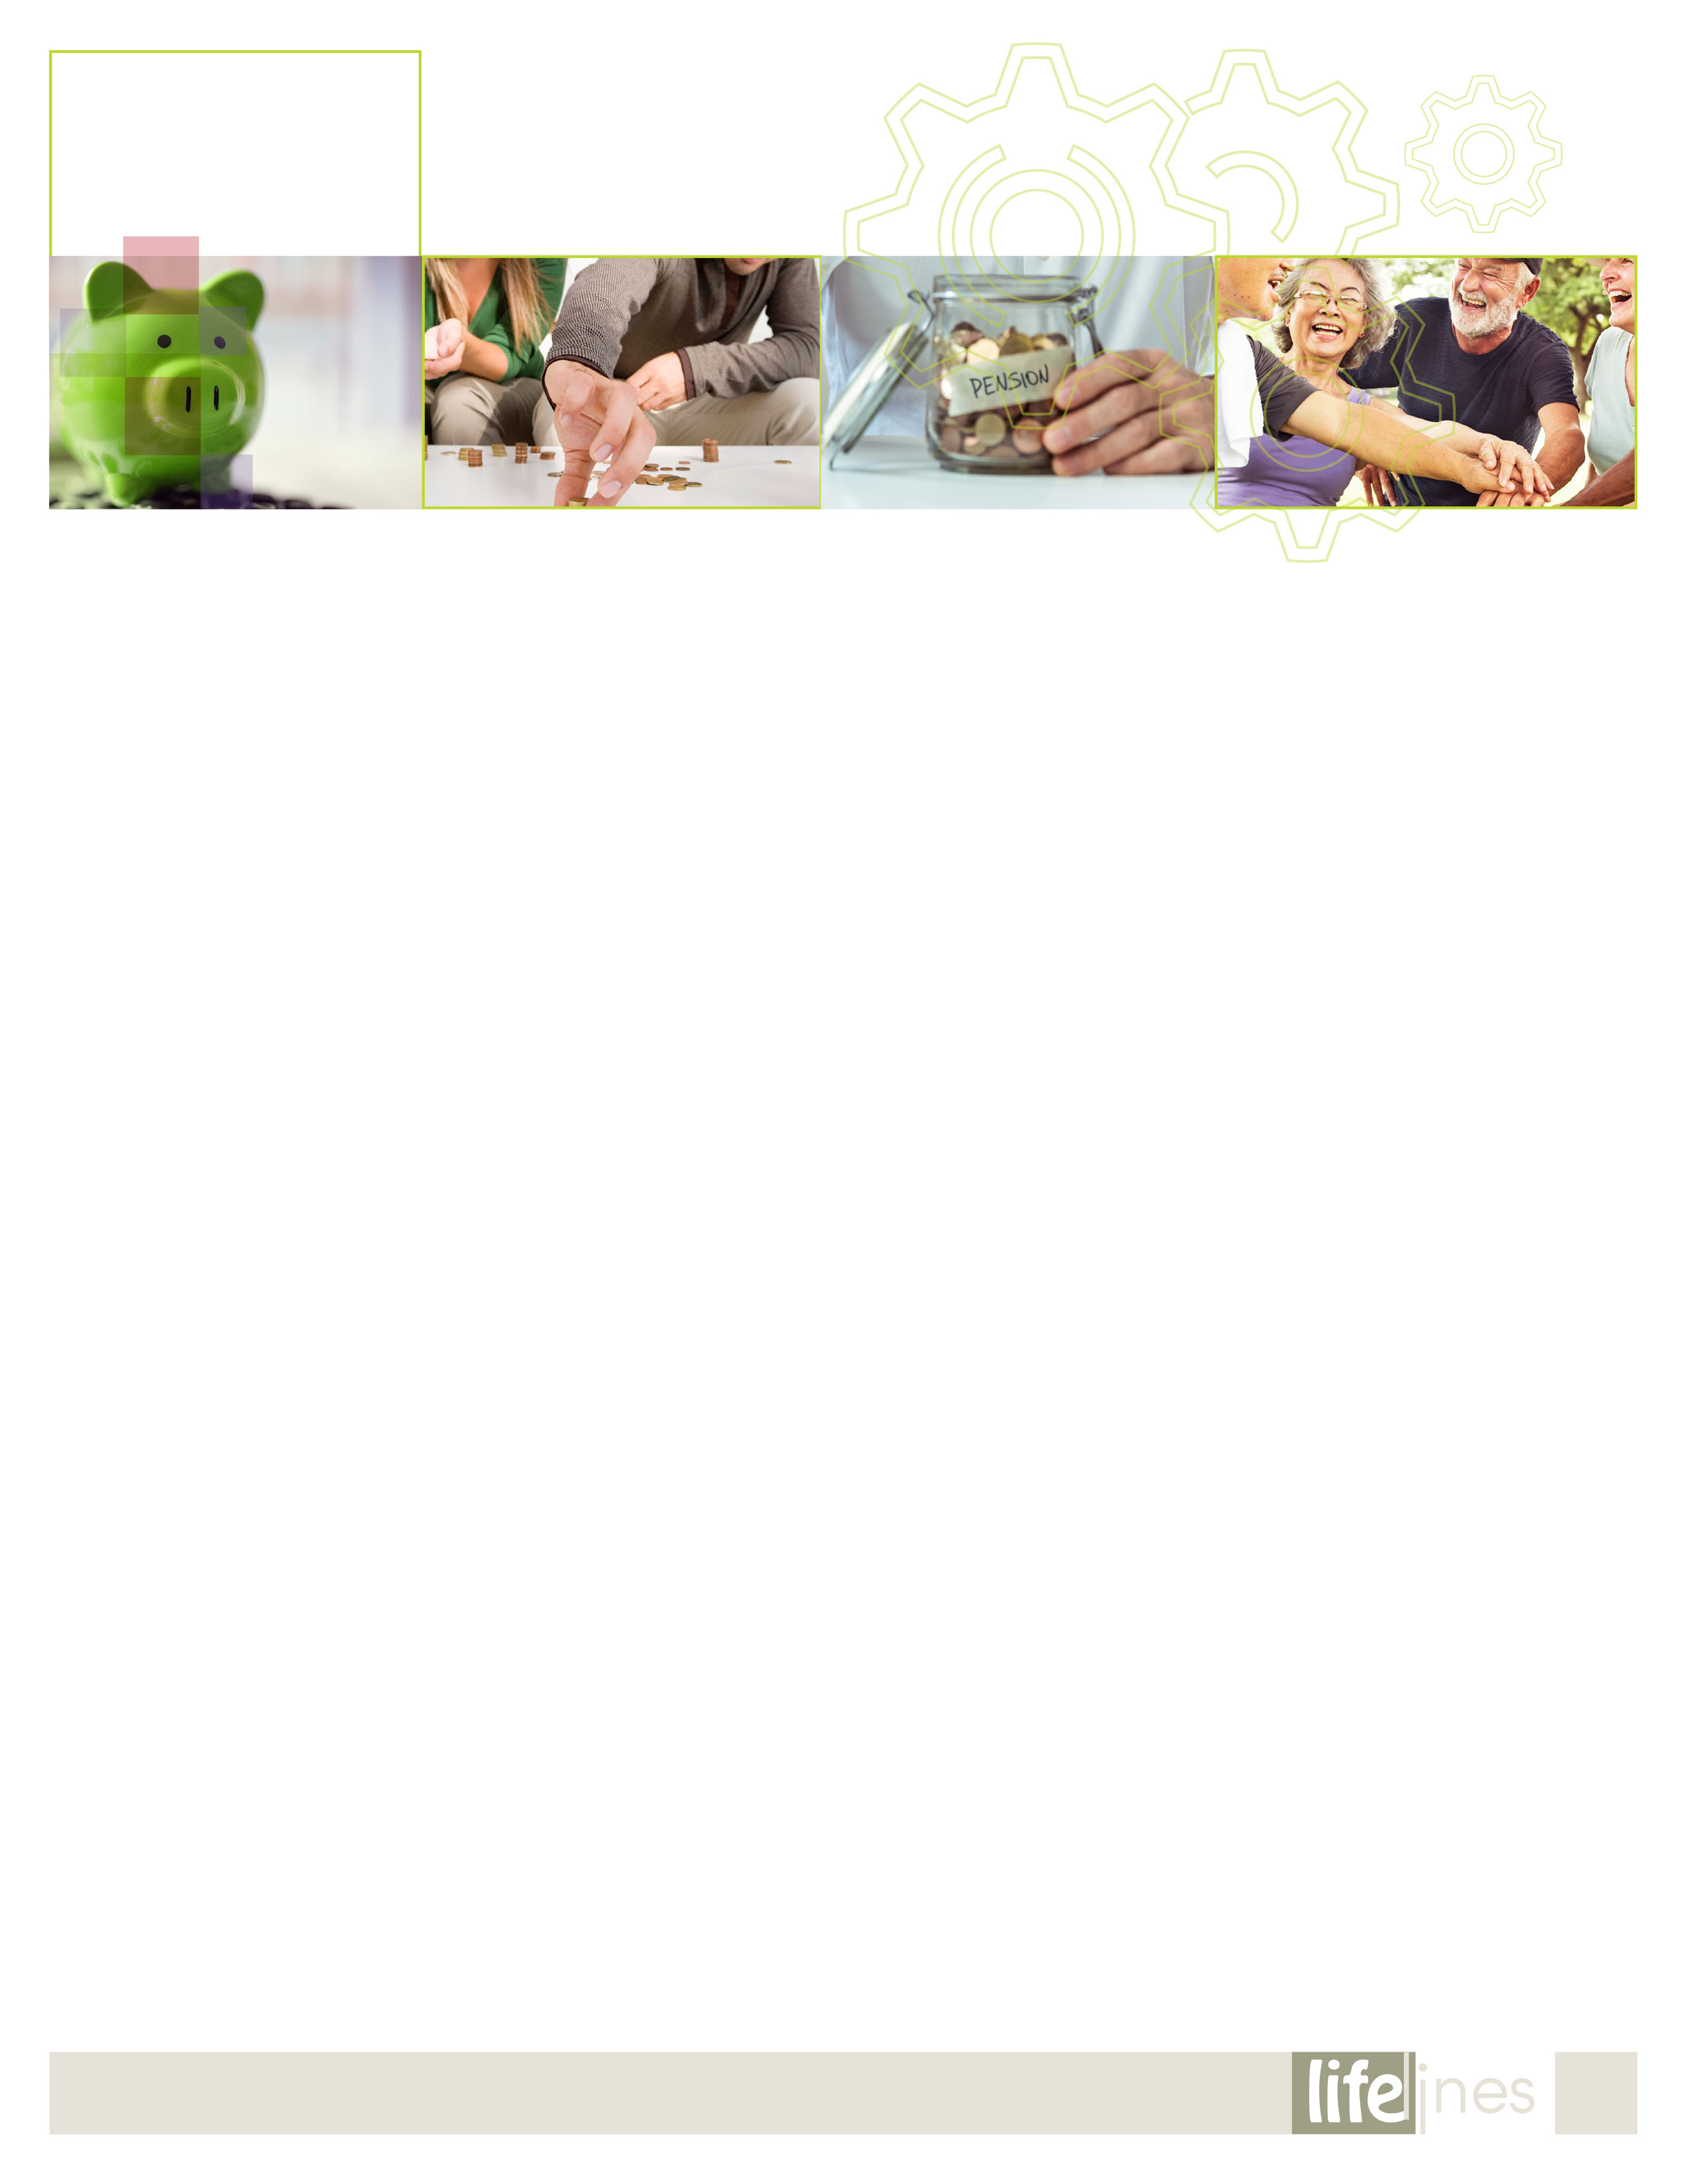

* Reflect on the decision you're planning to make: What will it feel like to take those steps and make that choice you're considering? What will it feel like not to make that choice? Is the decision you're pondering permanent or is it reversible?

Explore your options.

There are lots of options for retirees today. Be adventurous and explore them all. It's possible that an off-the-wall idea will spin into the perfect plan.

**Change your scene...permanently.**

Sometimes a job is the only thing that keeps you connected to the place where you live. After you retire, you may want to move near your family or friends, next to a golf course, beach, or on top of a mountain. When considering new locales, remember to check out the tax situation. One way to stretch your retirement dollars is to choose a location that offers residents special tax incentives. There are lots of places in the United States and abroad that offer enjoyable lifestyles and reduced taxes.

**Travel.**

Retirees can travel from home or even take their home on the road. Travel can also reduce your tax burden. Travelers can usually spend as many as 9 months in a foreign country on a tax-free visitor's visa. Banks treat yachts as homes, so why not make the boat your primary residence? That way, you can bring your home along when you travel.

**Volunteer.**

Volunteering is an excellent way to pursue an interest and be part of the community. Lend your marketing expertise to a local environmental organization or become a church deacon. Serve as a reading coach at a local school. Volunteers set their own schedules, but still have a place to report to each day or week. Volunteering also provides challenges and social connections.

Combine traveling and volunteering by joining the Peace Corps. Seven percent of Peace Corps volunteers are older than 501. If 2 years seems like too much of a commitment, consider volunteering at a park, zoo, theater group, or any other place in which you have an interest. There's even a program called RSVP (Retired Senior Volunteer Program) run by the National and Community Service's Senior Corps that focuses on volunteer opportunities for retired people. You can visit their website at <https://www.nationalservice.gov/programs/senior-corps/senior-corps-programs/rsvp> to learn more.

**Explore your spiritual needs.**

Retirement can be the perfect time to focus on spiritual journeys. Want to visit a monastery or learn to meditate? Consider international retreat centers or retreats offered through your place of worship.

**Do work your way!**

You can work for fun and money in retirement. If your favorite thing in the world is work, your dream retirement might involve a combination of part-time jobs or a new business.

If this is your dream, now is your time. In the current labor market, sometimes called the *gig economy*, temporary, flexible jobs are commonplace, and companies are trending toward hiring independent contractors or freelancers instead of full-time employees. Part-time work is also a good way to stretch your retirement dollars.

Set a course toward your goals.

After the self-evaluation process is complete, choose a plan. Don't be afraid to reconsider and revise retirement plans as your situation changes.

While exploring your options, make sure to account for transition time; to build new relationships and maintain existing ones. While you're making time to take care of business, be sure to plan for the fun things in life, too.

____________________________________________________________  
Feeley, V. & Gorman, M. (Reviewed 2019). *Lifestyle planning for retirement*. Raleigh, NC: Workplace Options.

**8**

**SPRING 2021**

RETIREMENT

Lifestyle Planning (Contd.,)

winter 2020

t

9

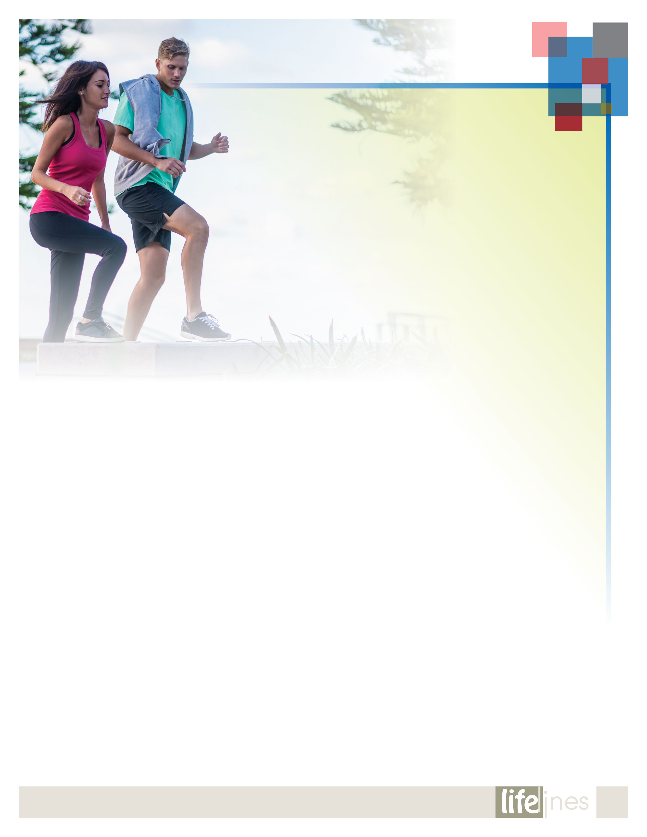

*continued on page 10*

**SPRING 2021**

**9**

How you feel can affect your ability to carry out everyday activities, your relationships, and your overall mental health. How you react to your experiences and feelings can change over time. Emotional wellness is the ability to successfully handle life's stresses and adapt to change and difficult times.

Six Strategies for Improving Your Emotional Health

**Brighten your outlook.**

People who are emotionally well, experts say, have fewer negative emotions and are able to bounce back from difficulties faster. This quality is called resilience. Another sign of emotional wellness is being able to hold onto positive emotions longer and appreciate the good times.

Here are some tips on developing a more positive mindset:

* Remember your good deeds. Give yourself credit for the good things you do for others each day.
* Forgive yourself. Everyone makes mistakes. Learn from what went wrong, but don't dwell on it.
* Spend more time with your friends. Surround yourself with positive, healthy people.
* Explore your beliefs about the meaning and purpose of life. Think about how to guide your life by the principles that are important to you.
* Develop healthy physical habits. Healthy eating, physical activity, and regular sleep can improve your physical and mental health.

**Reduce stress.**

Everyone feels stressed from time to time. Stress can give you a rush of energy when it's needed most. If stress lasts a long time, however—a condition known as chronic stress—those "high-alert" changes become harmful rather than helpful. Learning healthy ways to cope with stress can also boost your resilience. Here are some tips to help manage stress:

* Get enough sleep.
* Exercise regularly. Just 30 minutes a day of walking can boost mood and reduce stress.
* Build a social support network.
* Set priorities. Decide what must get done and what can wait. Say no to new tasks if they are putting you into overload.
* Think positive. Note what you've accomplished at the end of the day, not what you've failed to do.
* Try relaxation methods. Mindfulness, meditation, yoga, or tai chi may help.
* Seek help. Talk to a mental health professional if you feel unable to cope, have suicidal thoughts, or use drugs or alcohol to cope.

**Get quality sleep.**

To fit in everything you want to do in your day, you often sacrifice sleep. However, sleep affects both mental and physical health. It's vital to your wellbeing. When you're tired, you can't function at your best. Sleep helps you think more clearly, have quicker reflexes, and focus better. Take steps to make sure you regularly get a good night's sleep.

**Emotional**

Wellness Toolkit



**Emotional**

Wellness Toolkit

(Contd.,)

Here are some tips on getting better quality sleep:

* Go to bed the same time each night, and get up the same time each morning.
* Sleep in a dark, quiet, comfortable environment.
* Exercise daily (but not right before bedtime).
* Limit the use of electronics before bed.
* Relax before bedtime. A warm bath or reading might help.
* Avoid alcohol and stimulants such as caffeine late in the day.
* Avoid nicotine.
* Consult a health care professional if you have ongoing sleep problems.

**Be mindful.**

The concept of mindfulness is simple. This ancient practice is about being completely aware of what's happening in the present—of all that's going on inside and all that's happening around you. It means not living your life on "autopilot." Becoming a more mindful person requires commitment and practice. Here are some tips to help you get started:

* Take some deep breaths. Breathe in through your nose to a count of 4, hold for 1 second, and then exhale through the mouth to a count of 5. Repeat often.
* Enjoy a stroll. As you walk, notice your breath and the sights and sounds around you. As thoughts and worries enter your mind, note them, but then return to the present.
* Practice mindful eating. Be aware of taste, textures, and flavors in each bite, and listen to your body when you are hungry and full.
* Find mindfulness resources in your local community, including yoga and meditation classes, mindfulness-based stress-reduction programs, and books.

**Cope with loss.**

When someone you love dies, your world changes. There is no right or wrong way to mourn. Although the death of a loved one can feel overwhelming, most people can make it through the grieving process with the support of family and friends. Learn healthy ways to help you through difficult times.

**Here are some tips to help cope with loss:**

* Take care of yourself. Try to eat right, exercise, and get enough sleep. Avoid bad habits—like smoking or drinking alcohol—that can put your health at risk.
* Talk to caring friends. Let others know when you want to talk.
* Find a grief support group. It might help to talk with others who are also grieving.
* Don't make major changes right away. Wait a while before making big decisions like moving or changing jobs.
* Talk to your doctor if you're having trouble with everyday activities.
* Consider additional support. Sometimes short-term talk therapy can help.
* Be patient. Mourning takes time. It's common to have roller-coaster emotions for a while.

**Strengthen social connections.**

Social connections might help protect health and lengthen life. Scientists are finding that people's links to others can have powerful effects on health—both emotionally and physically. Whether with romantic partners, family, friends, neighbors, or others, social connections can influence our biology and wellbeing.

Here are some tips to build healthy support systems:

* Build strong relationships with your kids.
* Get active and share good habits with family and friends.
* If you're a family caregiver, ask for help from others.
* Join a group focused on a favorite hobby, such as reading, hiking, or painting.
* Take a class to learn something new.
* Volunteer for things you care about in your community, like a community garden, school, library, or place of worship.
* Travel to different places and meet new people.

___________________________________________________________  
U.S. National Institutes of Health. (Reviewed 2018, December 10). *Emotional wellness toolkit*. Retrieved 21 June 2019 from https://www.nih.gov

**10**

**SPRING 2021**