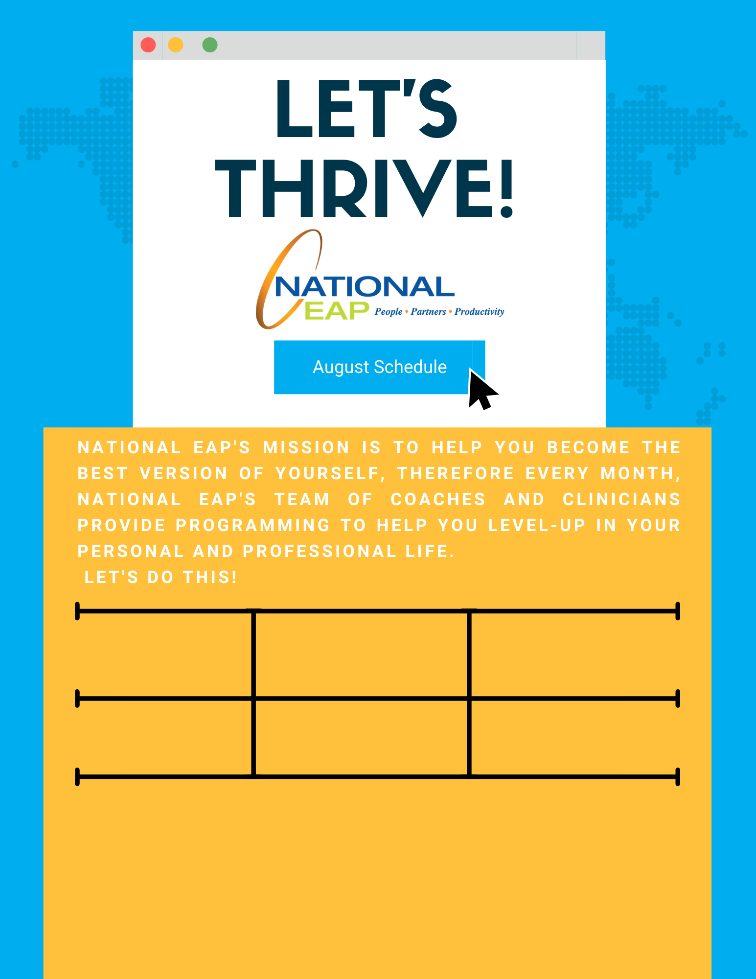

**[Register Here](https://attendee.gotowebinar.com/register/4031149793004333836)**

**Tuesday, August 24th at 12pm – 12:30pm ET**

**Thursday, August 26th at 12pm – 1pm ET**

**Problem Solving: Be Apart of the Solution**

[**Register Here**](https://attendee.gotowebinar.com/register/132146320980429580)

**Calm the Chaos: Restoring Balance in Your Life**

**Toll-free: 800-624-2593  
Email:** [**info@nationaleap.com**](mailto:info@nationaleap.com) **Website:** [**www.nationaleap.com**](http://www.nationaleap.com) **USERNAME: Your Company Name  
PASSWORD Your Company Name**