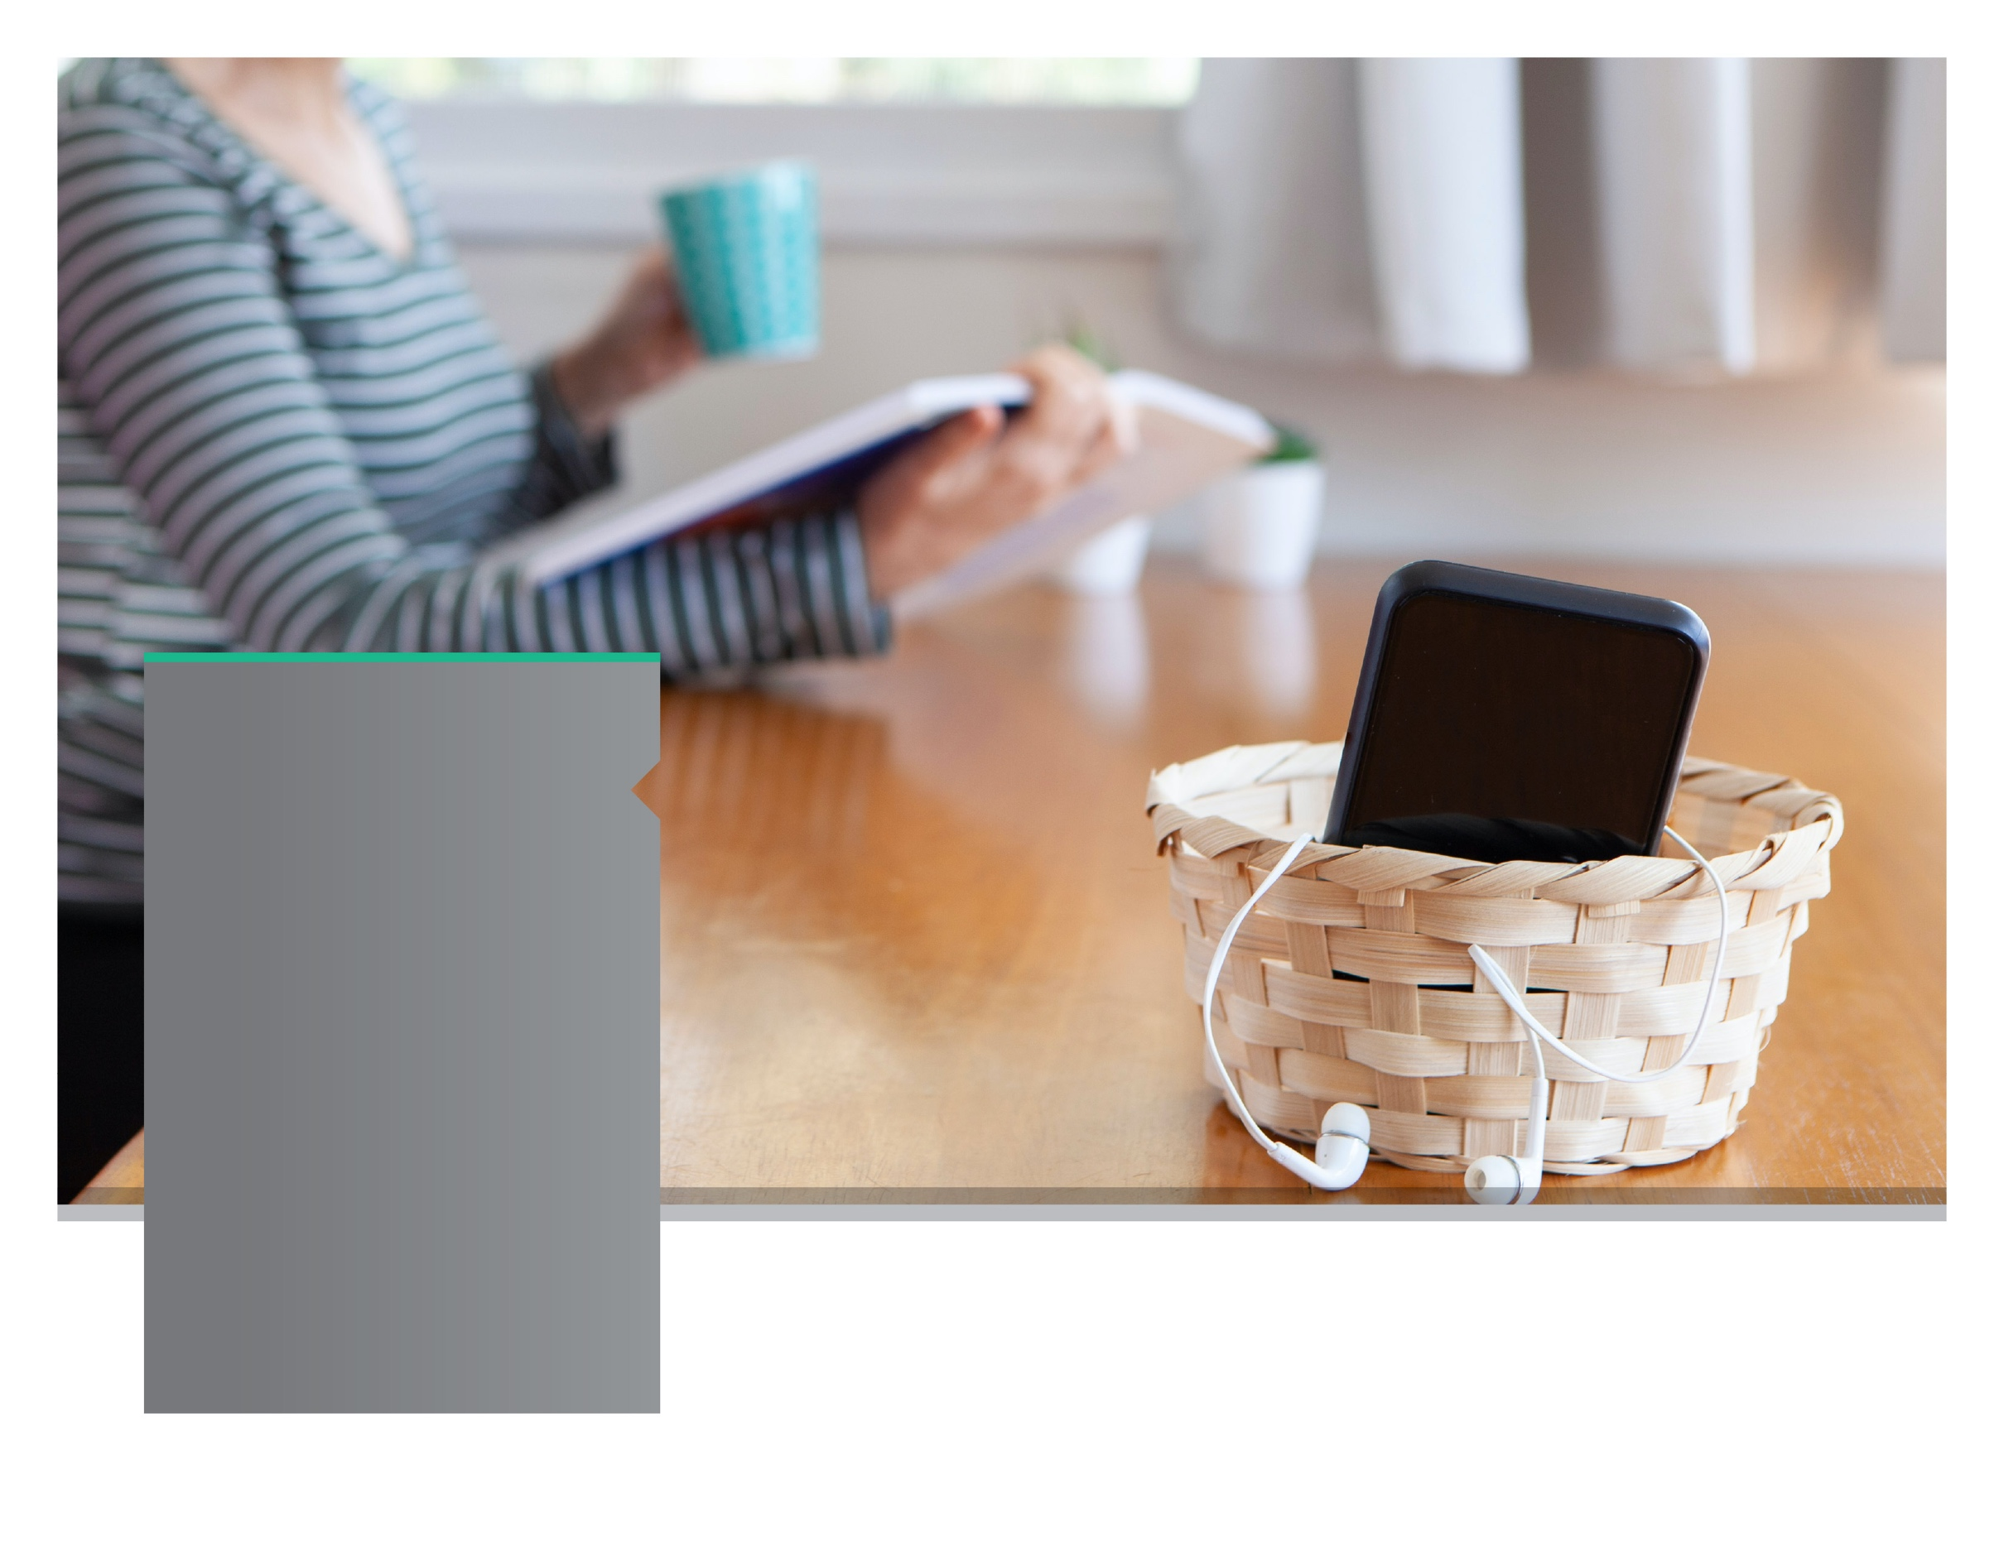

**SEPTEMBER 2021**

**SEPTEMBER 2021**

Technology Time Out

Reducing technology overload

Don't miss out by being stuck on your devices. Schedule 'no technology time', learn to be present, and learn mindfulness practices.

LET US HELP

TOLL-FREE: enter your toll-free number here

WEBSITE: enter your website URL here

USERNAME: username

PASSWORD: password

Always Available | Free | Confidential

**YOUR EMPLOYEE**

**SUPPORT PROGRAM**

**YOUR EMPLOYEE**

**SUPPORT PROGRAM**