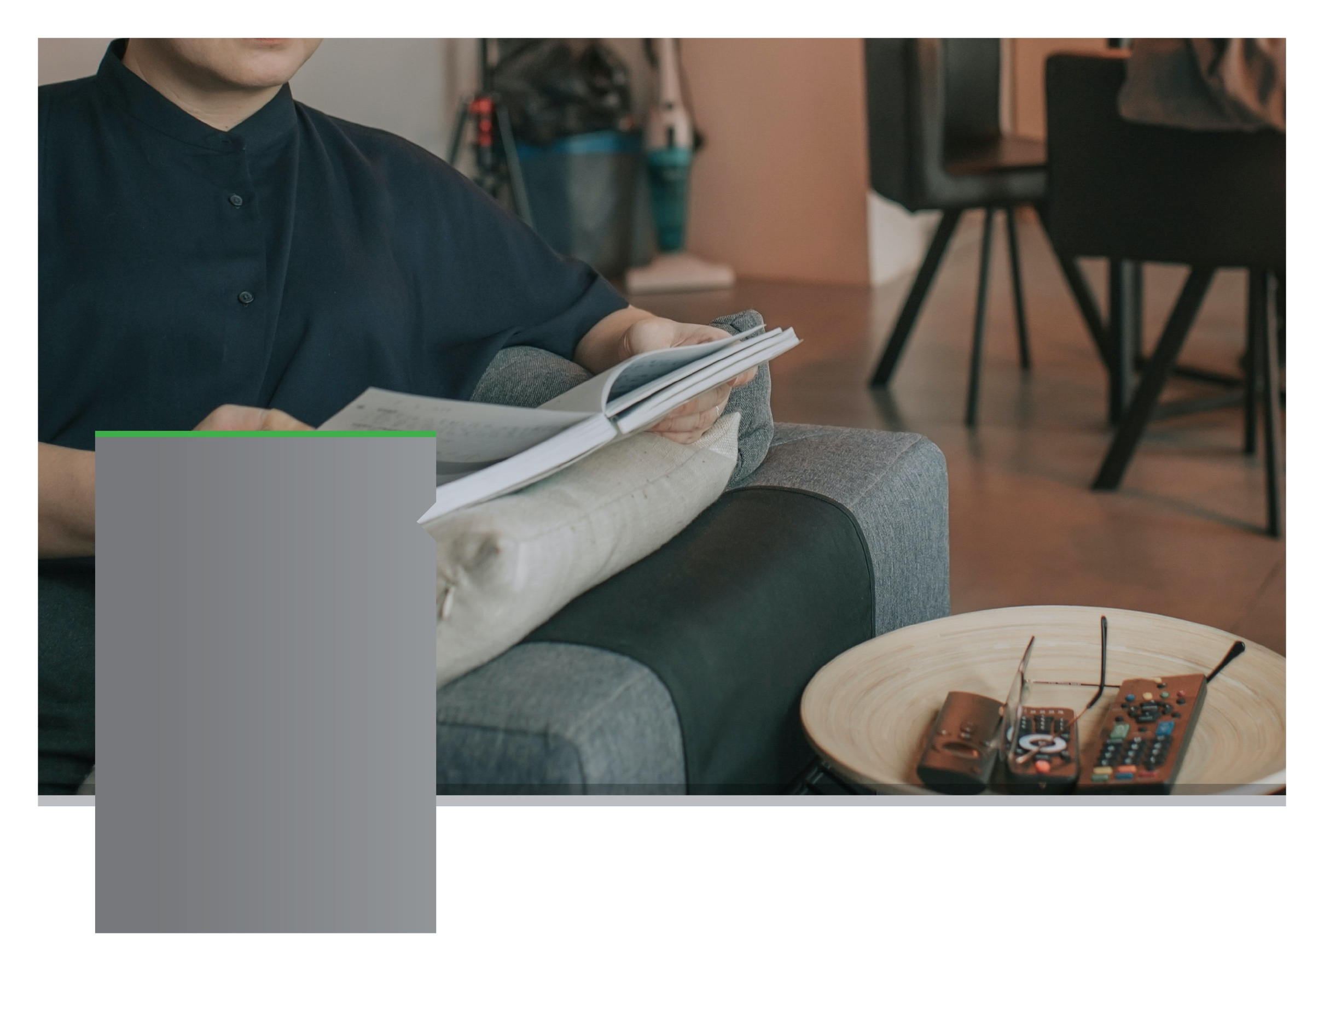



Switch on to Being More Present

ONLINE SEMINAR

Reducing technology overload

Discover the key to being more present and actively taking the time to digitally disconnect to spend quality time with those around you.

**SEPTEMBER 2021**

**YOUR EMPLOYEE**

**SUPPORT PROGRAM**

Visit your home page starting September 21st

WEBSITE: www.workplaceoptions.com

*Click on “Member Benefits Website” at the top of the web page.*

USERNAME: username

PASSWORD: password

LET US HELP

Always Available | Free | Confidential

**SEPTEMBER 2021**

**YOUR EMPLOYEE**

**SUPPORT PROGRAM**