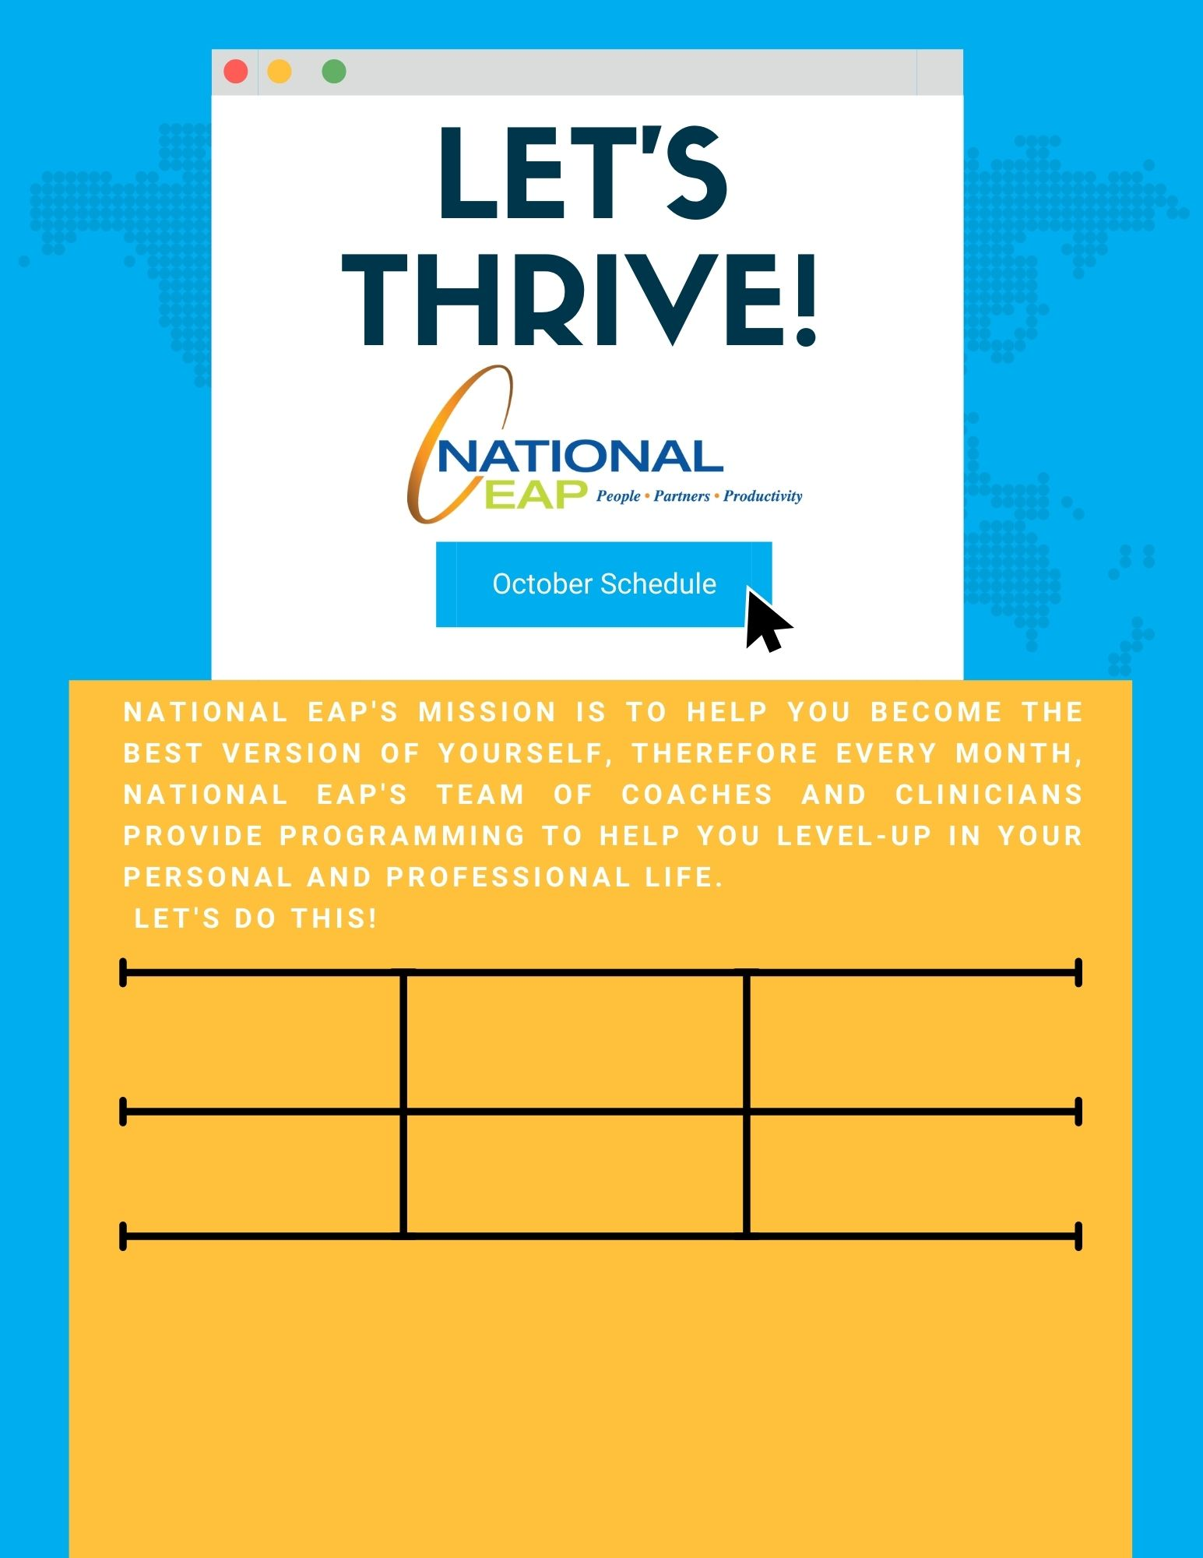

**Thursday, October 21st at 12pm – 1pm ET**

**Thursday, October 21st at 12pm – 1pm ET**

**Cultivating Wellness: Health is Wealth**

**Tuesday, October 19th at 12pm – 12:30pm ET**

[**Register Here**](https://attendee.gotowebinar.com/register/8113756315098445072)

**Building and Cultivating Trust**

[**Register Here**](https://attendee.gotowebinar.com/register/6628594282414889232)

**Toll-free: 800-624-2593  
Email:** [**info@nationaleap.com**](mailto:info@nationaleap.com) **Website:** [**www.nationaleap.com**](http://www.nationaleap.com) **USERNAME: Your Company Name  
PASSWORD Your Company Name**