

LET US HELP

TOLL-FREE: 800-624-2593

WEBSITE: www.nationaleap.com

USERNAME: YOUR COMPANY NAME

PASSWORD: YOUR COMPANY NAME

Always Available | Free | Confidential

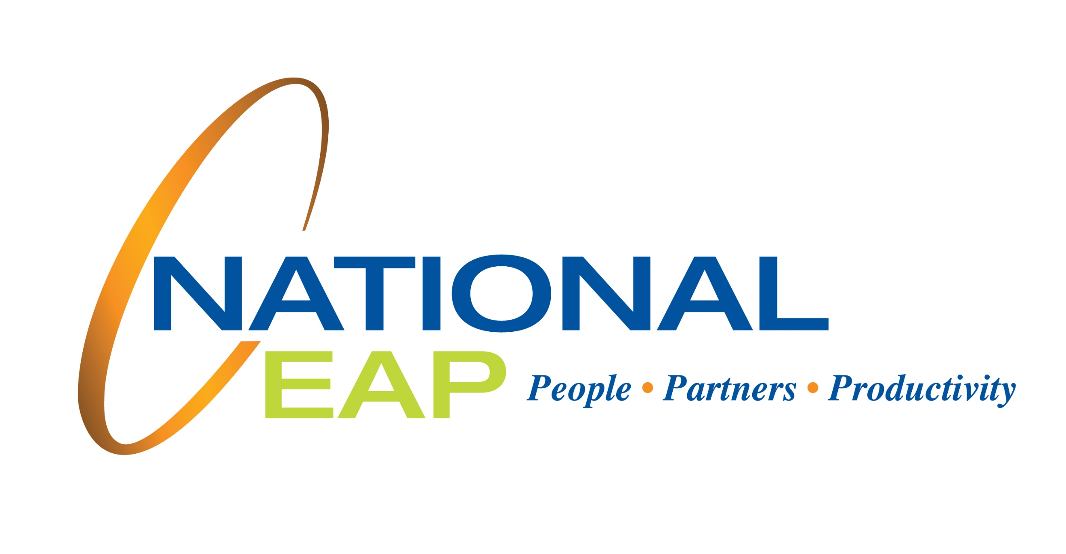

Perspective and Reframing

Approaching 2022 with a fresh perspective

Reframing is a good way to check in with yourself and see a situation differently. We can help you think about things realistically with a positive focus.

JANUARY 2022

YOUR EMPLOYEE ASSISTANCE PROGRAM