

JANUARY 2022

Reframing Your Way Through 2022

ONLINE SEMINAR

Starting the year in the right mindset

Learn practical steps to use positive reframing strategies to guide your way through 2022.

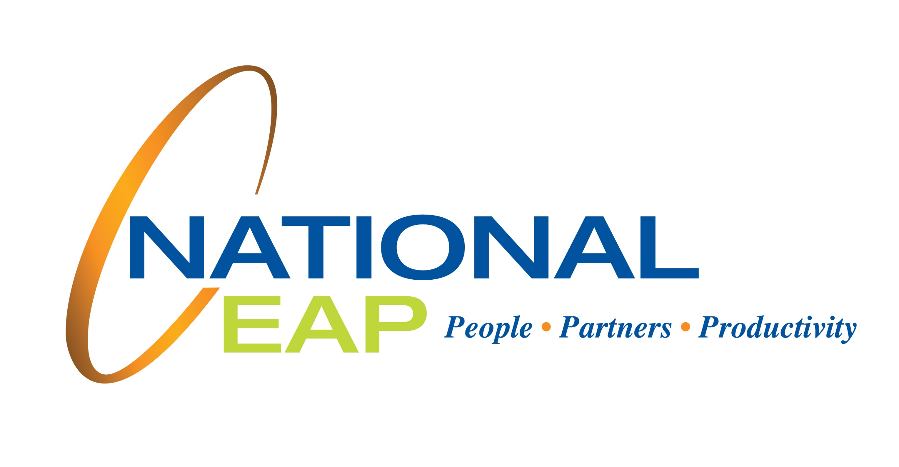

LET US HELP

Visit your home page starting January 18th

WEBSITE: www.nationaleap.com

USERNAME: YOUR COMPANY NAME

PASSWORD: YOUR COMPANY NAME

Always Available | Free | Confidential

YOUR EMPLOYEE ASSISTANCE PROGRAM