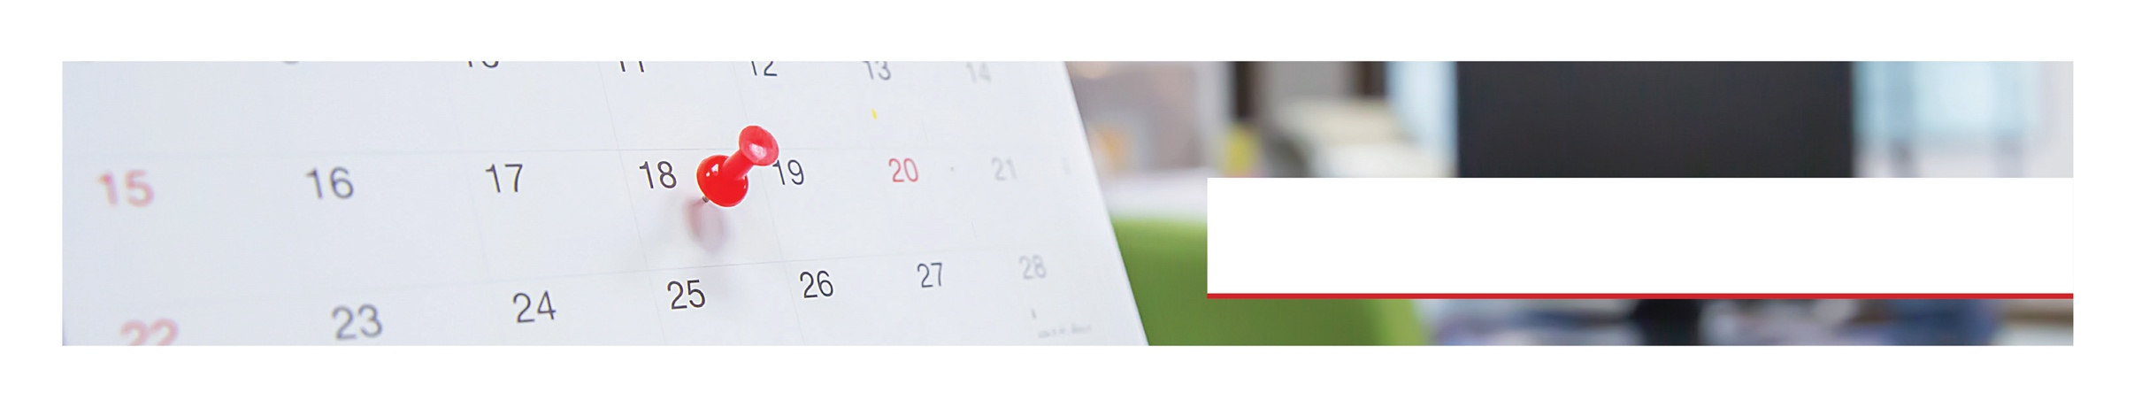

|  |  |  |  |
| --- | --- | --- | --- |
|  | **THEME** | **ONLINE SEMINAR\***  *For clients with Advantage Complete or Enhanced Web | **DESCRIPTION**  Seminars can be found on your home page, or you can search for them by title. |
| JAN | **Getting Into the Right  Frame of Mind for 2022** | ***Reframing Your Way Through 2022***  Available on Demand Starting **Jan 18th** | Learn practical steps to use positive reframing strategies and guide your way through 2022. |
| FEB | **Honoring Grief and Loss** | ***Navigating Through Grief and Loss***  Available on Demand Starting **Feb 17th** | Discover ways to say goodbye and going through five stages of grief in a healthy way. |
| MAR | **Engagement** | ***From Tired to Inspired: Keeping Engaged and Preventing Burnout***  Available on Demand Starting **Mar 17th** | Learn how to get around burnout, prevent it, and keep yourself engaged in work and personal life. |
| APR | **Finding a Hobby** | ***Finding a Hobby: How It Impacts Your Life***  Available on Demand Starting **Apr 19th** | Understand the importance of having a hobby and how you can start finding one  to help you feel happier. |
| MAY | **Getting a Good Night’s Sleep** | ***Sleep Essentials***  Available on Demand Starting **May 17th** | Explore strategies to start a healthy bedtime routine to help you reduce stress  and improve your wellbeing. |
| JUN | **Exploring Nature** | ***Finding Yourself Through Nature***  Available on Demand Starting **Jun 21st** | Discover the importance of being outside and find your own way to enjoy nature and increase your wellbeing. |
| JUL | **Digital Health** | ***Unplugged: Digital Detoxing***  Available on Demand Starting **Jul 19th** | Find the reasons why we need to do digital detox and learn practical steps on  how to start incorporating it into your schedule. |
| AUG | **Self-Care Strategy** | ***Self-Care: Better Care of Yourself***  Available on Demand Starting **Aug 16th** | Identify the ways to implement self-care as a part of your schedule and learn the art of slowing down. |
| SEP | **Open Communication** | ***Open Communication: Powerful Ways to Create It***  Available on Demand Starting **Sep 20th** | Attain the skills to have open and effective communication at work and at home. |
| OCT | **Navigating Holidays** | ***Navigating Your Holidays***  Available on Demand Starting **Oct 18th** | Learn some effective ways to plan, organize, and make the most of your holiday. |
| NOV | **Overtime:  Working Caregivers** | ***The Sandwich Generation at Work***  Available on Demand Starting **Nov 22nd** | Find out some practical and effective strategies to balance your work and personal  life as the sandwich generation. |
| DEC | **Taking Control of Stress** | ***Stress Buster:  Managing and Taking Control of Your Life***  Available on Demand Starting **Dec 21st** | Manage your stress in a healthier way and learn some strategies to take  control of your life. |

Always Available | Free | Confidential

**LET US HELP**

**TOLL-FREE:** 800-624-2593

**WEBSITE:** www.nationaleap.com

**USERNAME:** username | **PASSWORD:** password

# **2022** Calendar

**Managing Your Money**