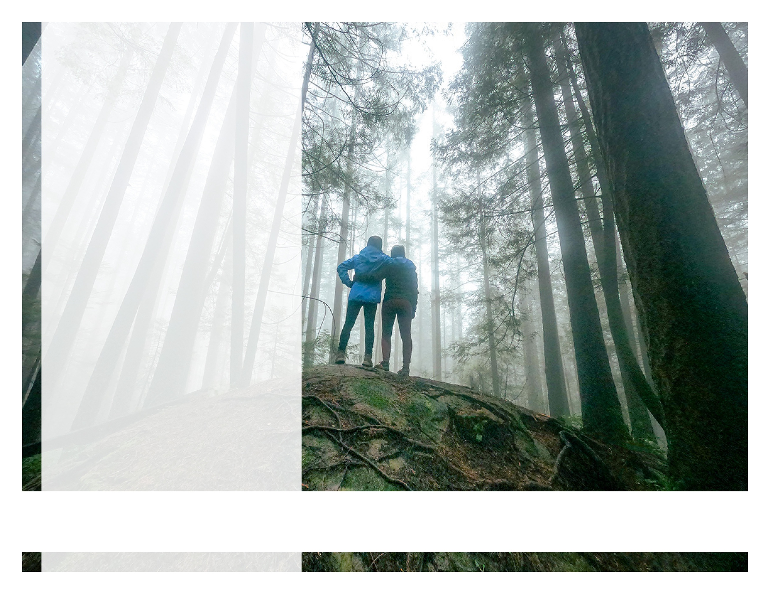

Finding Yourself Through Nature

ONLINE SEMINAR

Taking the path less traveled

Discover the importance of being outside and find your own way to enjoy nature, and increase your wellbeing.

JUNE 2022



LET US HELP

Visit your home page starting June 21st

WEBSITE: www.nationaleap.com

USERNAME: YOUR COMPANY NAME

PASSWORD: YOUR COMPANY NAME

Always Available | Free | Confidential

YOUR EMPLOYEE ASSISTANCE PROGRAM