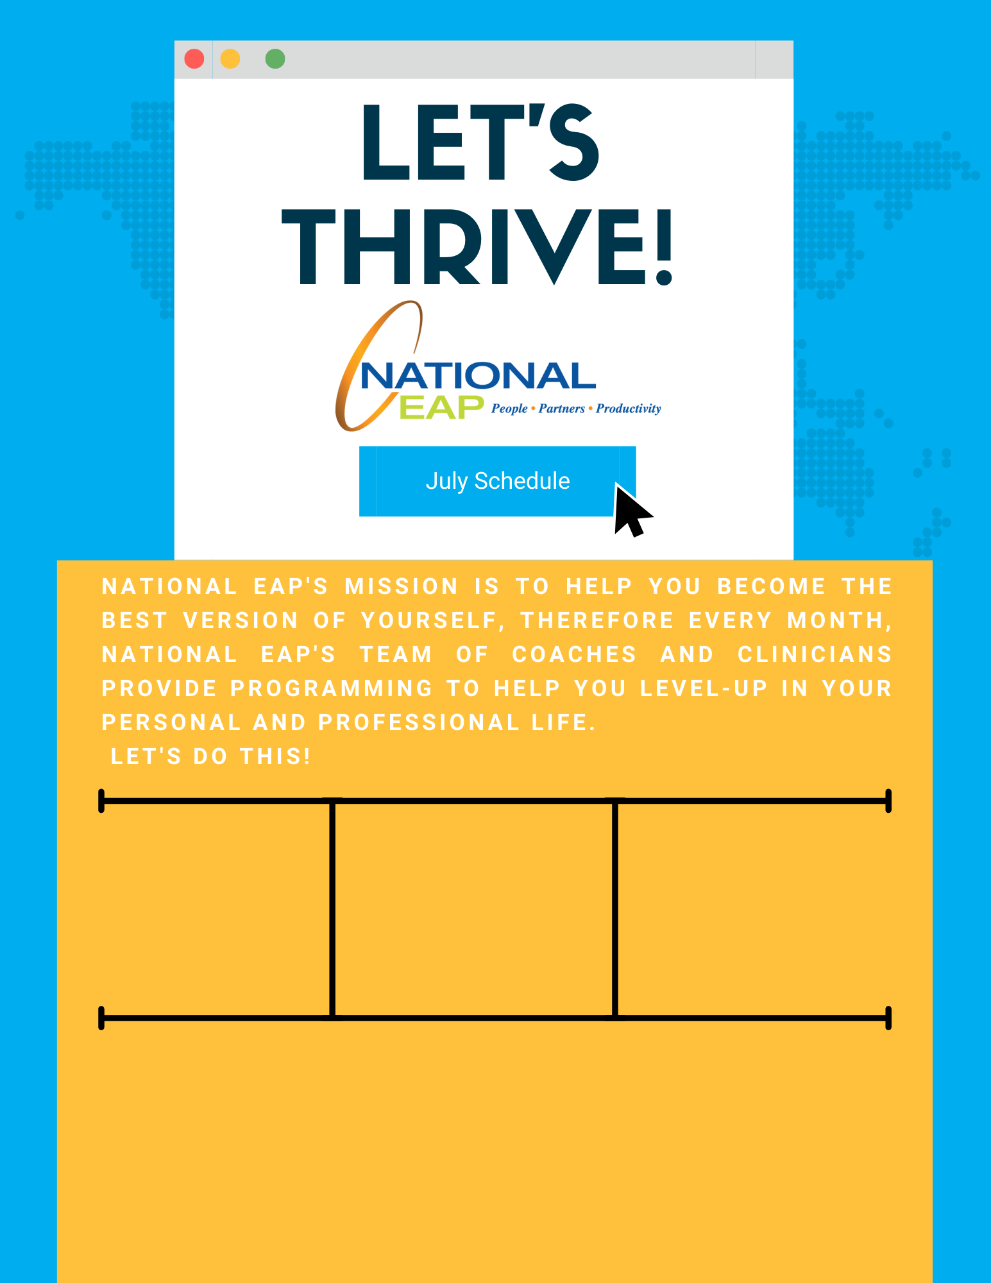

**The Emotion Ocean with eM Life’s Jim Austin**

**Thursday, July 14th at 12:00 pm EDT- 12:30pm EDT**

[**Register Here**](https://emindful.webex.com/emindful/k2/j.php?MTID=t9498495552e1814747ce8bb2514efccb)

**Toll-free: 800-624-2593  
Email:** [**info@nationaleap.com**](mailto:info@nationaleap.com) **Website:** [**www.nationaleap.com**](http://www.nationaleap.com) **USERNAME: Your Company Name  
PASSWORD Your Company Name**