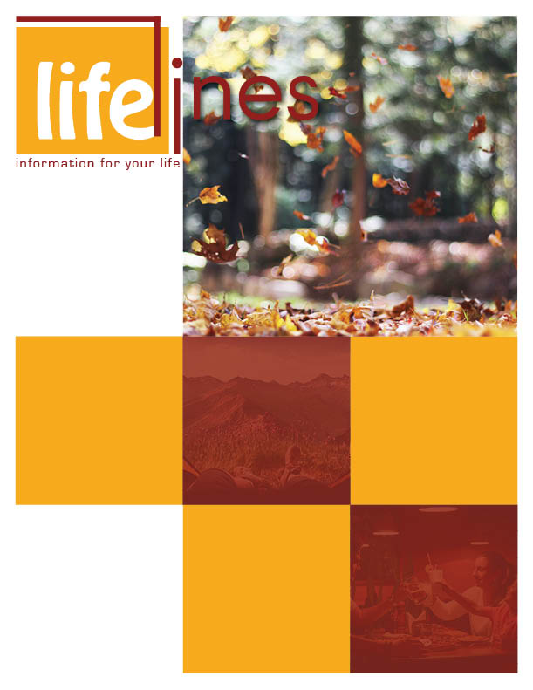

**FALL ISSUE**

**SELF-CARE FOR THE CAREGIVER**

# **PG: 4**

**SUCCESSFUL COMMUNICATION WITH YOUR CHILDREN**

# **PG: 9**

**NAVIGATE STRESS THIS SEASON WITH A HOLIDAY ROADMAP**

# **PG: 2**

**FEELING STRESSED?**

# **PG: 6**

# 2022

**Contact Us**

TOLL-FREE: **800-624-2593**

www.nationaleap.com

USERNAME: **username**

PASSWORD: **password**

**'Tis the season for family get-togethers and Hallmark family movies, but for many employees the holiday season can be the most difficult time of the year—especially with all the challenges and limitations on in-person contact coronavirus can bring. The need for emotional support, specifically for anxiety and depression, often quadruples from October through December each year.**

There are a number of reasons why people struggle more emotionally during the holidays, beginning with the season itself. In many parts of the world, daylight is shorter and temperatures are colder this time of year, resulting in less time spent outdoors or doing physical activity.

The sheer busyness of the holidays is another common stress factor. Not only are there more errands to run (i.e. presents to buy, packing to do), but the calendar is usually full of concerts, parties, and family commitments. The COVID-19 pandemic brings a whole new set of concerns, such as worries about your or a loved one's health, increased stress about whether or not to travel, or grief at missing the usual in-person holiday festivities.

Anxiety over finances is also common during the holidays. The push to buy and spend begins weeks before Black Friday and lasts all season long. You may feel bad for spending too much and going overboard or worry that you haven't spent enough and fear disappointing people.

For those grieving a personal loss, the season is particularly difficult. Whether someone is grieving the absence of a family member who has passed or one that is just no longer present in their lives, or they are experiencing grief from not being able to meet with loved ones this year, thinking of families celebrating together can trigger painful emotions.

According to Shannon LaRance, Licensed Clinical Social Worker Associate (LCSWA) and a clinical counselor with Workplace Options, the holiday season sets up unrealistic expectations, leaving many people feeling overwhelmed, disappointed, and often lonely. "People put a lot of pressure on themselves to create picture-perfect holiday memories," shares Shannon. "But the expectations are impossible to live up to."

When Shannon is providing support to someone struggling with anxiety due to the holidays, she encourages them to develop their own personal roadmap for the season. "A *holiday roadmap* encourages people to think through their schedule and decide in advance what their holiday will look like," shares Sharon.

Below are five tips that Shannon suggests for developing a healthy, holiday roadmap.

1. **Set realistic expectations for your time and energy.** By the end of the holidays people are exhausted because they have simply tried to do too much. Decide in advance what events you really want to attend (if any), and politely decline the others. Give yourself the freedom to say no without guilt. For "pandemic-safe" holiday plans, get creative and come up with alternative traditions to your usual events: Set up virtual meetups, send gifts in the mail, or limit your gathering to a small social bubble where everyone has taken thorough precautions. Don't feel bad if you aren't seeing anyone: Health and safety are the most important things.
2. **Set realistic expectations for your finances.** Decide on a budget that is reasonable. Don't get roped into the commercialism of the season. It's about thoughtful, meaningful gifts, not the price tag. Make homemade presents, like recipes, photo albums, or other crafts.
3. **Surround yourself with healthy people.** Make an effort to spend time with people who encourage and support you, not only in-person but also via phone and social media. Avoid toxic people, even if that means declining some holiday invitations or limiting virtual communication with certain individuals or groups. If you are dealing with grief or addiction, consider joining a support group so you can communicate with people sharing similar struggles; most organizations have set up special online, telephone, and email support systems.
4. **Take care of yourself physically.** Don't sacrifice sleep in an effort to get things done. Instead, recognize that you need rest to be able to recharge. Aim to eat healthy, and try to stock your fridge with nutritious options (and fewer sugary snacks). Avoid excessive consumption of alcohol.
5. **Take care of yourself emotionally.** Schedule quiet time for yourself daily to unplug and unwind. During this time, you may choose to walk, journal, meditate, or practice mindfulness.  
   Shannon adds that ultimately you get to choose what kind of holiday season you want, so make it your own!

Workplace Options. (Revised 2022, May [Ed.]). *Navigate stress this season with holiday roadmap* (Z. Meeker & B. Schuette, Eds.). Raleigh, NC: Author. Retrieved May 17, 2022, from https://www.workplaceoptions.com

*continued on page 3*

**NAVIGATE STRESS THIS SEASON WITH A HOLIDAY ROADMAP**

**FALL 2022**

**2**

**NAVIGATE STRESS THIS SEASON WITH A HOLIDAY ROADMAP**

(Contd.,)

**3**

**FALL 2022**



***Caring for an aging spouse or relative can be an incredibly rewarding experience. For many however, it is also a source of great stress.***

Caring for an aging spouse or relative can be an incredibly rewarding experience. For many however, it is also a source of great stress. This stress can lead to feelings of anger and guilt. These feelings can get in the way of successful caregiving, and may even impact your health. If you are a caregiver, it is important to learn that you cannot take care of others unless you take care of yourself as well.

**Your feelings are important.**Many caregivers feel guilty about expressing feelings of anger or resentment. It is very common to have these feelings and it is important that you acknowledge them so that you can seek out the help you need:

* Recognize your limitations.
* Ask for help when it is needed.
* Attend a support group.
* Keep friends and family in your life.
* Communicate your feelings.

**Learn how to accept help.**

There may be many reasons for rejecting help that may be offered from friends and family. You might feel that it is your duty alone to take care of your family member, or that you don't want to be a burden on others. Accepting help from others can allow you more time for yourself. This will make you a better caregiver:

* Accept acknowledgment when it is given to you.
* When someone offers help, be specific about what they can do. Help with the marketing or meal preparation can leave you with more time for yourself.
* Allow yourself to be proud of all the things you do for others and don't dwell on the things you aren't able to do.

**There is support for you out there.**

Meals-on-Wheels ([https://www.mealsonwheelsamerica.org](https://www.mealsonwheelsamerica.org/)), in-home care agencies, and adult day programs are only a few of the many support services available when you are taking care of an aging family member. Finding appropriate services can be as much an act of caregiving as providing them yourself:

* Contact your Employee Assistance Program (EAP) for assistance in finding help.
* Find the local Area Agency on Aging (https://www.n4a.org) office that serves your community. They have a wealth of information on local resources. Your EAP consultant can assist you in finding your local office and help you to access services.
* Network with other caregivers to find out what services help.
* Remember: Allowing help from outside sources is a way to take care of you.

**Recharge your batteries.**

Do you have hobbies or leisure time activities that you don't seem to have time for anymore? Will talking to a counselor or attending a support group meeting help your mood? It is important that you do things you enjoy. Taking care of yourself means replenishing your spirit as well:

* A simple walk around the neighborhood can feel like a mini-vacation.
* Read a book or watch a movie you enjoy.
* Arrange to meet a friend, even if it is only for a few minutes.
* Use time away from your caregiving duties to do special things for yourself, not to run errands.

Workplace Options (WPO). (Revised 2019). *Self-care for the caregiver*. Raleigh, NC: Author.

**SELF-CARE FOR THE CAREGIVER**

**FALL 2022**

**4**

*continued on page 5*



**FALL 2022**

**5**

**SELF-CARE FOR THE CAREGIVER**

(Contd.,)

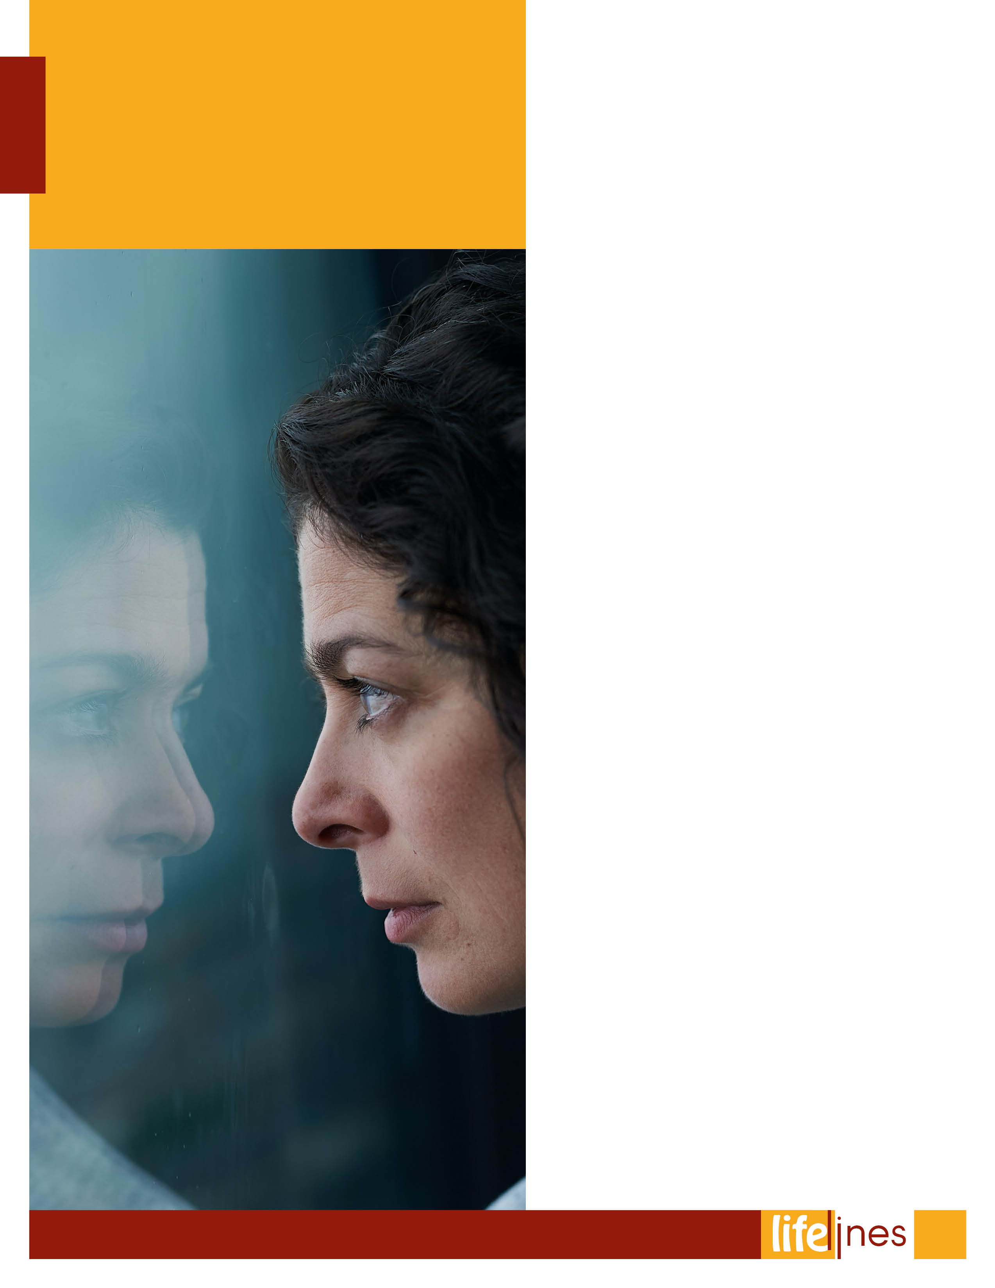

**FEELING STRESSED?**

**STRESS RELIEF MIGHT HELP YOUR HEALTH!**

Winter holidays—do they fill you with joy or with worries about gift-giving and family gatherings? Do summer vacations leave you relaxed or fretful over travel and money? If you're feeling stressed out over supposedly fun things, it might be time to reassess. Take a few moments to learn how stress affects your health and what you can do about it.

Everyone feels stressed from time to time. Stress can give you a rush of energy when it's needed most—for instance, competing in sports, working on an important project, or facing a dangerous situation. The hormones and other chemicals released when under stress prepare you for action. You breathe faster, your heartbeat quickens, blood sugar rises to give you energy, and your brain uses more oxygen as it shifts into high alert.

If stress lasts a long time, however—a condition known as *chronic stress*—those "high-alert" changes become harmful rather than helpful. "Stress clearly promotes higher levels of inflammation, which is thought to contribute to many diseases of aging. Inflammation has been linked to cardiovascular disease, diabetes, arthritis, frailty, and functional decline," says Dr. Janice Kiecolt-Glaser, a leading stress researcher at Ohio State University. She and other researchers have found that stress affects the body's immune system, which then weakens your response to vaccines and impairs wound healing.1

Research has linked chronic stress to digestive disorders, urinary problems, headaches, sleep difficulties, depression, and anxiety.

"Some studies have found the physical, emotional, and social effects of a disease like cancer to be stressful for patients, caregivers, and long-term cancer survivors," says Dr. Paige Green McDonald, an expert on stress and cancer biology at the U.S. National Institute of Health (NIH). "However, there's no definitive evidence that stress causes cancer or is associated with how long one survives after a cancer diagnosis."

The top causes of stress in the U.S. are money and work-related pressures, according to a 2013 survey from the American Psychological Association.2 Stress can also arise from major life changes, such as the death of a loved one, divorce, illness, or losing a job. *Traumatic stress* is brought on by an extreme event such as a major accident, exposure to violence, or a natural disaster such as a hurricane or flood.

Caring for a person with severe illness—such as dementia or cancer—can also be a significant source of stress. More than a decade ago, studies by Kiecolt-Glaser and others showed that the stressful demands placed on caregivers can lead to poorer health, lower responses to vaccines, increased inflammation, and a more than 60 percent higher death rate compared to noncaregivers.

It's not clear why some people can sidestep or recover more quickly from stress than others. These resilient people seem to bounce back more easily after stressful situations. Recent studies of animals suggest that resiliency may depend at least in part on genes. However, learning healthy ways to cope with stress can also boost your resilience.

"There are many different ways to cope with stress. We know from a lot of different studies that having close personal relationships—people with whom you can talk, with whom you can share your feelings—can be helpful," says Kiecolt-Glaser. "So, spending time with family and friends in order to maintain those relationships is perhaps one of the most crucial things you can do as a stress reducer."

Unfortunately, Kiecolt-Glaser adds, "When we're stressed, we tend to do the worst things that are not at all helpful to our health."

For instance, stressed out people may tend to isolate themselves and not seek social support. "Exercise is a great stress reducer, but when people are stressed, exercise becomes less common and less appealing," Kiecolt-Glaser says. "Instead of maintaining a healthy diet—also important to reducing stress—some people who are stressed tend to eat more donuts than vegetables."

You may think that the agitation brought on by stress might help to burn calories, but evidence hints that the opposite is more likely. Kiecolt-Glaser and colleagues found that, compared to nonstressed people, those who were stressed burned fewer calories after high-fat meals, and they produced more of the hormone *insulin*, which enhances fat storage. "So, stress may contribute to weight gain and obesity through these biological routes," Kiecolt-Glaser adds.

Getting enough sleep is also key to resilience and stress relief—although stress itself can interfere with sleep. To improve your sleep habits, go to bed the same time each night and get up the same time each morning, and limit the use of light-emitting electronics like computers and smartphones before bed. The light can reduce production of a natural sleep hormone called *melatonin*, which then makes it hard to fall asleep.

Beyond recommendations for exercise, healthy diet, social contacts, and getting enough sleep, Green McDonald says, "Studies have also shown that mindfulness (focused attention on one's own emotions) and other meditative practices can effectively relieve stress."

"Mindfulness means staying aware and conscious of your experiences. No matter what we're doing, we can always make time to bring our attention to our breath and body and stay there for a short period of time," says NIH psychologist Dr. Rezvan Ameli, who specializes in mindfulness practice. "Recent studies show that even short periods of mindful attention can have a positive impact on health and wellbeing."

Other NIH-funded studies have shown that mindfulness meditation can reduce stress, alter brain structure and function, and have a positive effect on the immune system.3

"Mindfulness is a simple and effective tool that anybody can use to reduce stress," Ameli says. Although the concept is simple, becoming more mindful requires commitment and practice. You can learn more about mindfulness meditation from local resources like yoga or meditation classes, mindfulness-based stress-reduction programs, or books.

If you feel overwhelmed by stress, talk with a health care provider or mental health professional. Medications or other therapies might help you cope. In the long run, reducing stress may help you to slow down and enjoy your time with the people and activities you really care about.

**TIPS TO REDUCE STRESS**

* **Get enough sleep.**
* **Exercise regularly.** Just 30 minutes a day of walking can boost mood and reduce stress.
* **Build a social support network.**
* **Set priorities.** Decide what must get done and what can wait. Say no to new tasks if they are putting you into overload.
* **Think positive.** Note what you've accomplished at the end of the day, not what you've failed to do.
* **Try relaxation methods.** Mindfulness, meditation, yoga, or tai chi may help.
* **Seek help.** Talk to a mental health professional if you feel unable to cope, have suicidal thoughts, or use drugs or alcohol to cope.

If you or someone you know is in crisis, call the toll-free, 24-hour National Suicide Prevention Lifeline ([https://suicidepreventionlifeline.org](https://suicidepreventionlifeline.org/)) at 800-273-TALK (800-273-8255).

References

1. Kiecolt-Glaser, J.K., Habash, D.L., Fagundes, C.P., Andridge, R., Peng, J., Malarkey, W.B., et al. (2015, April 1). Daily stressors, past depression, and metabolic responses to high-fat meals: A novel path to obesity. *Biological Psychiatry, 77*(7), 653–660. doi: 10.1016/j.biopsych.2014.05.018
2. American Psychological Association (APA). (2014, February 11). *Stress in AmericaTM 2013*. Washington, DC: Author.
3. Davidson, R.J., Kabat-Zinn, J., Schumacher, J., Rosenkranz, M., Muller, D., Santorelli, S.F., et al. (2003, July-August). Alterations in brain and immune function produced by mindfulness meditation. *Psychosomatic Medicine, 65*(4), 564–570.

______________________________________________________________  
Wein, H. (Ed.). (2018, April). Building social bonds. *NIH News in Health*. U.S. National Institutes of Health (NIH). Retrieved February 24, 2021, from https://newsinhealth.nih.gov

*continued on page 7-8*

**6**

**FALL 2022**



**7**

**FALL 2022**

**FEELING STRESSED?**

(Contd.,)



**FEELING STRESSED?**

(Contd.,)

**8**

**FALL 2022**

**Building Social Bonds**



It takes both talking and listening to your children to communicate successfully with them. As parents, you are their role models. They watch and listen to you and pick up your communication style, whether it is effective or not. Communication is made up of more than the words you speak. Children will hear the tone of voice you use, and they interpret body language better than many adults do. Learning to communicate effectively with your children as they grow and develop will help to create a lifelong bond.

**Infancy**

You begin communicating with your infants immediately at birth, if not before. Speak softly and hold them gently, letting them know they are safe. Use a higher pitched voice, because babies respond to that. Talk to them about the world around them and how important they are. Respond when they coo and babble—that is their language.

**Toddlers**

As they grow, you will continue to do many of the same things you did when they were infants. You continue to provide names for things that they see or do, and you begin to help them label their emotions. For example, "I see that it makes you sad that we cannot play outside today because it is raining." Ask your toddler questions, and listen to their answers without interrupting. Be sure to have time alone every day with your toddler so he or she learns how important he or she is to you.

**Preschoolers**

Your child has a lot to say now! Be sure to continue to listen to him or her and be responsive to questions. Resist the temptation to answer before he or she finishes a thought, or to finish sentences for him or her. Try not to interrupt during long stories. Respect his or her feelings when he or she expresses them, and do not dismiss them as invalid or unimportant. It is important to continue to help your child learn how to label feelings. Continue to spend time alone with your preschooler every day.

**School-Age Children**

Your school-age children begin to have real-life experiences of their own. Their friends are becoming very important to them, so make those friendships a frequent topic of conversation with your children. Talk about what your children like and what they don't like. Ask questions and listen carefully to your children's answers, taking care not to have preconceived notions of what those answers should be. Continue to talk to your children about their feelings and help them to develop empathy towards others.

**Teens**

Continue to show interest in your teen's life. Ask questions, and listen carefully as they express themselves before you jump in with your opinion. Many teens become less communicative than they were as young children, so you will probably have to initiate many of your conversations with your teens. Their circle of influence is growing, and they will have lots of ideas to contemplate—make sure some of them come from you! Expect that they will have opinions that are different from yours. Be sensitive to your teen's amazing growth, and do your best to remember the ups and downs for the teen years.

Workplace Options. (Revised 2019). *Successful communication with your children*. Raleigh, NC: Author.

**SUCCESSFUL COMMUNI-  
CATION WITH YOUR CHILDREN**

**9**

**FALL 2022**

winter 2020

t

9