

LET US HELP

Visit your home page starting November 22nd

WEBSITE: www.nationaleap.com

USERNAME: YOUR COMPANY NAME

PASSWORD: YOUR COMPANY NAME

Always Available | Free | Confidential

The Sandwich Generation at Work

ONLINE SEMINAR

Caring for children and parents

Find out some practical and effective strategies to balance your work and personal life.

NOVEMBER 2022

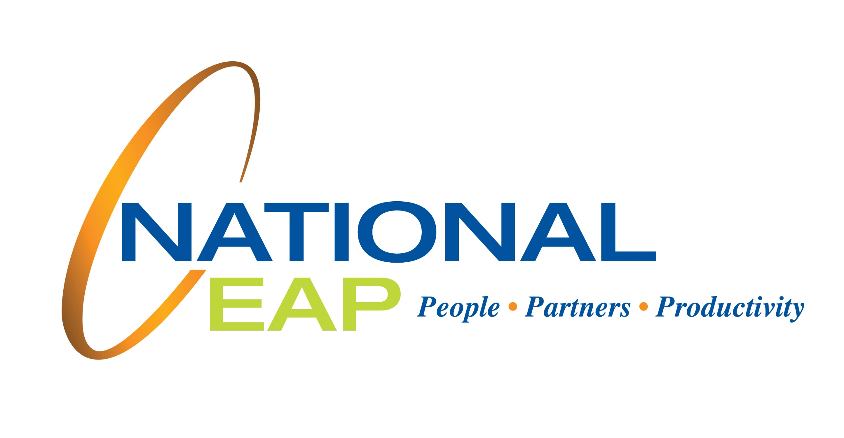

YOUR EMPLOYEE ASSISTANCE PROGRAM