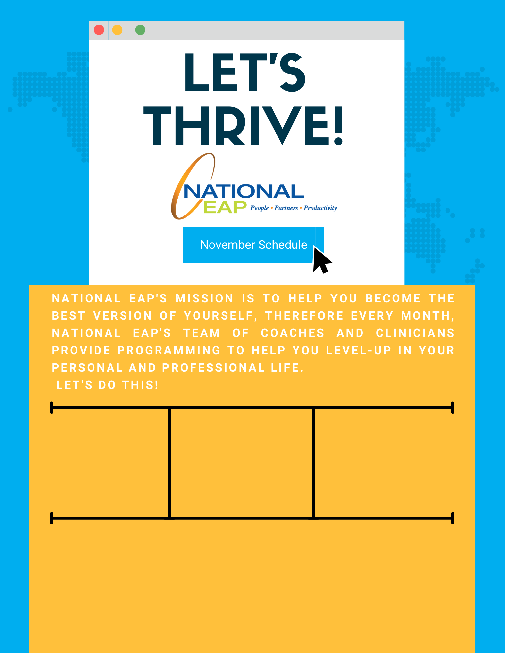

**[Zoom Link Info](https://nationaleap.com/wp-content/uploads/2022/10/National-EAP-webinar-Zoom-instructions20.docx)**

**The Basics of Mindful Eating with eM LIFE**

**November 15th at 12:00 pm EDT- 12:30 PM EDT**

**Toll-free: 800-624-2593  
Email:** [**info@nationaleap.com**](mailto:info@nationaleap.com) **Website:** [**www.nationaleap.com**](http://www.nationaleap.com) **USERNAME: Your Company Name  
PASSWORD Your Company Name**