

ALWAYS AVAILABLE | FREE | CONFIDENTIAL

YOUR EMPLOYEE SUPPORT PROGRAM

LET US HELP

Visit your home page starting January 17th

WEBSITE: www.nationaleap.com

USERNAME: YOUR COMPANY NAME

PASSWORD: YOUR COMPANY NAME

ONLINE SEMINAR

Being in nature increases serotonin, which is responsible in boosting our mood and helps us feel calm. In this session, we will explore the benefits of getting outdoors as a part of your self-care routines.

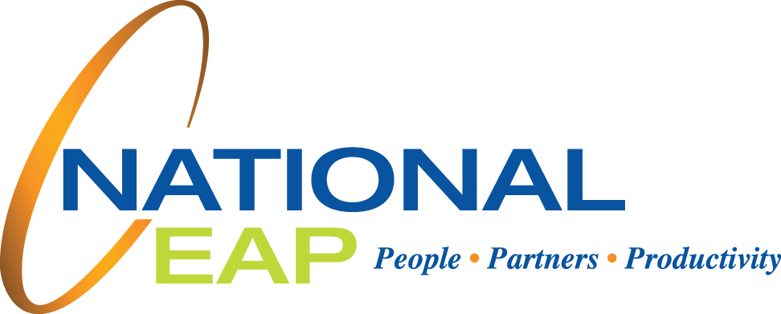

**Rays of Sunshine**

**JANUARY 2023**