

LET US HELP

Visit your home page starting April 18th

WEBSITE: www.nationaleap.com

USERNAME: YOUR COMPANY NAME

PASSWORD: YOUR COMPANY NAME

ALWAYS AVAILABLE | FREE | CONFIDENTIAL

YOUR EMPLOYEE SUPPORT PROGRAM

ONLINE SEMINAR

In this session, we will explore the steps towards greener living and how to guide our family to living more sustainably. We can help you connect intentions with actions for better mental wellbeing.

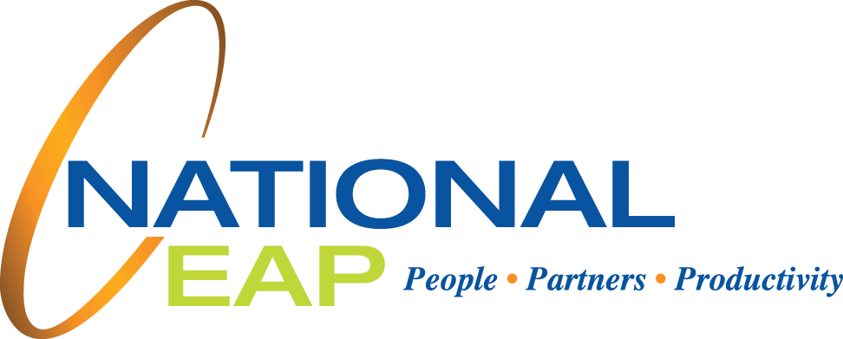

**Guiding Your Family to Greener Living**

**APRIL 2023**