

Being kind to planet Earth

Are you interested in exploring how to live a sustainable life? We can help you connect intention with action and engage with your community.

LET US HELP

TOLL-FREE: 800-624-2593

WEBSITE: www.nationaleap.com

USERNAME: YOUR COMPANY NAME

PASSWORD: YOUR COMPANY NAME

ALWAYS AVAILABLE | FREE | CONFIDENTIAL

YOUR EMPLOYEE SUPPORT PROGRAM

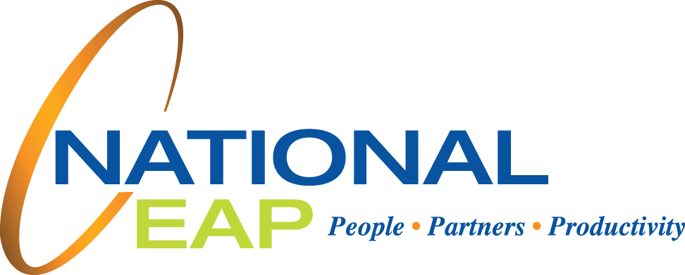

**Mindful Living**

**APRIL 2023**