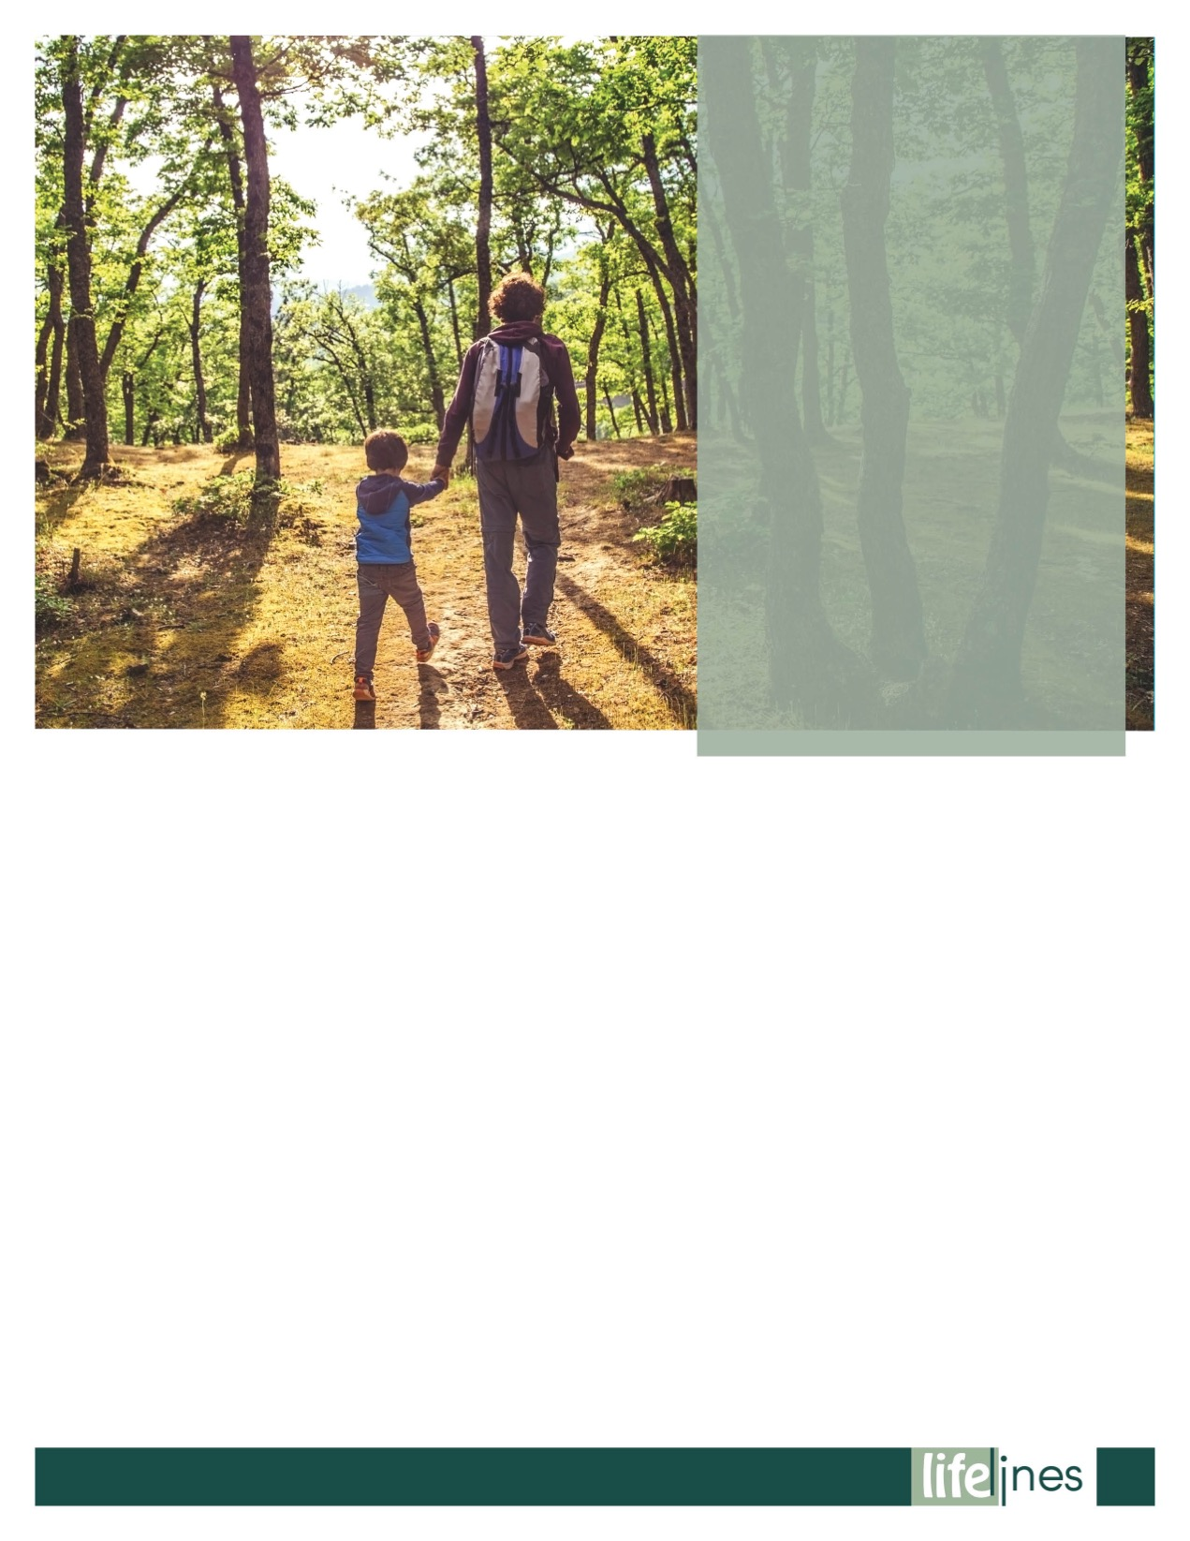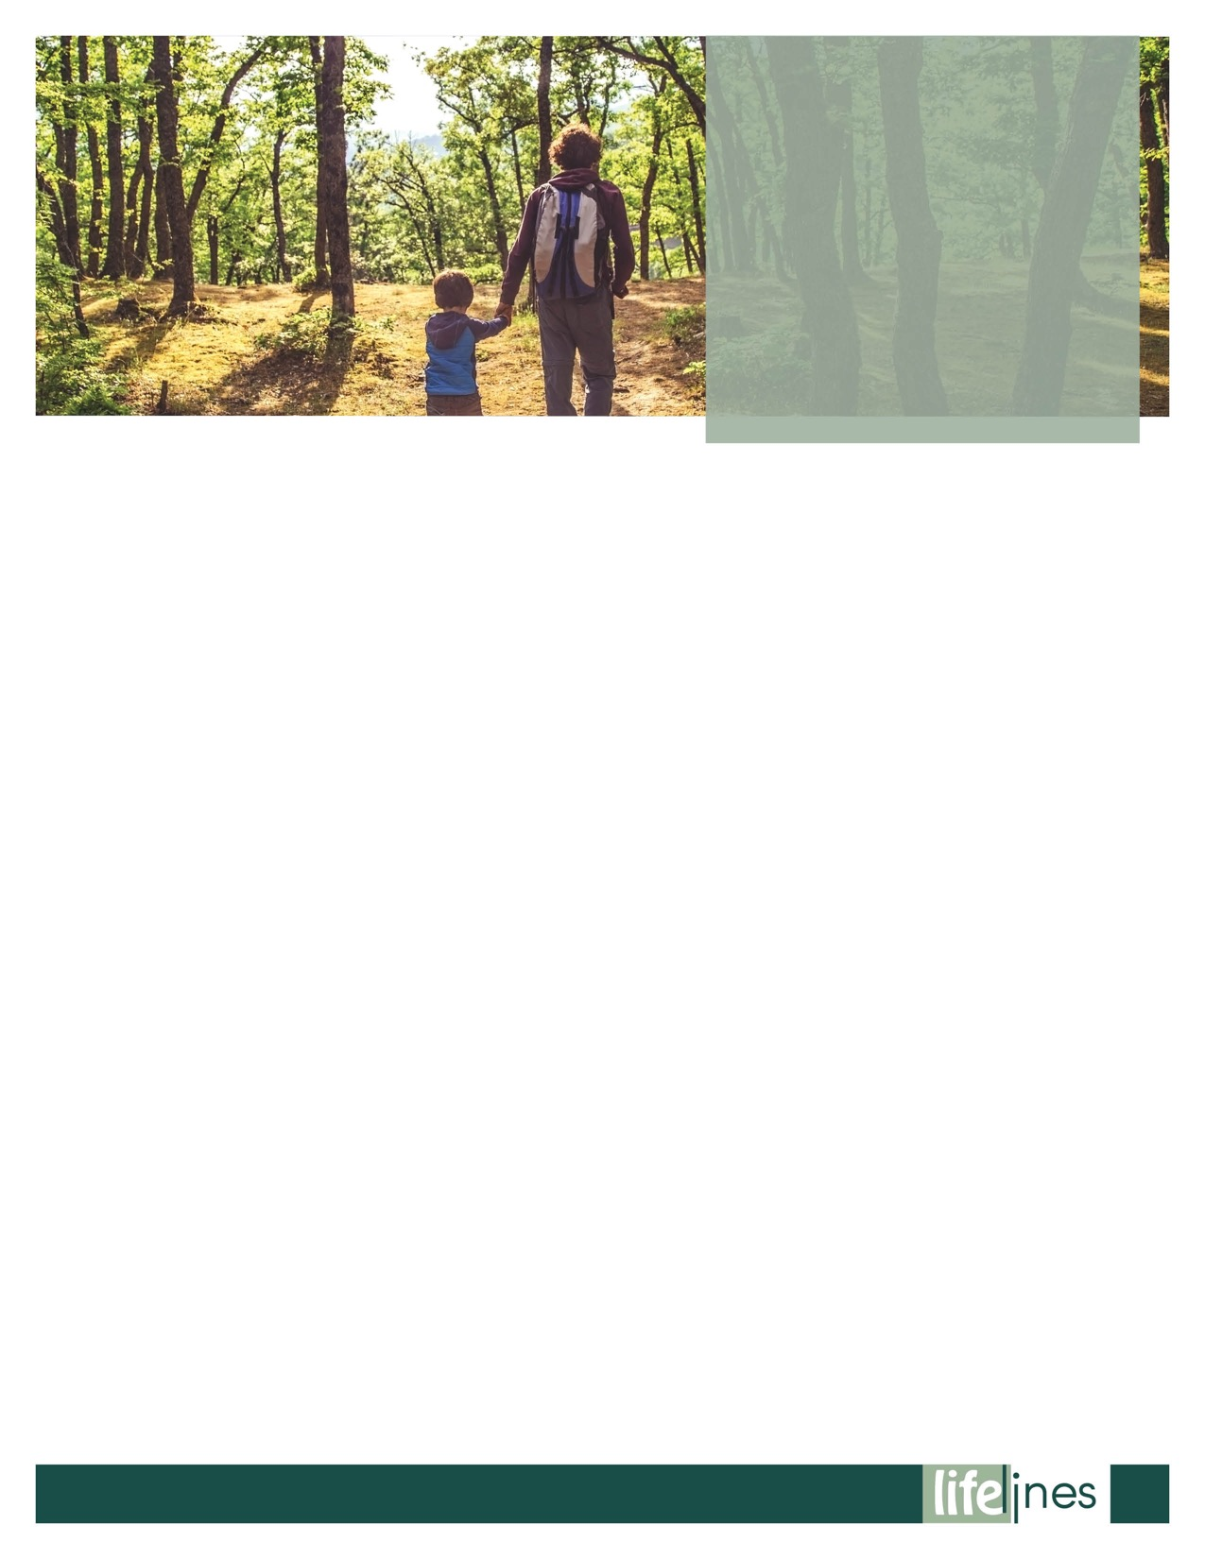

**OVERCOMING LONELINESS AS AN ADULT**

# **PG: 7**

# **2023**

**SPRING**

**ISSUE**

**Contact Us**

TOLL-FREE: **800-624-2593**

www.nationaleap.com

USERNAME: **username**

PASSWORD: **password**

**SETTING BOUNDARIES TO AVOID BURNOUT**

**PG: 11**

**WHAT IS RESILIENCE?**

# **PG: 5**

**The Benefits of Spending Time in Nature**

# **PG: 2**

**The Benefits of SpendinG Time in Nature**

**The term *nature* has a wide definition. This article will refer to nature as the physical world including plants, landscape, and other features of the Earth.**

Regardless of the definition used, spending time outdoors can and does bring about a wide range of positive emotions—such as calmness and serenity—and it can improve your focus, attention, and memory. Whether simply taking a walk in the countryside or practicing *shinrin-yoku* (also known as "forest bathing"), everyone could probably benefit from spending time in nature.

Nature Throughout Time

Spending time in nature used to be a bigger part of daily life, but the discourse of how and when people spent time in nature has changed as society moved on. Urbanization and technological advancements meant a steady decrease in the amount of time people spent outdoors, and a shift to a gadget-oriented world of TV and smartphones. Humankind and nature, in a way, became separate entities. There are many benefits of spending time in nature, and people should strive to reconnect with the world around them.

**Proven Benefits**

Research has shown that time in nature is a direct antidote for stress. When you are experiencing physical or psychological stress, your sympathetic nervous system (SNS) is activated. Spending time in nature can calm you down and reshape your reactions to stressors. For example, it can reduce high blood pressure (often caused by too much *cortisol*—the stress hormone).

As well as reducing stress levels, research has shown that time in nature can increase self-esteem, reduce anxiety, and improve low mood. Being outside, under natural light, can also be super helpful if you experience seasonal affective disorder (SAD).

There are also notable physical benefits, including the enhancement of immune system function and lowering of type 2 diabetes. Neighborhood "greenness" is associated with a reduced likelihood of being diagnosed with type 2 diabetes.1–4

Be mindful of how you spend that time in nature. When outdoors, engage with your senses. Take note of what you see, smell, feel, and hear.

Ecotherapy and Connectedness

Ecotherapy, sometimes known as "green care," comprises nature-based therapeutic interventions in a variety of natural settings.5 To practice ecotherapy, you may take part in these activities:

Meditation in nature—This can be self-guided or as part of a group with an instructor. It may take place in a park or on the beach, for example.

Green exercise—Physical exercise in a natural environment is a great way to spend more time outside while increasing your activity levels. Exercises outside may include walking, yoga, jogging, or cycling, to name a few.

Conservation activities—Helping to restore or conserve the natural environment can assist in creating a sense of purpose and connectedness while also being eco-friendly. If done in a group, it can enhance your sense of belonging and togetherness.

A Nature Prescription

Nature prescriptions can be formally prescribed in clinical practice by doctors to encourage people to embrace the benefits of nature. They generally involve green exercise (physical activity in nature settings, as described above) as well as other methods to connect to nature in a personal way. Let nature nurture you.

Many organizations have incorporated nature prescription initiatives, inspired by the direct links between exposure to nature and a range of physical and mental health benefits.

The Royal Society for the Protection of Birds (RSPB) Scotland, in collaboration with the National Health Service (NHS), conducted a pilot study of 350 people across all age groups, with participants receiving a nature prescription to improve mental or physical health (or both). Just under 75 percent of patients said there had been marked benefits after using the prescription, and 87 percent said they would continue using it.6

For example, Dose of Nature (based in Richmond, London, UK) provides a 10-week program, which can be accessed via a doctor's referral (https://www.doseofnature.org.uk). The program combines an assessment with a psychologist and one-to-one support from a guide, introducing people to the mental health benefits of spending time in nature, with the aim of encouraging lifestyle changes that can have a significant and, importantly, long-lasting impact on mental health and wellbeing.

Park Rx America (https://parkrxamerica.org) and Walk with a Doc (https://walkwithadoc.org) are also on board—encouraging clinical professionals to prescribe nature prescriptions as part of patient care in America.

Time In Nature: More Than A Walk

Going for a walk is a wonderful way to spend time in nature. You can walk solo, with a loved one, or in a group. You can walk fast or slow. You can walk in the city, countryside, or by the coast. But remember, there are many fun ways to incorporate more time outside:

Water activities—Try swimming, rowing along the canal, or dipping your feet in the sea!

Forest bathing—Try the peaceful Japanese practice of calmly and quietly observing the forestry around you, breathing deeply and mindfully, and simply being in nature.

Nature journaling—Take a seat and see how many types of trees, flowers, birds, and insects you can spot!

Composting—This will encourage you to spend more time outside with the added benefit of improving your sustainability!

*continued on page 3*

**SPRING 2023**

**2**

*continued on page 4*

**THE BENEFITS OF SPENDING TIME IN NATURE**

(Contd.,)

**3**

**SPRING 2023**



What if i live in the city?

You can still connect with nature and feel the benefits:

Spend some time researching nearby parks, woodlands, botanical gardens, riversides, and beaches.

If you have outside space (even a small patio or balcony), aim to spend at least 15 minutes in that outside space each day, taking in the sights, smells, and sounds.

Don't underestimate your windowed areas. Incorporate some house plants, grow some herbs, or maybe invest in a comfortable window seat and relax with the window open (weather permitting, of course!).

Unplug and "be still." When outdoors, swap out your electronic devices for a book, magazine, or a pen to write or draw.

Take some time to reconnect with the natural world around you!

References

Astell-Burt, T., Feng, X., & Kolt, G.S. (2014). Is neighborhood green space associated with a lower risk of type 2 diabetes? Evidence from 267,072 Australians. *Diabetes Care, 37*(1), 197–201. doi: 10.2337/dc13-1325

Doubleday, A., Knott, C.J., Hazlehurst, M.F., Bertoni, A.G., Kaufman, J.D., & Hajat, A. (2022, January 16). Neighborhood greenspace and risk of type 2 diabetes in a prospective cohort: The Multi-Ethnic Study of Atherosclerosis. *Environmental Health, 21*(18), 1–10. doi: 10.1186/s12940-021-00824-w

Fan, S., Xue, Z., Yuan, J., Zhou, Z., Wang, Y., Yang, Z. et al. (2019, December). Associations of residential greenness with diabetes mellitus in Chinese Uyghur adults. *International Journal of Environmental Research* *and Public Health, 16*(24), 5131. doi: 10.3390/ijerph16245131

Yang, B., Markevych, I., Heinrich, J., Bowatte, G., Bloom, M.S., Guo, Y. et al. (2019, March). Associations of greenness with diabetes mellitus and glucose-homeostasis markers: The 33 Communities Chinese Health Study. *International Journal of Hygiene and Environmental Health, 222*(2), 283–290. doi: 10.1016/j.ijheh.2018.12.001

McGeeney, A. (2016, April). *With nature in mind: The ecotherapy manual for mental health professionals*. London: Jessica Kingsley Publishers.

Royal Society for the Protection of Birds (RSPB) Scotland. (2020, November 2). *Nature being prescribed in Edinburgh to support health and wellbeing*. Retrieved May 19, 2022, from https://www.rspb.org.uk

_____________________________________________________

Copeland, R. (2022, May 19). *The benefits of spending time in nature* (B. Schuette, Ed.). Raleigh, NC: Workplace Options (WPO).

**THE BENEFITS OF SPENDING TIME IN NATURE**

(Contd.,)

**SPRING 2023**

**4**

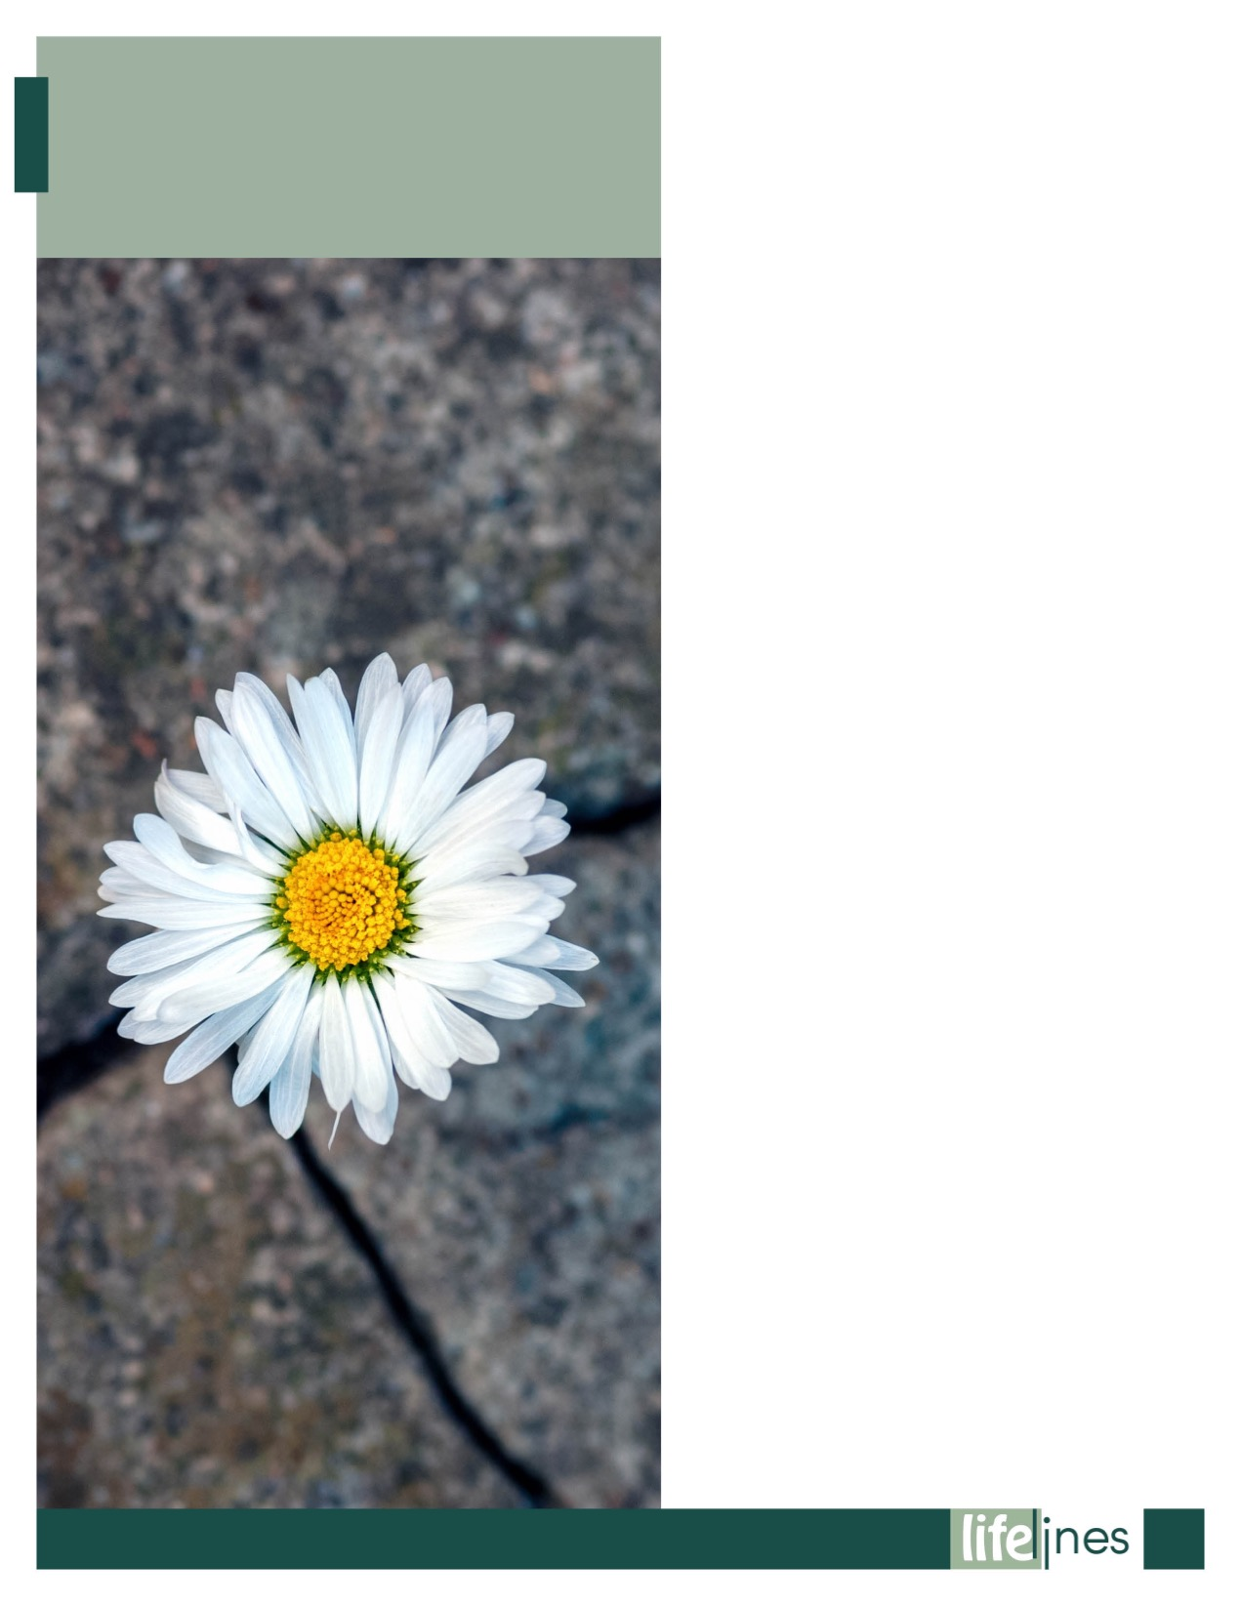

***Resilience* refers to the ability to successfully adapt to stressors, maintaining psychological wellbeing in the face of adversity. It's the ability to bounce back from difficult experiences. Resilience is not a trait that people either have or don't have. It involves behaviors, thoughts, and actions that can be learned and developed in everyone.**

Resilience is about being adaptable. It's about being flexible. It's about recognizing that you've got strengths that perhaps you never knew you had until you have to use them. It's like many things in life: The more you practice, the more you learn. The more you find out about resilience and certainly the more you do of it, then the more resilient you become.

Resilient people are able to adapt to stress, crises, and trauma. They find ways to bounce back from the ups and downs of life and move forward. Some people are born with a strong sense of resilience. Others may need to learn skills and develop resilience. If you would like to become more resilient, these tips can help. Remember that resilience is a skill, like riding a bike. The more you practice, the better you'll be.

**Ways to Become More Resilient**

Resilience isn't about "toughing it out" or reacting to every setback with a smile. Resilient people still feel sad, angry, or frustrated when faced with a setback. They just find ways to move forward and to tackle challenges with creativity, hope, and a positive attitude.

Here are some ways to increase your resilience:

* **Maintain a sense of perspective.** Ask yourself, "How big is this problem really?" and "What do I need to do?" Remember not to blow things out of proportion or catastrophize; remind yourself of the good in your life and that things really will change.
* **Recognize that you have a choice in how you handle challenges.** You can't control what happens to you, but you can choose how you respond. You can choose to react to changes and problems with hope and a positive attitude.
* **Accept change.** Change and uncertainty are part of life. When you accept this, you'll be better able to react to change with flexibility.
* **Anticipate challenges** by focusing on the positive ways in which you can meet them rather than possible negative outcomes. This will help you feel more in control and less overwhelmed.

*continued on page 6*

**WHAT IS RESILIENCE?**

**SPRING 2023**

**5**

**Learn how to calm yourself.** When you feel yourself reacting to a challenge with escalating stress and anxiety, take steps to calm yourself (deep breathing, replacing negative thoughts).

**Overcome your fear.** Everyone feels fear, especially when faced with a change. However, fear can hold you back from new experiences and opportunities for growth. If you are faced with a challenge that feels scary or overwhelming, start with the simplest thing you can do that takes you in the direction you want to go. Ask yourself, "What's the smallest thing I can do to get started?" Once you've thought about it, do it.

**Let go of your anger.** A difficult challenge can cause you to feel angry and upset. These feelings are normal, but they won't help you move forward. Work through your anger, and try to let go of negative feelings by writing about them or talking with a trusted friend.

**Take action.** Avoid dwelling on problems. Focus on solutions instead. Figure out what you can do and then do it, one step at a time.

**Laugh.** Even when things seem to be falling apart around you, try to find time to smile and laugh. It's very healing, and it will help you forget your worries for a few moments. Watch a movie that makes you laugh, or spend time with a friend with a good sense of humor

_____________________________________________

U.S. Department of State Archives. (n.d.). *What is resilience?* Retrieved August 5, 2021, from https://www.state.gov

**WHAT IS RESILIENCE?**

**6**

**SPRING 2023**



## The Community Life Survey, conducted from April 2020 to March 2021 (during the COVID-19 pandemic), found that 48 percent of adults in England felt lonely at least occasionally; 6 percent felt lonely often or always.3,4

## People who feel marginalized because of their race, ethnicity, language, financial resources, gender identity, sexual orientation, physical health, or disability are even more likely to experience loneliness. Younger adults are more likely to feel lonely than older adults.1–5

## A major life change, such as a breakup or divorce, job loss, the death of a loved one, or a long-distance move can contribute to feelings of loneliness. Changes in your circle of friends and family can also leave you feeling lonely.

## Feelings of loneliness may be intensified by the use of social media, which can replace in-person interactions with less satisfying remote connections. Social media can also present a false picture of other people's happiness and wellbeing, which can make a person feel lonely through unrealistic comparisons.

## What is loneliness?

## Loneliness is the distressing sensation of feeling alone and without meaningful human connections. It's typically accompanied by feelings of sadness, isolation, and disconnection. Loneliness is not the same as being alone: you can feel lonely while you're with other people if you don't feel a connection with them, and you can feel contented while you're alone if you feel that it's your choice to be by yourself.

## How common is loneliness among adults?

## Feelings of loneliness are common. Studies in the U.S. and the UK have estimated that between 40 and 60 percent of adults feel lonely at least some of the time. Those high rates of loneliness have been found in surveys conducted before, during, and after the COVID-19 pandemic:

## A survey by Cigna in December 2021 found that 58 percent of U.S. adults felt lonely (compared with 61 percent in a January 2020 survey, just before the COVID-19 pandemic).1

## A study by Making Caring Common, a project of the Harvard Graduate School of Education in fall 2020, found that 36 percent of U.S. adults reported feeling lonely frequently, almost all the time, or all the time.2

**OVERCOMING   
LONELINESS AS AN ADULT**

*continued on page 8*

**7**

**SPRING 2023**



*continued on page 9*

Is there a colleague at work whom you'd like to know better? Ask them to do something with you outside of work hours. A satisfying and supportive friendship is one in which you are both equally interested in each other. When you talk, ask how the other person is doing, listen to what they say, and respond in supportive ways. Share something of yourself, too, so they can get to know you.

## Try a new activity or join a group. New friends are often made through shared interests and activities. Expand the circle of people you're meeting by joining a group, whether for a creative activity, sports, getting out in nature, community service, or an interest you'd like to explore. These kinds of groups and activities offer opportunities for relaxed conversation and human connection. Spending time doing things you enjoy can also lift your spirits and could lead you to discover a new interest or passion. Your local library or community center may be able to direct you to groups and activities in your community, or you might try an online tool like Meetup.

## Volunteer. Contributing your time, energy, and expertise as a volunteer is a great way to meet people with similar interests and values while providing valuable services. Helping other people can help you feel better about yourself, too, which can help you overcome the negative emotions of loneliness

## Ways to Overcome Loneliness

## Find ways to enjoy the times when you're alone.  Take up a new hobby or return to one you've enjoyed in the past. Read books. Learn a new skill. Try your hand at drawing, painting, or playing a musical instrument. Work on a home-improvement project. Make your living space more comfortable. Spend time in nature. Explore a neighborhood or park you've never been to. When you're engaged in an activity you love, something that absorbs all your attention, you're less likely to feel lonely.

## Strike up conversations. Say hello to the neighbor you pass on the street. Ask them how their day is going and stop to chat if they're not in a hurry. Start a conversation with the person sitting next to you in the coffee shop or standing next to you in line. It can be hard to talk to strangers at first, but with some practice you'll find it gets easier. Consider that your smile or greeting can brighten another person's day. From what the surveys show, there's a good chance they're feeling lonely, too.

## Strengthen existing relationships. Think of the people you know, and consider how you might strengthen those relationships. Friendships require an investment of time and energy. They don't take hold without effort, and they can fade away with neglect. Do you have friends you talk with only occasionally? Call them or invite them out more often. Is there someone you used to spend time with who might still be available for the occasional walk, cup of coffee, or phone call? Reach out and see if you can reestablish reestablish that connection.

**OVERCOMING   
LONELINESS AS AN ADULT**

**SPRING 2023**

**8**

 

*continued on page 10*

## Spend time with animals. Pets, especially dogs and cats, can provide affection and companionship that take the edge off loneliness. Dogs bring an added benefit: Because they require walking, they get you outside and into the company of other dog owners. A cute dog on a leash can be both a magnet for other people and an easy way to break the ice and start conversations with strangers. If you're not ready to adopt a pet, you might ask neighbors and friends if they'd like you to walk their dog or take care of a pet when they go away.

## Take care of yourself. Loneliness is an emotional state, and emotions are tied to your physical and mental health. Eat a healthy mix of foods, get the sleep you need, engage in regular physical activity, and spend time outdoors. The combination of good nutrition, restorative rest, getting your body moving, and feeling the sunshine can lift your mood and help relieve the painful emotions of loneliness. Avoid trying to soothe your feelings with alcohol or other drugs. In the long run, they'll make you feel worse, and their use can build into a habit that's difficult to break.

## Take it slow and be patient. Take things one step at a time as you make efforts to build your social connections. It takes time to become comfortable with new people you meet and for those relationships to build into enjoyable and trusting friendships. Be patient. See what it's like to make small talk with a stranger and feel your confidence grow. Let new relationships develop naturally, at their own pace. Appreciate the new people you meet for their unique qualities. Avoid comparing them with old friends you miss.

## Recognize the limits of social media. Social media is not a substitute for in-person connections. It also tends to give unrealistically positive views of other people's lives, which can leave you feeling bad about your own life by comparison. Social media has great value as a tool for keeping up with certain aspects of people's lives, and it can help you make in-person connections with people who share your interests. However, it often contributes to, rather than relieves, loneliness. If social media is making you feel lonelier, cut back on it. If it's leading you to new connections, go with it (carefully).

## Bridge distances with phone calls and video chats. If your friends and family live far away, you can still spend time with them on the phone and by video. Text messages and online posts are fine for keeping up with someone at a surface level, but one-on-one conversations in real time are far more satisfying—and much better medicine for overcoming loneliness. You might schedule regular group video sessions with distant friends or family members—just to talk, or maybe to play a game, cook, or share another activity.

**OVERCOMING   
LONELINESS AS AN ADULT**

**9**

**SPRING 2023**

**SPRING 2023**

**10**

**OVERCOMING   
LONELINESS AS AN ADULT**

## Seek help.

If you've tried these steps and given yourself time to adjust to any changes you are going through, but you're still worried by your feelings of loneliness, you might benefit from some help. A counselor can help you understand what's making you feel lonely or getting in the way of building new social connections. They can also help you take steps to address both issues. If your loneliness is making you feel more than a normal level of sadness or is interfering with your work or daily life, a mental health professional can diagnose and treat a clinical problem such as depression or anxiety disorder.

## References

Cigna. (2022). *The loneliness epidemic persists: A post-pandemic look at the state of loneliness among U.S. adults*. Retrieved July 23, 2022, from <https://newsroom.cigna.com/loneliness-epidemic-persists-post-pandemic-look>

Making Caring Common Project, Harvard Graduate School of Education. (2021, February). *Loneliness in America: How the pandemic has deepened an epidemic of loneliness and what we can do about it*. Retrieved July 23, 2022, from <https://mcc.gse.harvard.edu/reports/loneliness-in-america>

GovUK. (2021, 29 July). *Community Life Survey 2020/21: Wellbeing and loneliness*. Retrieved July 23, 2022, from <https://www.gov.uk/government/statistics/community-life-survey-202021-wellbeing-and-loneliness>

Surkalim, D.L., Luo, M., Eres, R., Gebel, K., van Buskirk, J., Bauman, A. et al. (2022, 9 February). The prevalence of loneliness across 113 countries: A systematic review and meta-analysis. *British Medical Journal, 376*, e067068. doi: 10.1136/bmj-2021-067068

Mental Health Foundation. (2022, May). *All the lonely people*. Retrieved July 23, 2022, from <https://www.mentalhealth.org.uk/sites/default/files/2022-06/MHAW22-Loneliness-UK-Report.pdf>

_____________________________________________

Morgan, H. (2022, July 30). *Overcoming loneliness as an adult* (B. Schuette & E. Morton, Eds.). Raleigh, NC: Workplace Options (WPO).

## 

## If you're feeling overloaded and burned out, one problem could be the boundaries you're setting around your work, time, and relationships. Boundaries are the limits you establish on what responsibilities you take on, how you spend your time, and how you expect other people to treat you. Boundaries are key to maintaining healthy relationships and an appropriate balance between your own needs and work requirements, and the needs and expectations of others. If you find yourself saying "yes" too readily to additional demands on your time, attention, and energy, to the point where you feel overloaded, exhausted, resentful, and emotionally drained, you may need to pay closer attention to your boundaries.

## Saying "no" or "not now" is appropriate and necessary at times, even at work, with coworkers, customers, and your boss. You can do it without being rude or unhelpful or signaling that you're not committed to the work. When you set healthy boundaries for yourself and respect the boundaries of others, you'll build stronger relationships, help focus efforts on the most important priorities, and set yourself on a path to greater happiness and success

## How to Set and Maintain Boundaries

## Give yourself permission—to attend to your own needs, to focus on what's most important to you and your organization, or to take a break to relax and recharge. You have a right to set boundaries for your own wellbeing. You have an obligation to your employers to set boundaries to ensure that the most important work gets done.

* **Identify your limits.** Think about the requests you've said "yes" to or activities you've volunteered for that later left you feeling overloaded or resentful. Think about when you've put other people's wishes ahead of your own needs in ways that ultimately left you feeling bad. Think about times you've responded to "urgent" requests that pulled you away from more important obligations:   
  + It's great to apply your energies and skills to important endeavors. If helping someone, adding another activity to your busy schedule, or giving an extra effort at work feels good to you,   
    great—but you have needs, too. Pay attention to your emotions. If a relationship or activity drains your energy and makes you unhappy, it's likely you've allowed yourself to be pushed beyond an important boundary. If work feels overwhelming and you are at risk of burnout, you may need to step back and reconsider how you are focusing your efforts.
  + Consider what your emotions are telling you. What are your limits? Which people and activities energize you, bring you joy, or help you move toward your most important goals? Which bring you down or hold you back? Which of your work activities have high value to your customers and your organization, and which are taking your time and attention but producing little return? Paying attention to your emotions can help you identify the boundaries that are important to you.
* **Protect your time.** Think about how you spend your time. Are there meetings on your calendar that don't have a clear purpose or lead to productive outcomes? How often, when you're trying to concentrate on something, are you interrupted by incoming messages or other distractions? How much time do you spend outside of work checking news or social media or watching TV, or on other activities that don't bring satisfaction and restore your energy? You might be surprised to see what a difference it can make to focus your time and attention on your most important priorities at work and in your life outside of work:
  + Set aside time to focus on what's most important. That includes both the work that's most important and your priorities outside of work. It includes time to relax, connect with friends and family, recharge, and take care of yourself. Block time for these activities in your calendar, and treat them as unbreakable commitments.
  + To the extent that you can, find places and ways to work that minimize interruptions.
  + Set times when you'll respond to messages and times when you won't. You don't need to respond immediately to everything.
  + Expect that meetings you attend have a purpose and an agenda and that they lead to productive outcomes. When you're invited to a meeting, look at the agenda to make sure your attendance is needed. If it's not clear to you, ask why you've been invited.
  + Take short breaks during the workday, as allowed, to stretch, relax, clear your mind, and refresh your energy.
  + Protect time outside of work to be with family and friends, get physical activity, eat healthy foods, and get the sleep you need.
* **Reset unrealistic expectations**—both your own and other people's. If you're exhausting yourself because of your own high expectations of yourself, consider whether you might be crossing the boundary between pushing for excellence and striving for perfection. Excellence is an admirable goal, but perfectionism can be bad for your mental health. If other people have grown to expect you to respond immediately to their requests or to be the one who always volunteers for extra tasks, start resetting their expectations, politely but firmly. Make it clear that you are focusing on the most important work and that you have your own priorities and needs.
* **Start small.** It can be hard to break old habits in your own behavior and to change other people's expectations of you. Try setting boundaries with a friend or family member and see how it can improve your relationship. Try setting boundaries in small ways at work as a way to practice your communication.
* **Be consistent.** Don't say "no" to something, then give in to pressure and agree to it. If you feel guilty about not being more responsive and available, consider why you have those feelings. Challenge yourself to think about whether they are appropriate or helpful. You can't stop other people from asking you to do things, but you can control how you respond. With practice, maintaining your boundaries will become easier and you'll see the benefits in improved productivity and better relationships, work-life balance, and wellbeing.

**How to Communicate Your Boundaries**

* **Assert yourself.** If it's hard for you to say "no" to requests, it may be because you fear conflict, want too much to be liked or praised, or have fallen into a habit of putting other people's needs before your own. Learn to assert yourself. It won't lead to conflict if you're clear and respectful in your communication. Considering both your own needs, your organization's most important needs, and the needs of others, be firm and polite in explaining what you're willing and unwilling to do.
* **Be clear, calm, and direct.** If you're asserting your boundaries for the first time, you can't expect other people to know without telling them. Be clear, calm, and direct when you explain to someone that you're not able to do what they're asking. It may help you get your message across if you let the person know what your other priorities are, especially if they are work priorities. But that's not always necessary or even appropriate if your other priorities are personal. There's no need to defend or over-explain your reasons for maintaining a boundary.
* **Rehearse ahead of time.** If you're intimidated by the prospect of being more assertive, practice saying "no" in clear, calm, and respectful ways. You might do this in front of a mirror or with a trusted friend or family member.
* **Offer other options.** If you're willing to help someone, but not right now, suggest another time that might work for both of you. If you can't contribute to a project or effort right now and have thoughts on ways it might get done without you, offer your suggestions in a helpful way. If the request seems important but conflicts with other work priorities, ask your manager whether you should set aside existing work to make time for the new assignment.

**SPRING 2023**

*continued on page 12*

**11**

**SETTING BOUNDARIES TO AVOID BURNOUT**

## 

**SETTING BOUNDARIES TO AVOID BURNOUT**

**12**

**SPRING 2023**

*continued on page 13*



*continued on page 14*

**13**

**SPRING 2023**

**SETTING BOUNDARIES TO AVOID BURNOUT**



**Maintain your boundaries.**

**Be firm and stay strong in maintaining your boundaries.** Remind yourself of the reasons you've decided on them—the feelings of overload and resentment you've had in the past or the awareness that you're not getting to the most important work. If you back down or are inconsistent, you invite people to ignore your needs.

**Be realistic and adaptable.** While you need to be firm about important boundaries, be open to adjusting them if they prove to be too rigid. Your organization's needs and priorities can change quickly with economic conditions, innovation, and shifting customer preferences. You have to be flexible in supporting your organization as it adapts to those changes. Remember, too, that a key goal of boundaries is mutual respect—to have others respect your needs while you respect theirs. Don't set boundaries that are so protective of your needs that they get in the way of collaboration, friendship, and engagement with activities that are important to you and your organization.

**Seek help.**

If you're struggling to set and maintain healthy boundaries, reach out for help. Contact your employee wellbeing program to speak with an expert who can help you understand what boundaries might be helpful to you or coach you on how to explain your boundaries to others.

___________________________________________

Morgan, H. (2022, July 30). *Overcoming loneliness as an adult* (B. Schuette & E. Morton, Eds.). Raleigh, NC: Workplace Options (WPO).

**14**

**SPRING 2023**

**SETTING BOUNDARIES TO AVOID BURNOUT**

winter 2020

t

9